12/10/2023

Brenda Beach & Jonathan Hardwick

Video Game Library & Sales

Video Game Library & Sales

User Manual

Contents

**Installation of Required Programs to Write Code** 2

**Installation of Python** 2

**Installation of Visual Studio Code** 8

**Download Website Code** 16

**Clone GitHub Repository CSC289** 16

**Download Website Code** 23

**Download and Install MySQL Workbench** 30

**Open the Project in Visual Studio Code and Activate the Virtual Environment** 50

**Install All Necessary Modules inside the Virtual Environment** 58

**Initialize the Website** 63

**VGLS Website** 65

**Website Registration** 65

**Password Reset** 67

**Login to the Website** 69

**Select/Search for Specific Video Game** 70

**Creating a Video Game List on Account to Track Personal Collection** 72

**Search for New Games** 75

**Sell Library Items** 77

**Admin Portal** 78

**Edit User Accounts** 79

**Add/Edit Manufacturer** 80

**Add/Edit Game Systems** 82

**Add/Edit Video Games** 84

**Account Information** 86

**Website Reviews** 87

**Create a Review** 88

**Update a Review** 88

# **Installation of Required Programs to Write Code**

Currently, the Video Game Library and Sales program is not set to be run by an executable, so you will need to download and install a couple of programs if you do not already have them. Those programs are Python and Visual Studio Code. You can use a different IDE other than Visual Studio Code, but for this installation manual, we will be using Visual Studio Code.

## **Installation of Python**

1. The first thing you need to do to install Python onto your system is to go to the website <https://www.python.org>.

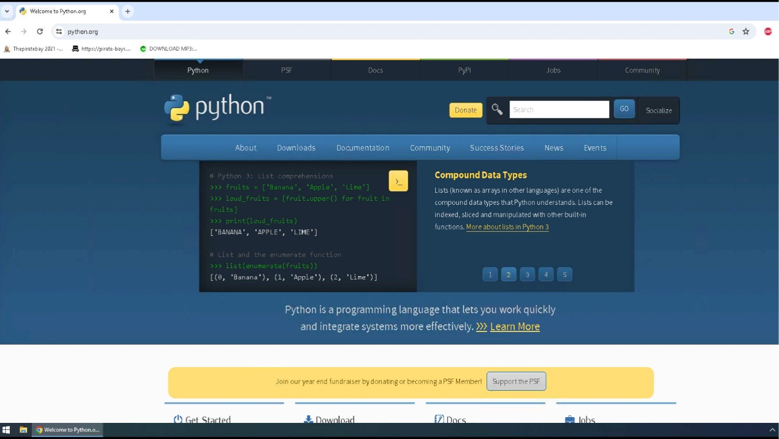

1. Once you have arrived at the website, you will click on the Downloads link and then click on the link to download the latest version of Python onto your system.

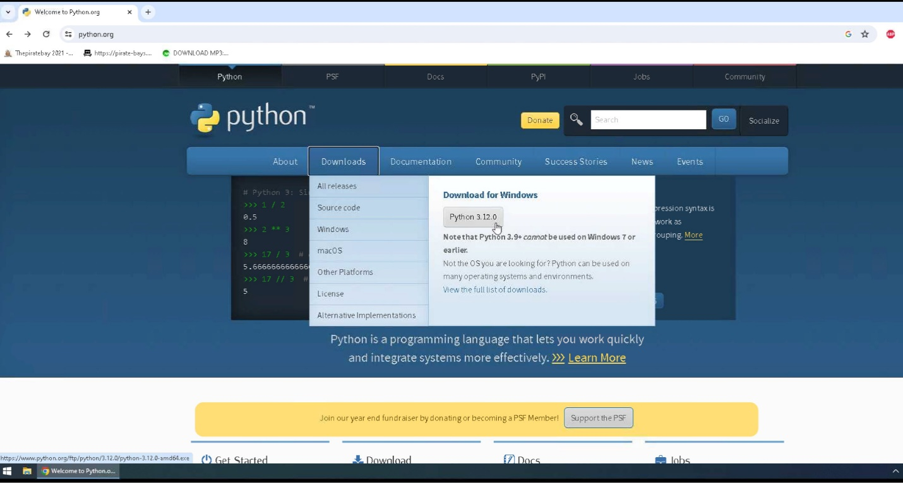

1. Python will download to your default downloads folder, and once it has been completed, you can click on the icon to view your downloaded file names in the upper right corner of your webpage so you can click on that file name and install the program onto your system.

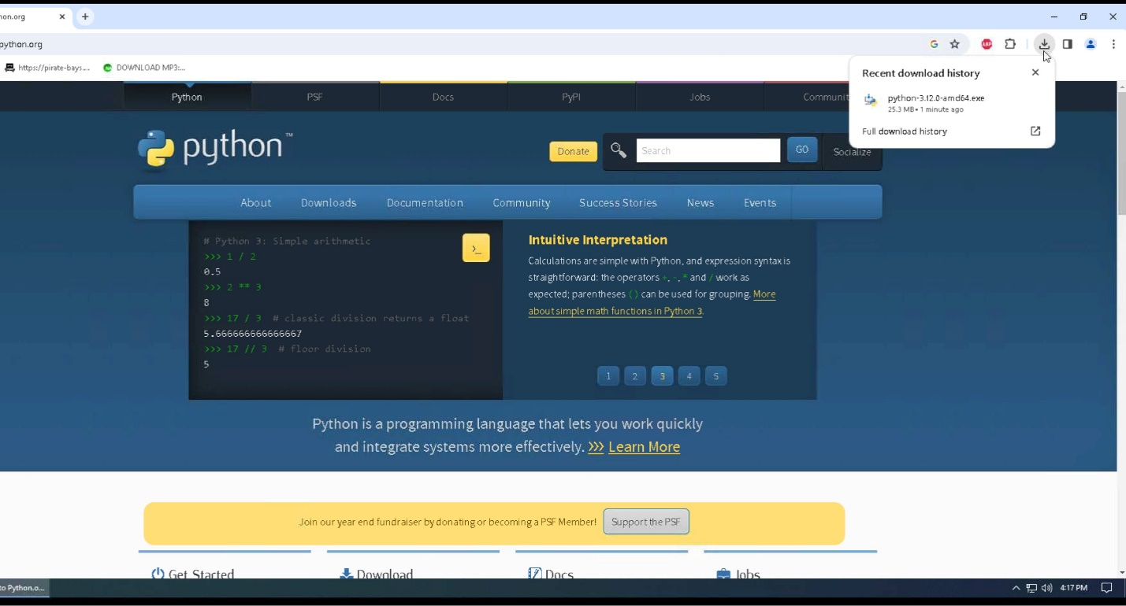

1. Click on run to install Python onto your system.

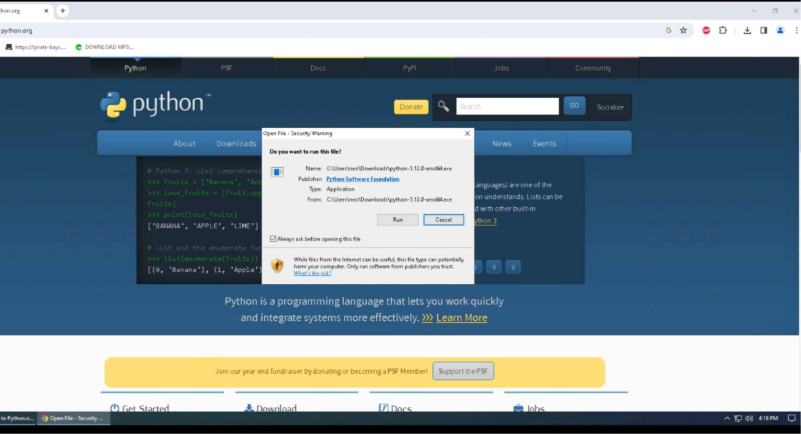

1. Click “Add Python to PATH,” then click Install Now.

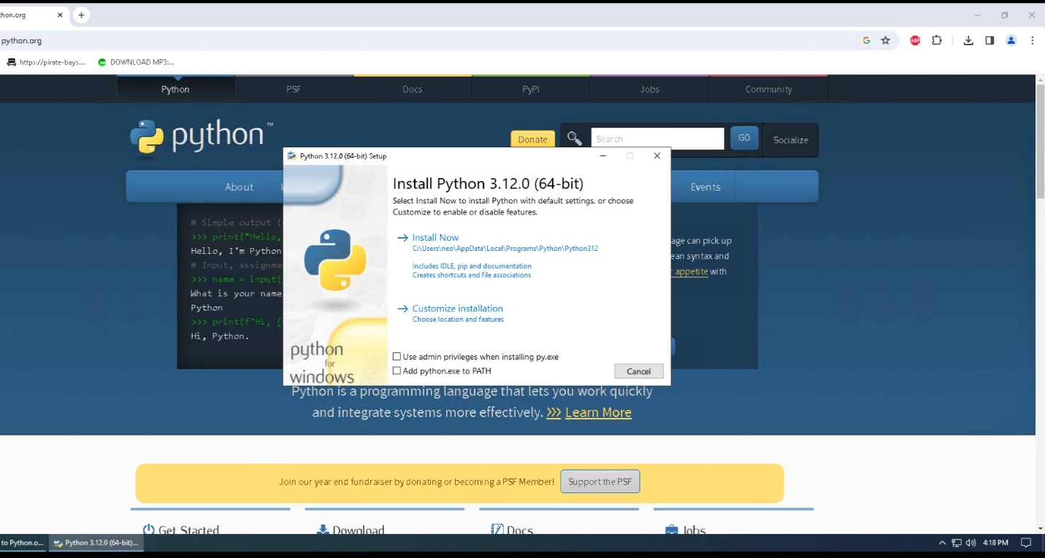

1. The program will now be installed on your system, and the status bar will show the progress level of the installation.

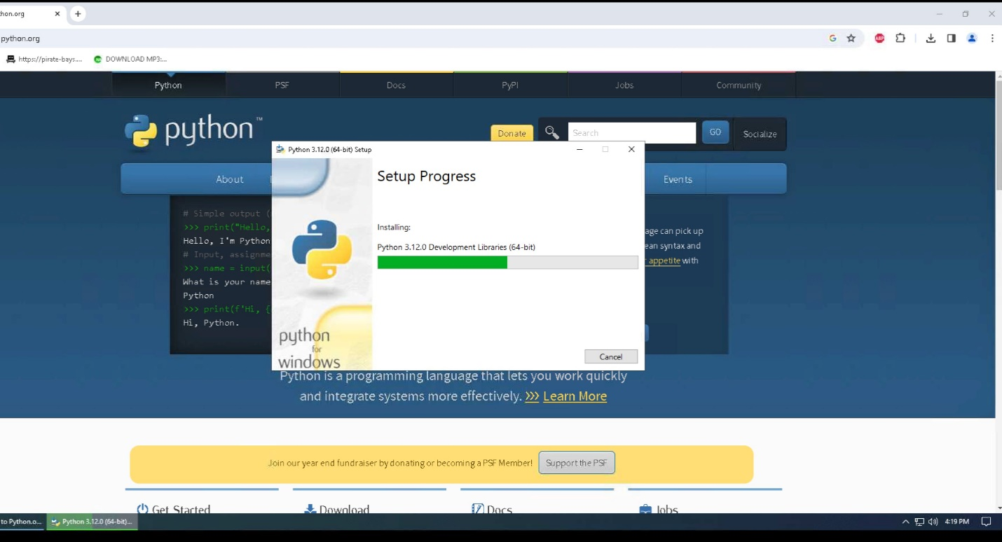

1. Once the installation is finished, click on Close to close the setup window. You can then close the web browser.

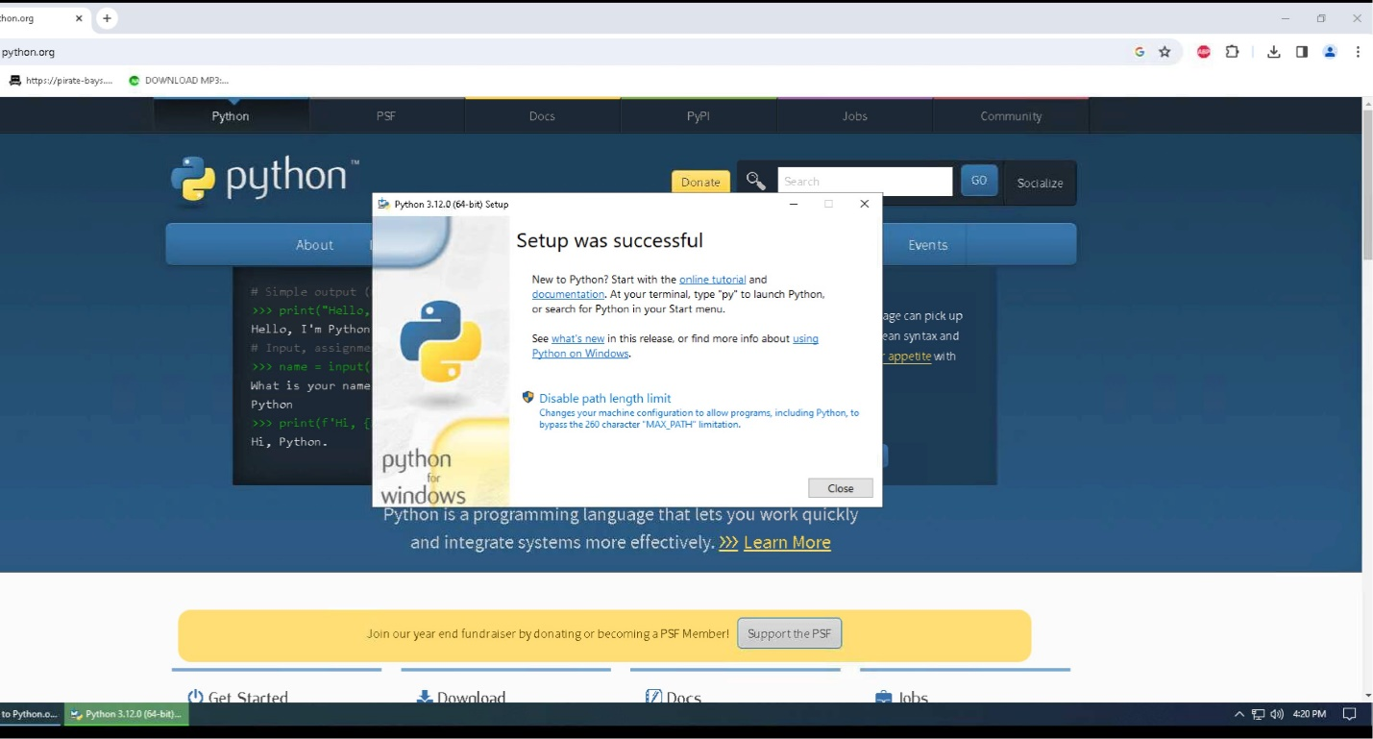

1. To verify the installation of Python onto your system, you can click on the Windows icon, also known as your start button, and under the recently added programs, you should see the Python program.

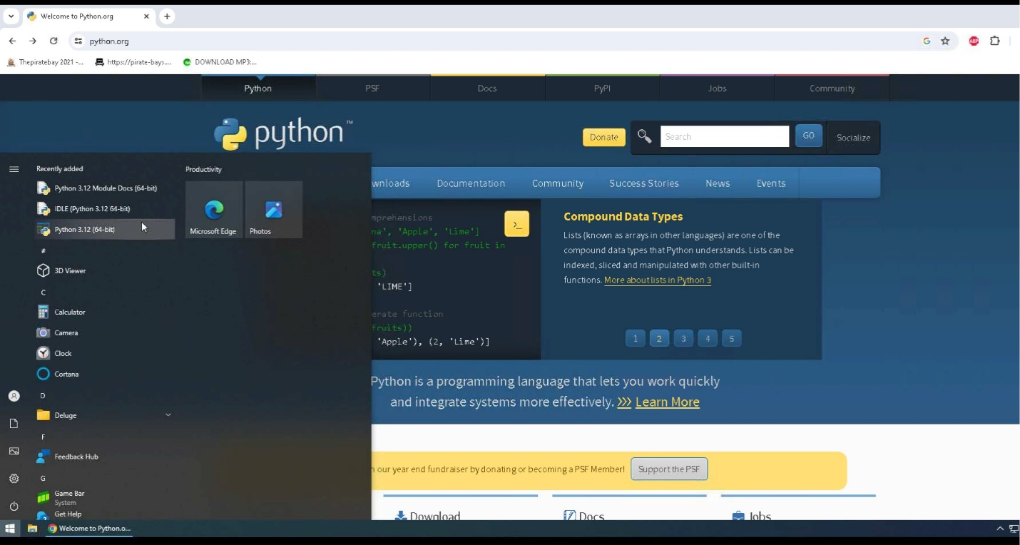

1. You can also verify that Python installed on your system by opening a command prompt (press the windows key and type cmd and select command prompt), and typing python –version. If you get an error message when you run this command, you must repeat these steps to reinstall Python on your system.

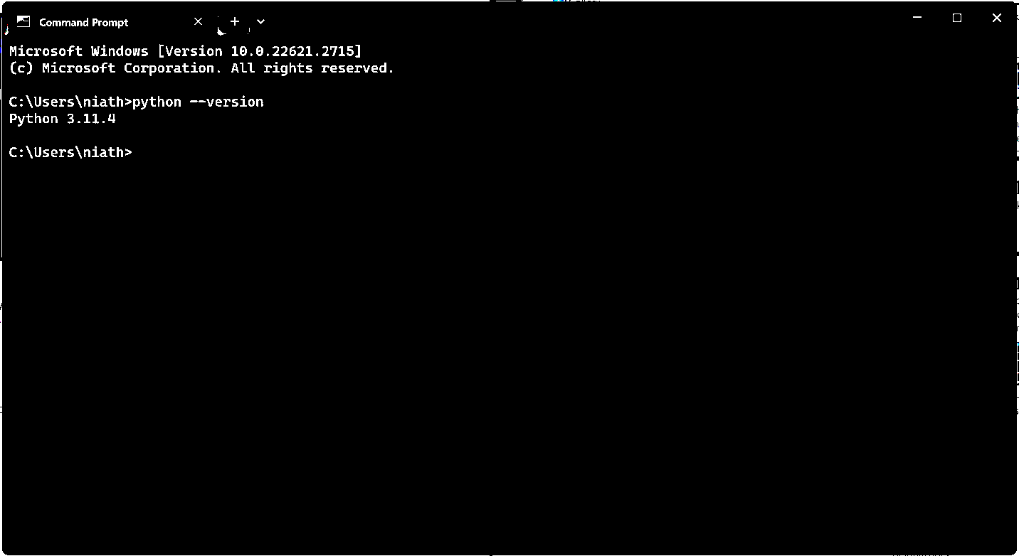

1. Now that Python is installed on your system, it is time to install our IDE so we can view our code and run the program.

## **Installation of Visual Studio Code**

1. To install Visual Studio Code, go to the webpage <https://code.visualstudio.com>.

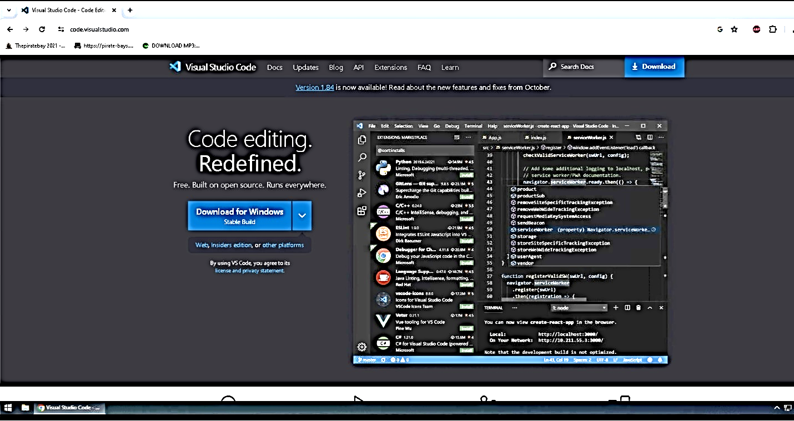

1. Click on download to download to your default downloads folder, and once it has been completed, you can click on the icon to view your downloaded file names in the upper right corner of your webpage.

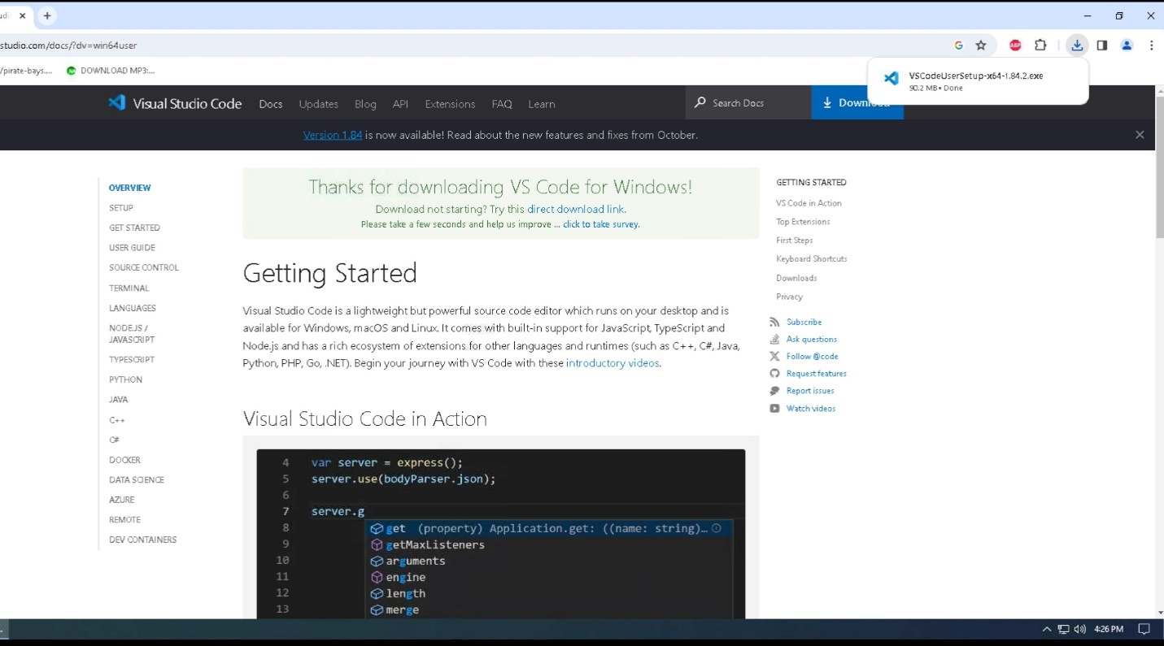

1. Click on the file name to install Visual Studio Code on your system.

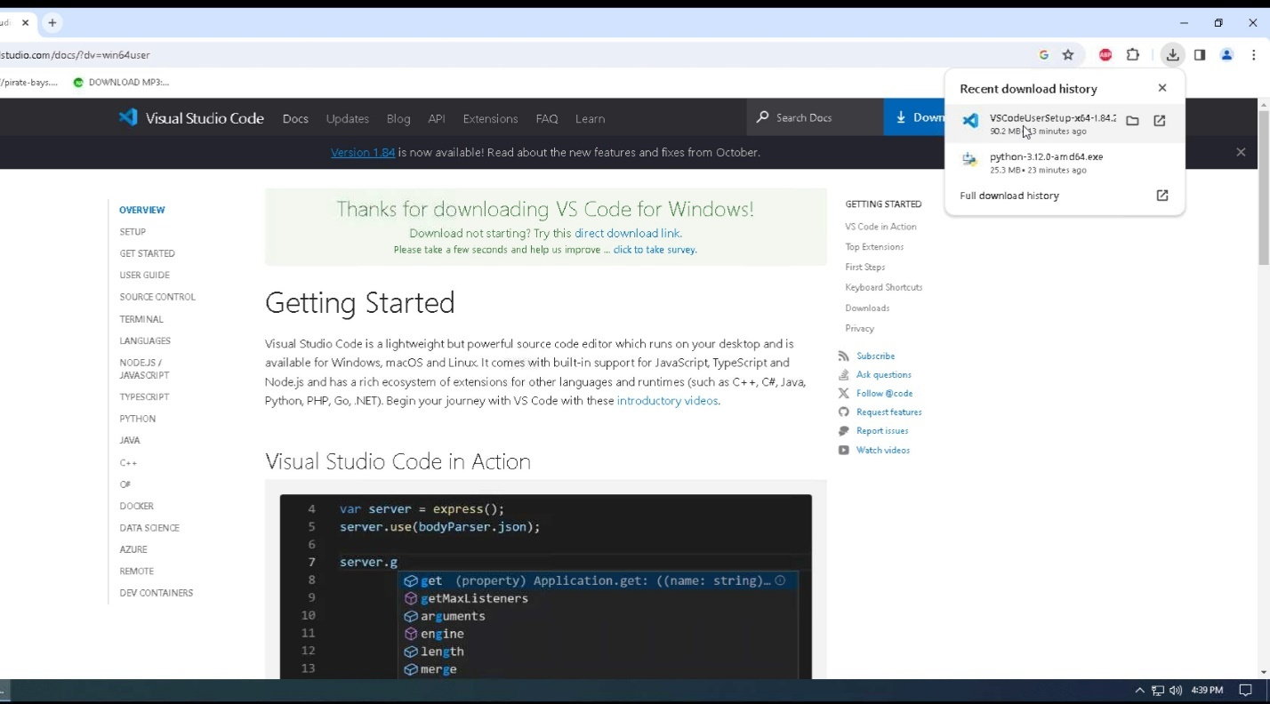

1. Click on Run to begin the installation of Visual Studio Code.

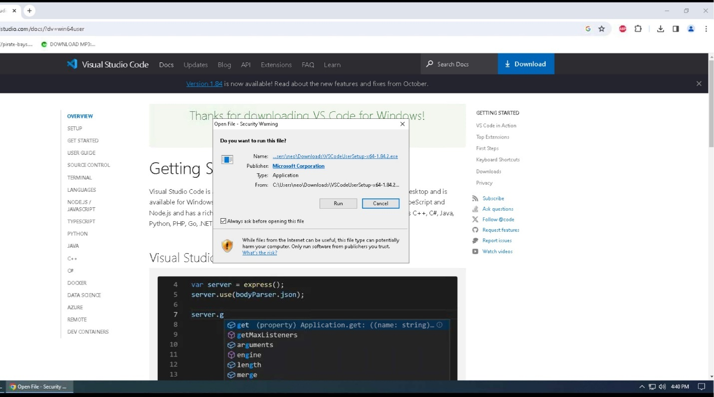

1. Select “I accept the agreement”, then click on Next.

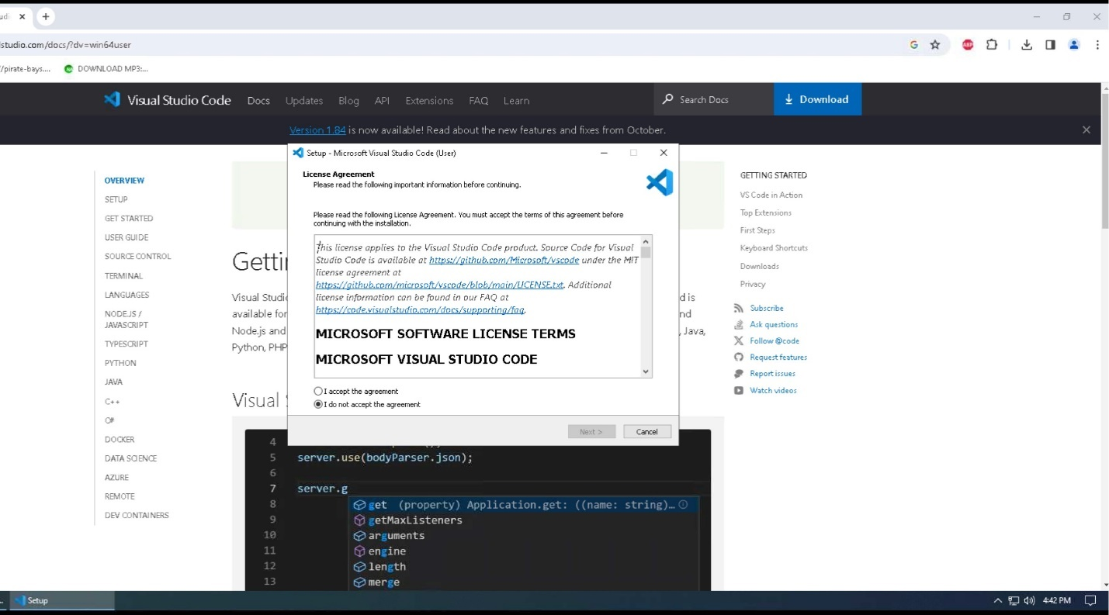

1. Click “Browse…” to select the location to install the program or leave it as the default location. Click Next to continue.

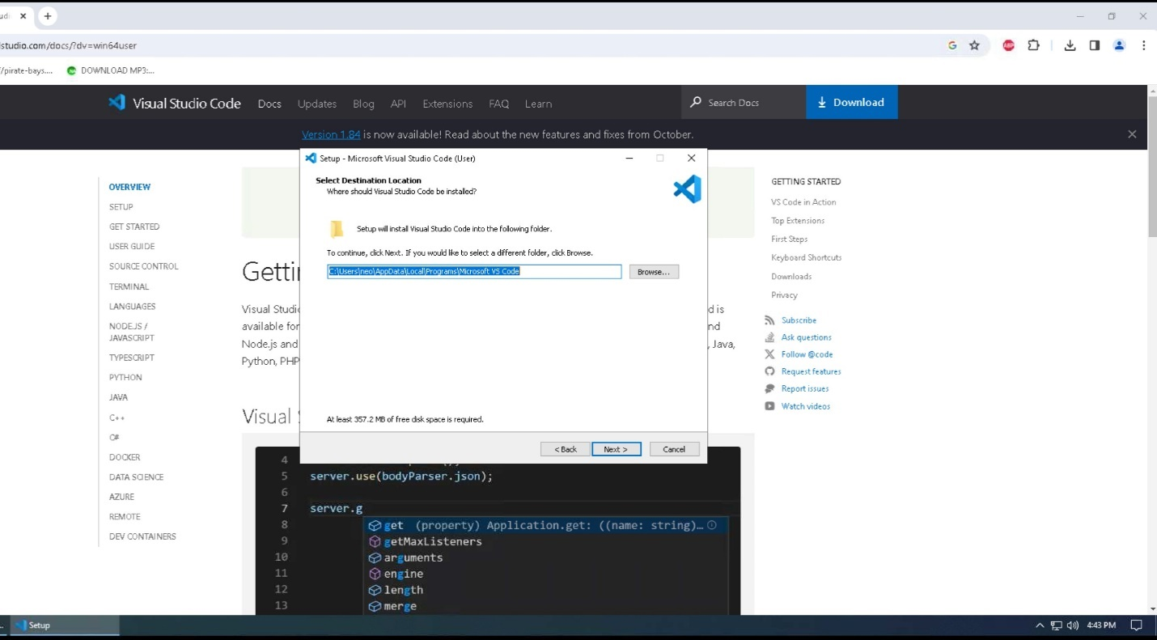

1. Click “Next” to accept the default location and continue to the next step in the installation process.

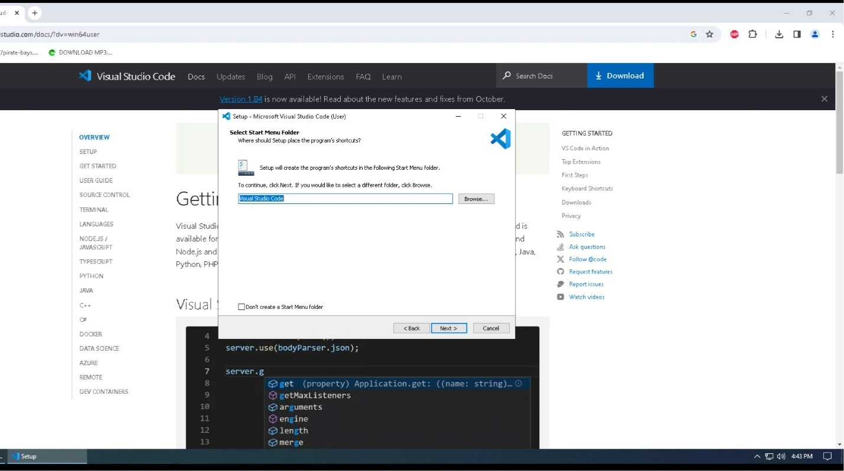

1. Click “Create Desktop Icon”, then click Next to continue to the next step of the installation process.

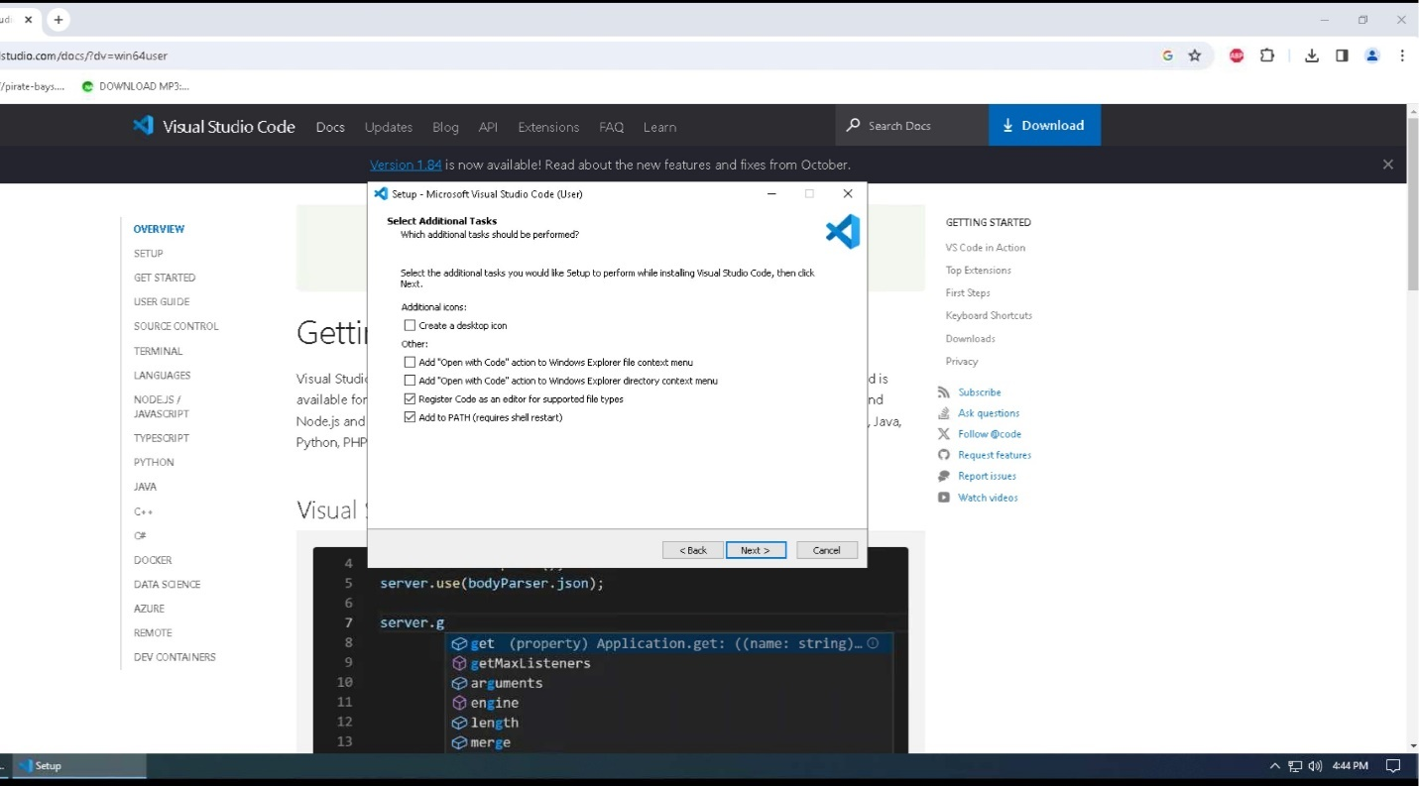

1. Click “Install” to install Visual Studio Code onto your system.

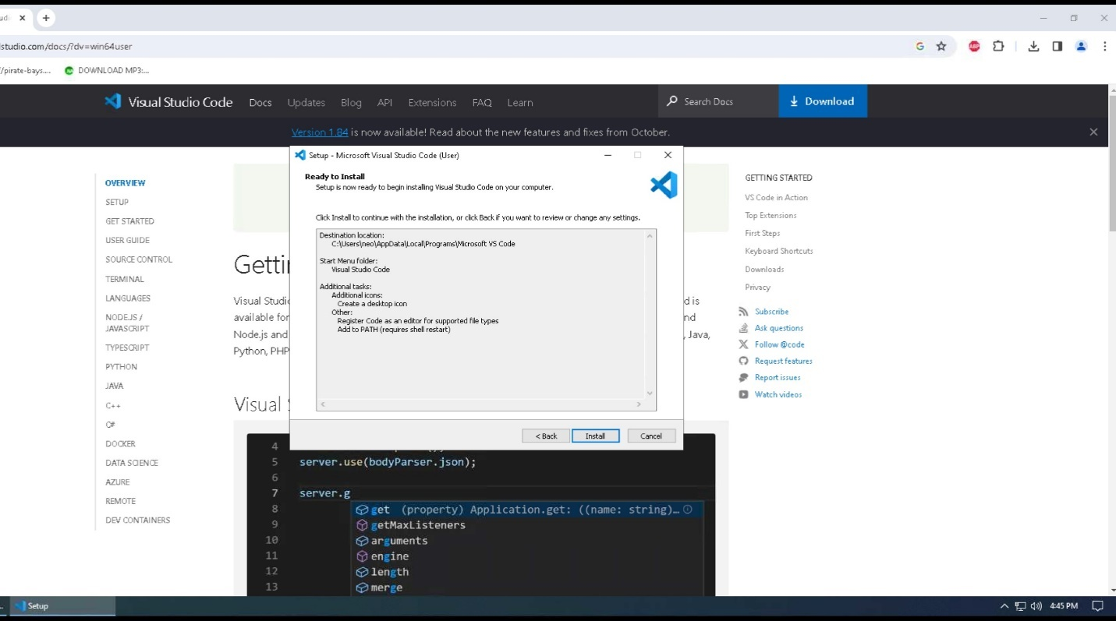

1. Visual Studio Code will now be installed on your system, and the status bar will show you the progress of that installation.

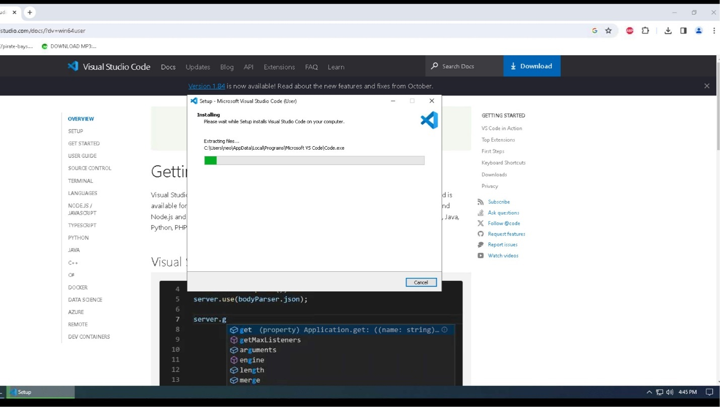

1. Once the program has been installed, ensure that the “Launch Visual Studio Code” is checked before you click “Finish”. This will close out the installation window and start the Visual Studio Code. You can also go ahead and close the web browser.

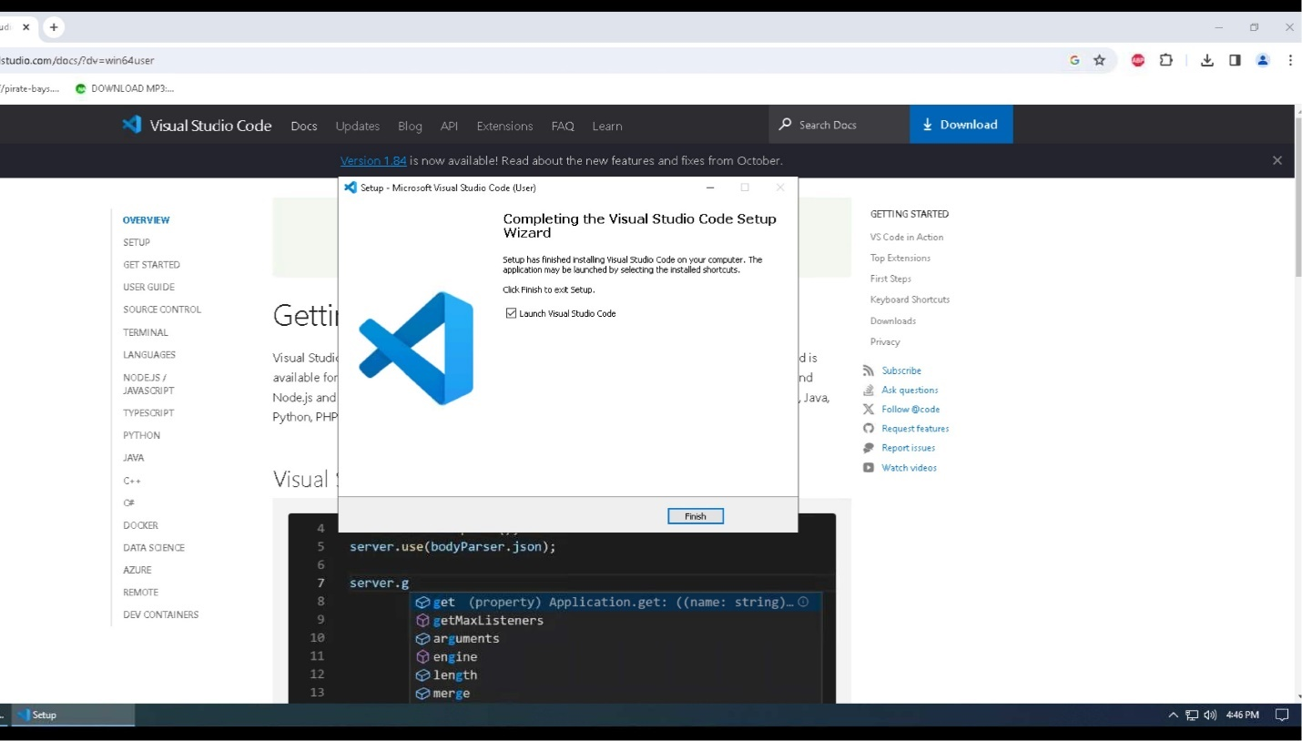

1. Visual Studio Code will now open. You will need to click on the “Extensions” icon 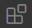 so the Python extension can be installed and write our Python code inside Visual Studio Code.

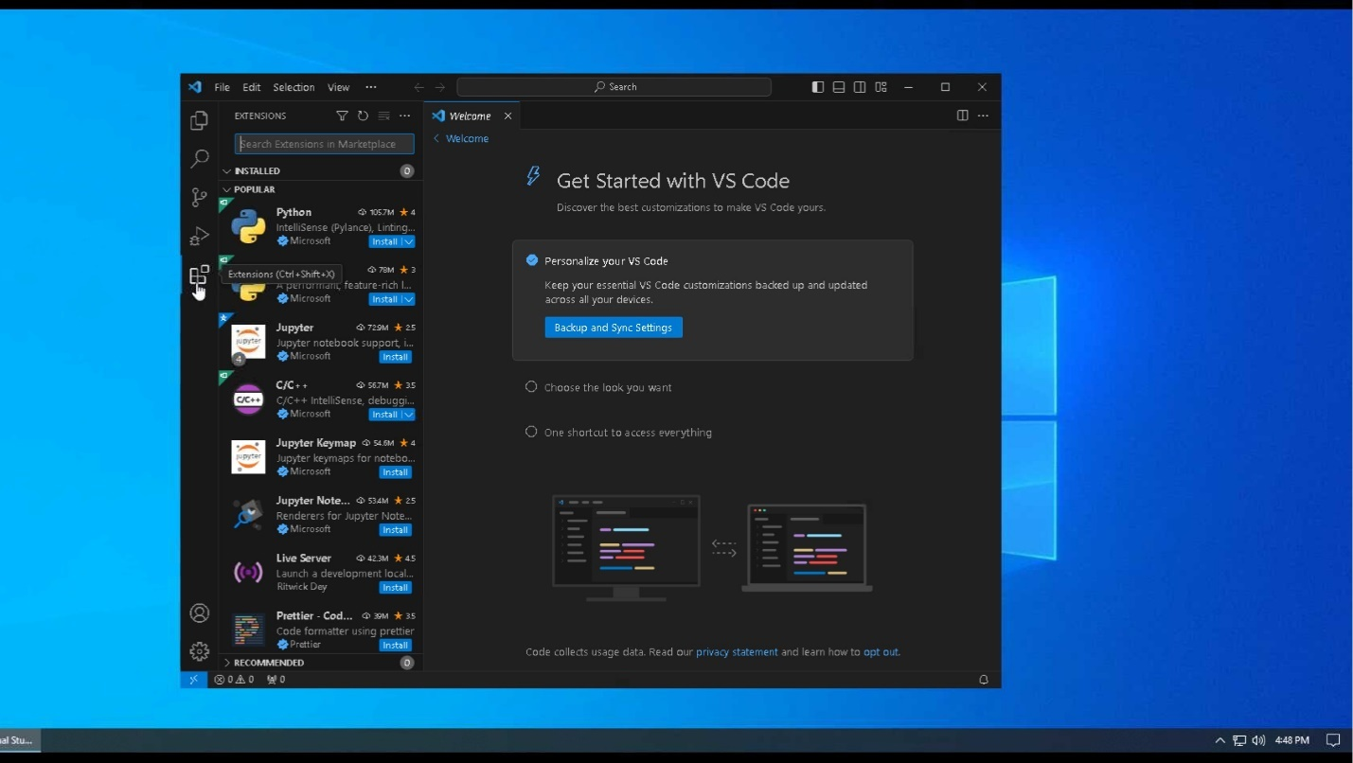

1. Click on “Install” under the Python Extension.

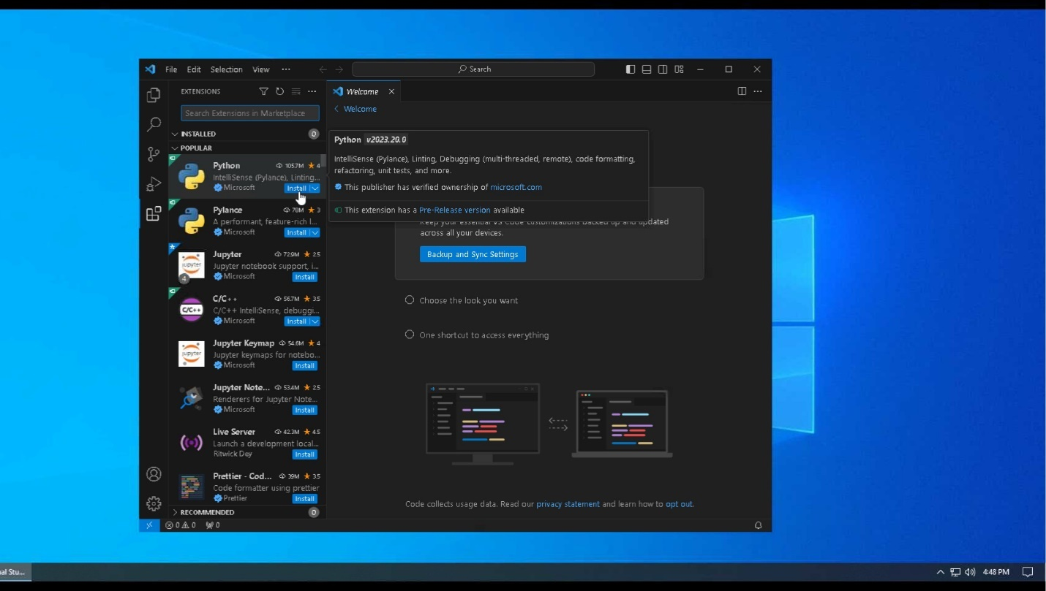

1. It will then install the Python extension. Once it is finished, you can write your Python code without receiving any errors.

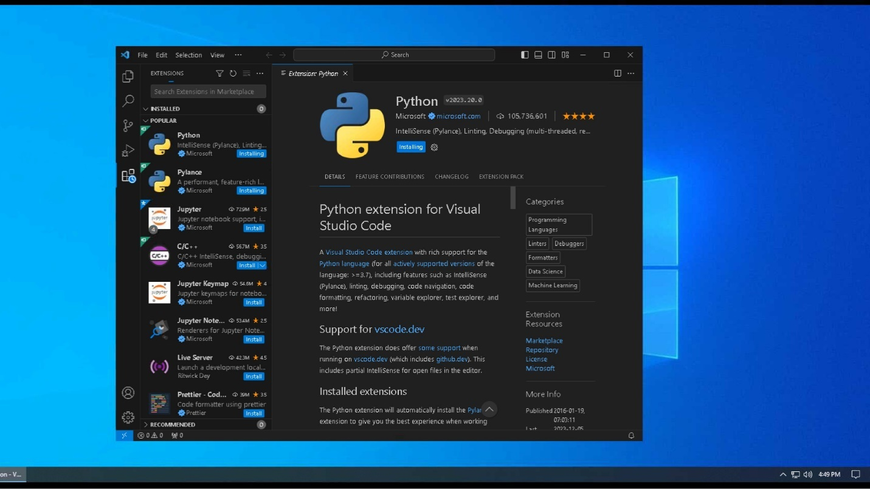

## **Download Website Code**

You will only need to choose one of the following methods to download the code

### **Clone GitHub Repository CSC289**

1. The first option will be to download the GitHub Desktop. You will go to the URL of <https://desktop.github.com> then click on “Download for Windows” button. This will download into your downloads folder.

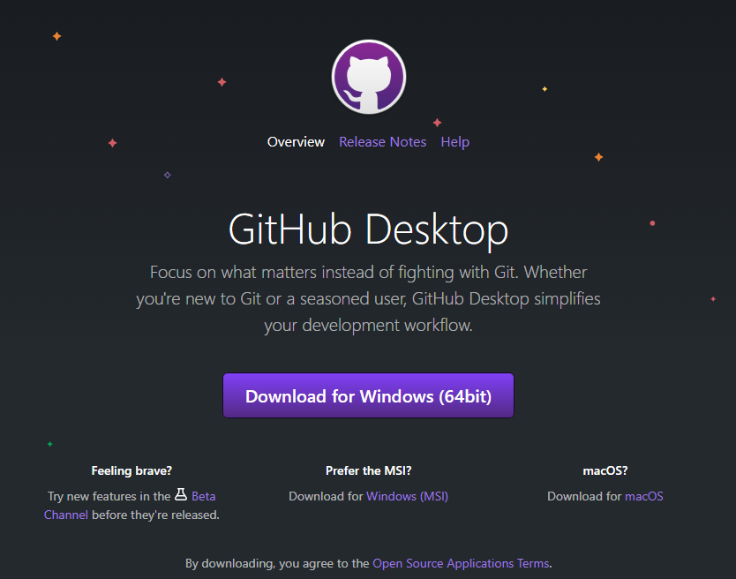

1. Go to your downloads folder and look for the GitHub Desktop Setup executable file and double-click it.



1. It will start to install onto your system and once it is complete, it will automatically open the GitHub Desktop program.

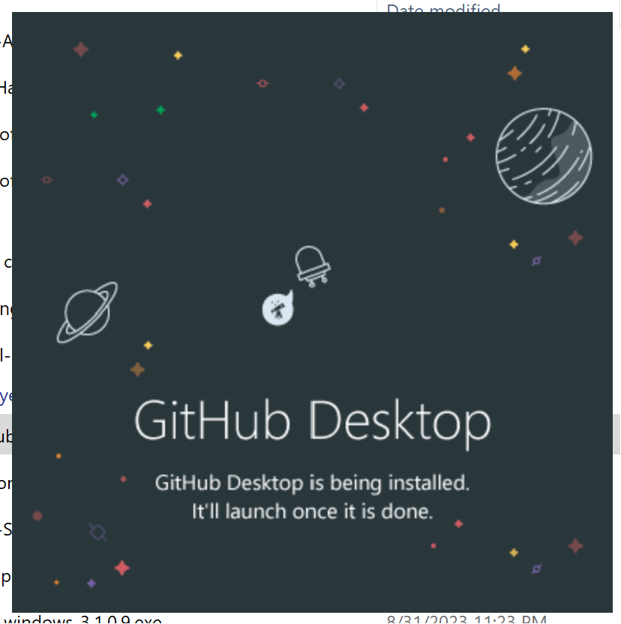

1. Click on “File”, then click “Clone Repository”. You will be able to download the repository you are looking for.

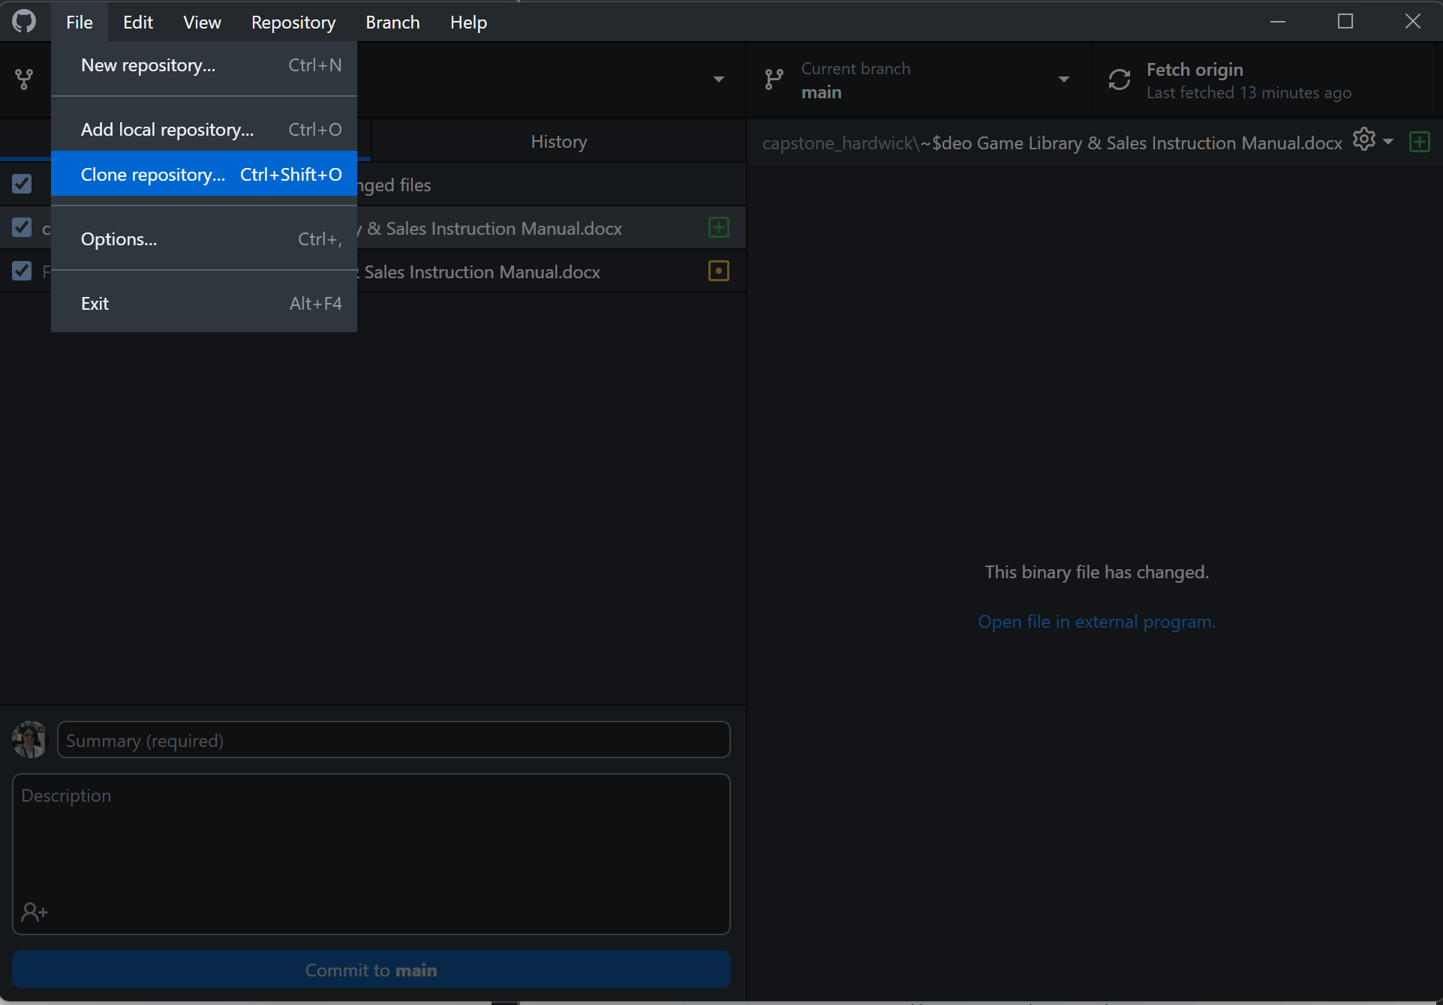

1. Select the repository you want to clone and then select the path you want to have the repository saved and click “Clone”.

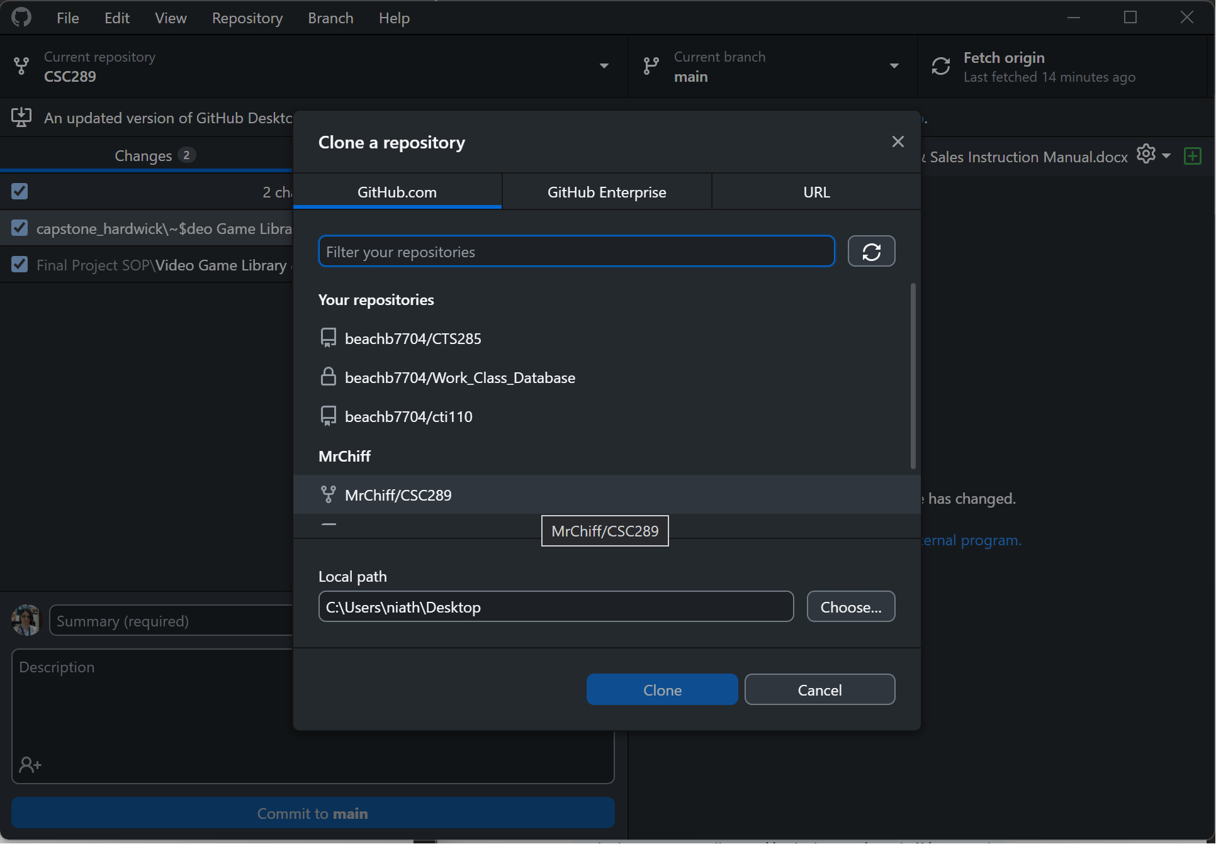

1. It will then start to download the repository to your system so you can have an offline version of your repository.

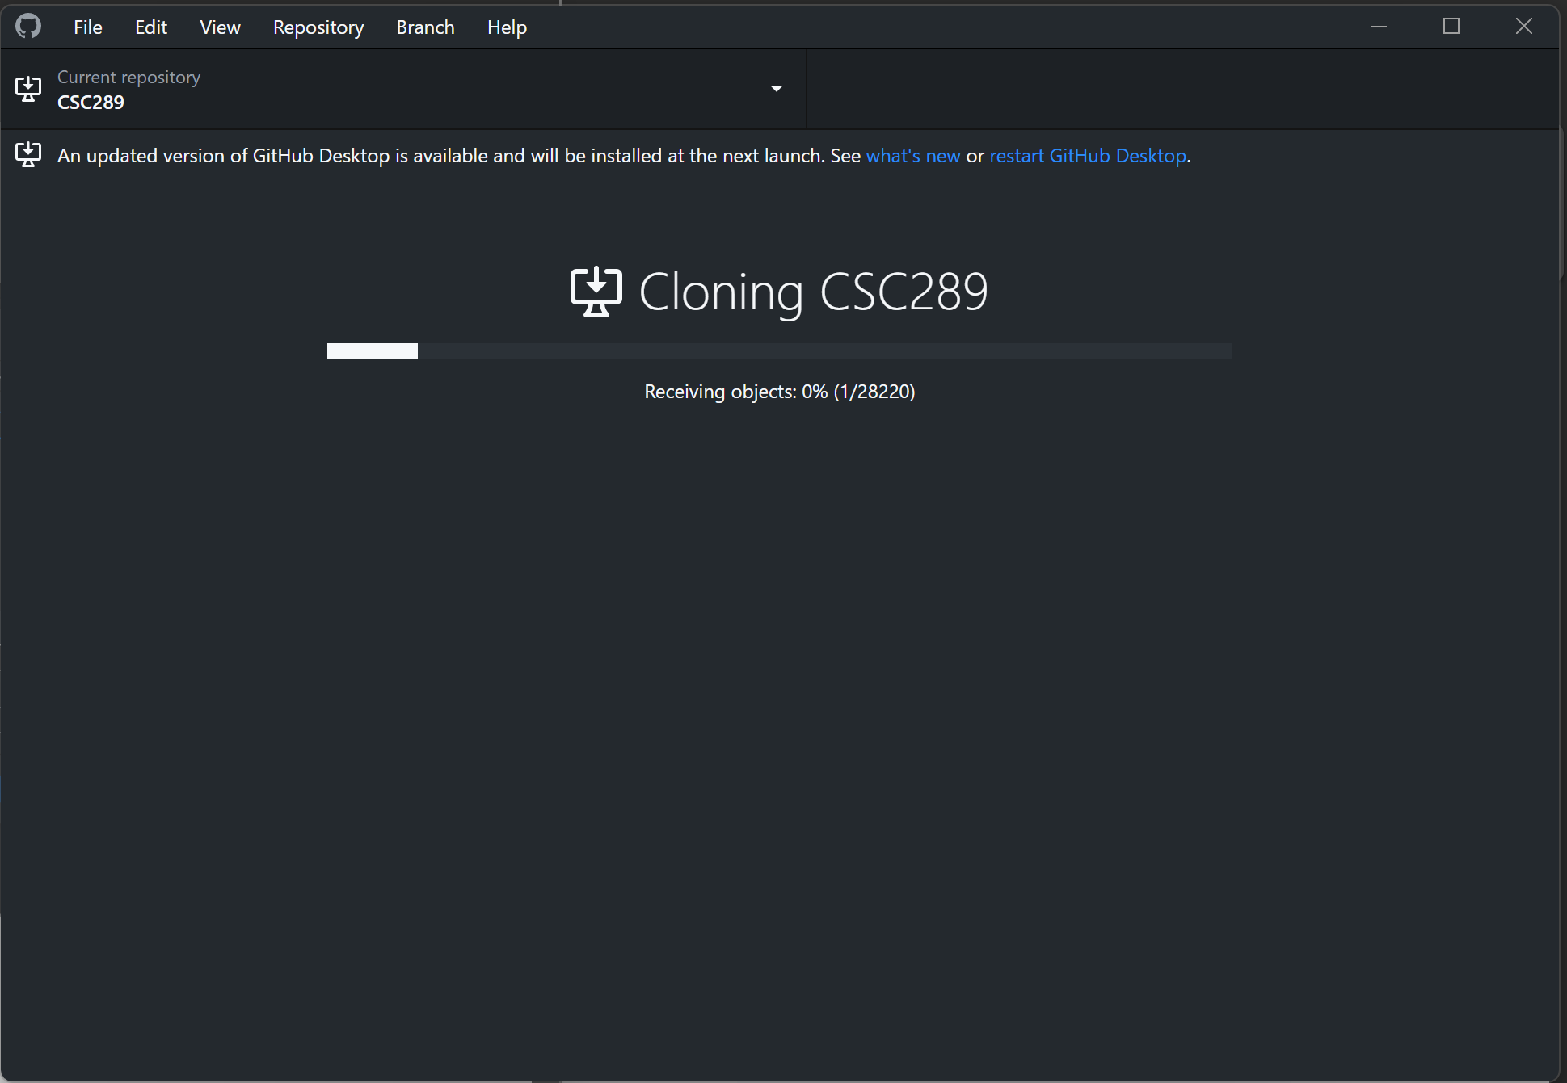

1. If you get a message asking you how you are planning to use this fork, just select for my own purposes, then click “Continue”.

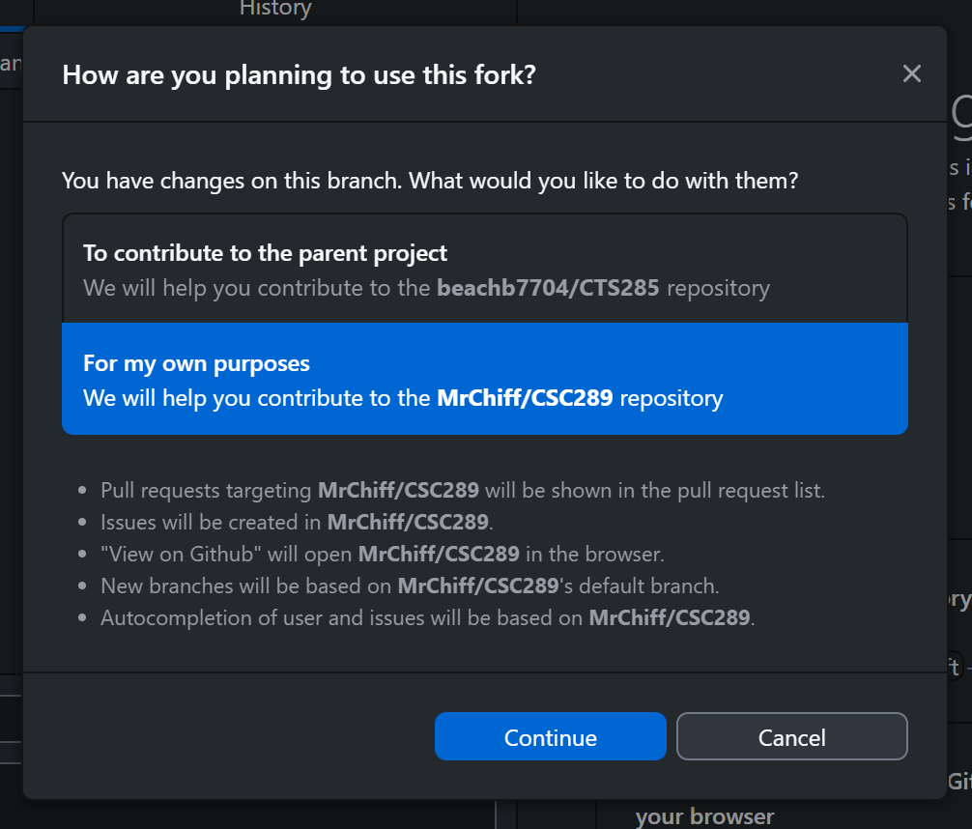

1. You have now downloaded your cloned repository and can now move on to opening the code inside Visual Studio Code.

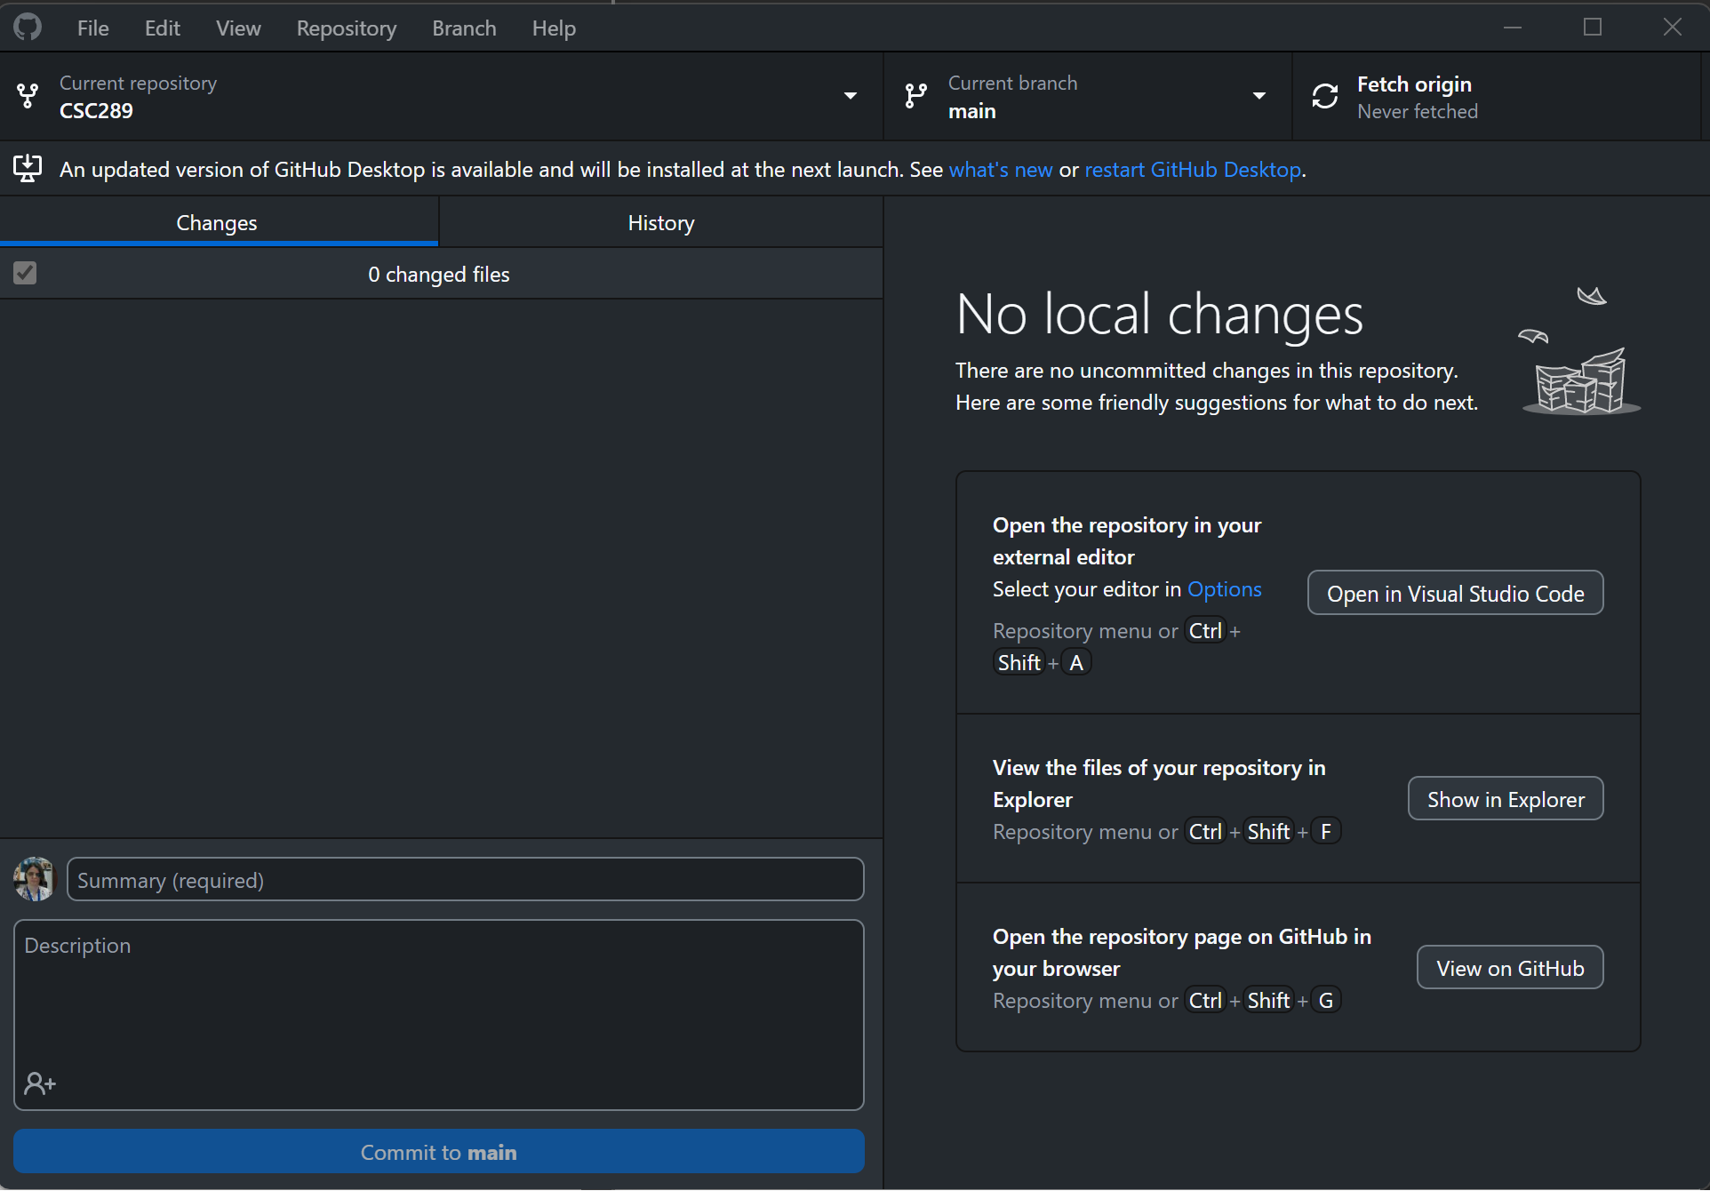

### **Download Website Code**

1. Go to the URL of <https://github.com/MrChiff/CSC289>.

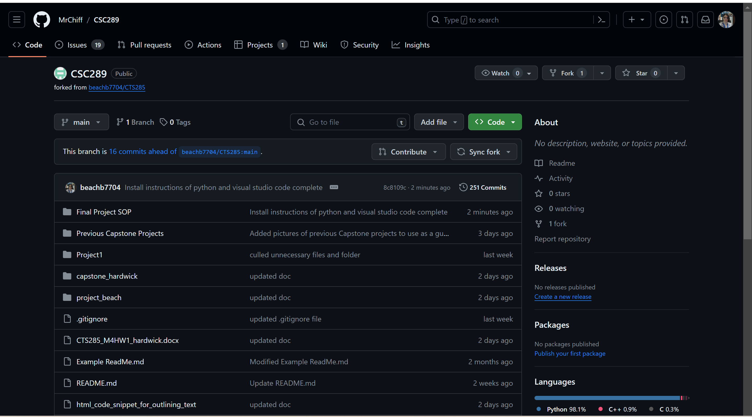

1. To download the code in a zipped file, click on the green button that says “<>Code” and then click on the Local Tab.

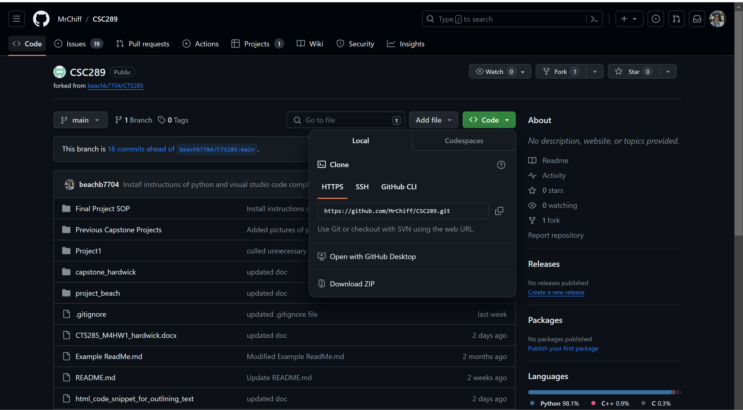

1. Click on Download ZIP, then select the location where you want the file downloaded if it brings up that option. If it does not, then it will download to your default folder for downloads.

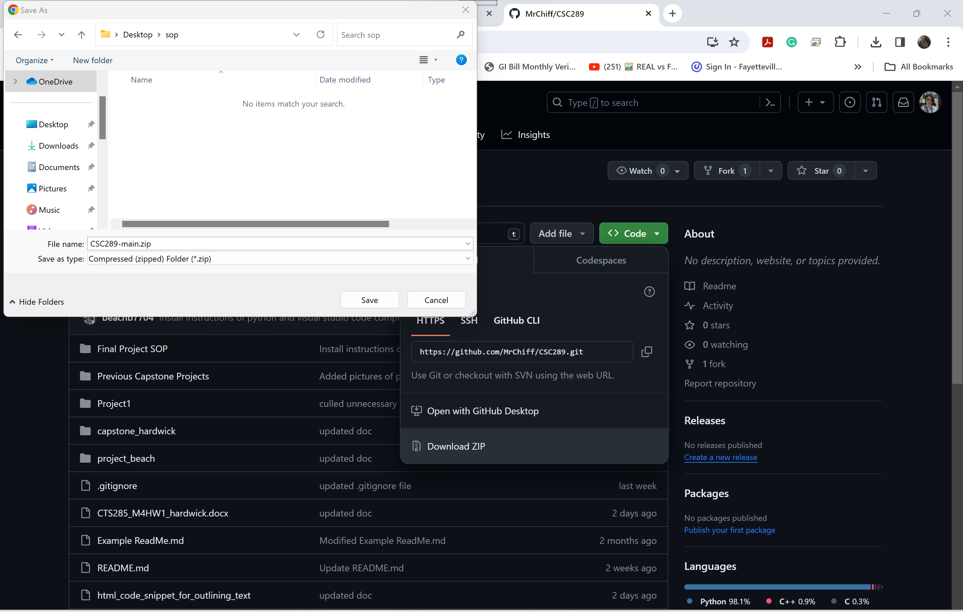

1. Open the folder to which you have saved the zipped file and right-click on it. Select Extract All so you can extract everything you have downloaded from GitHub.

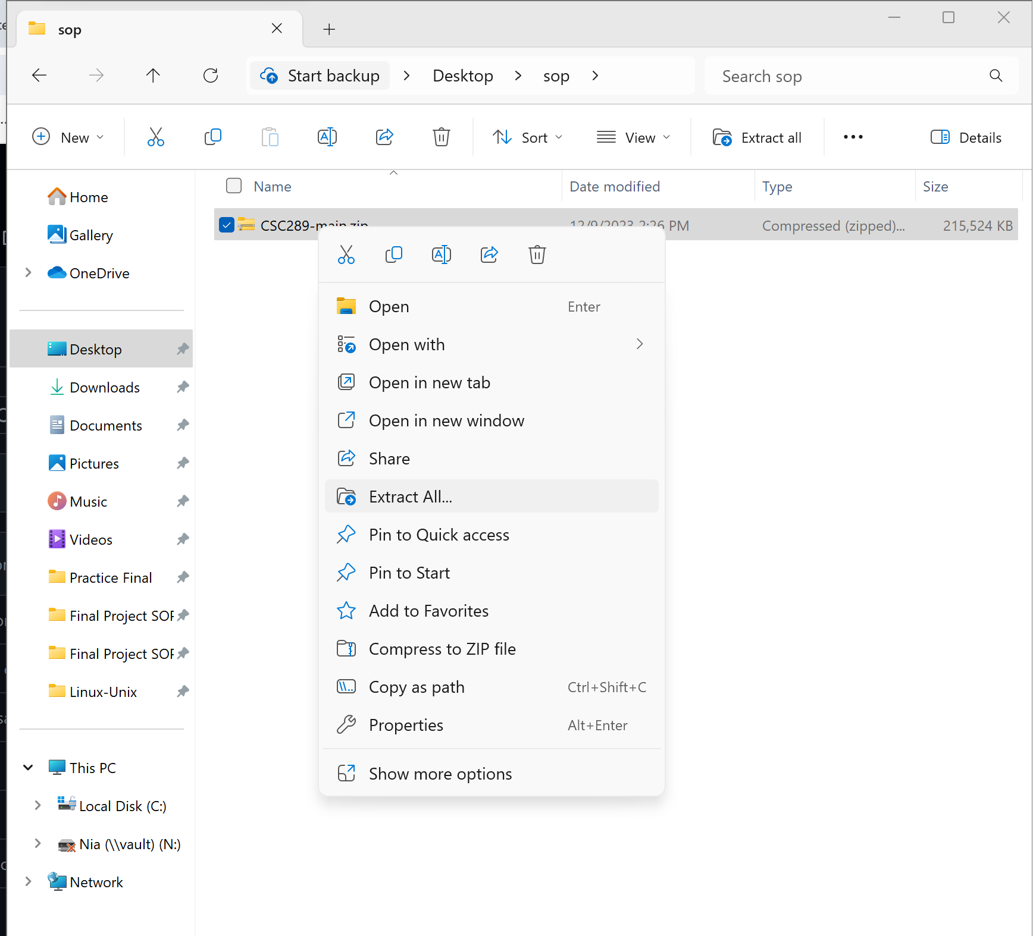

1. Select the folder to which you want to extract all the files, then click Extract.

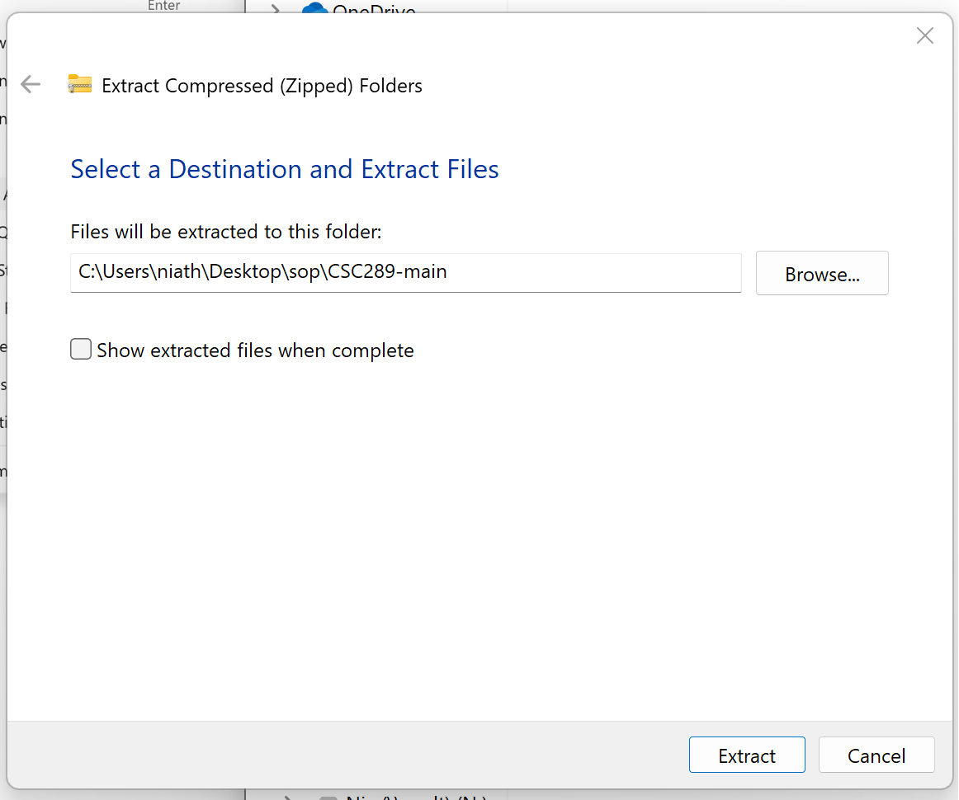

1. The files will now be extracted to that folder.

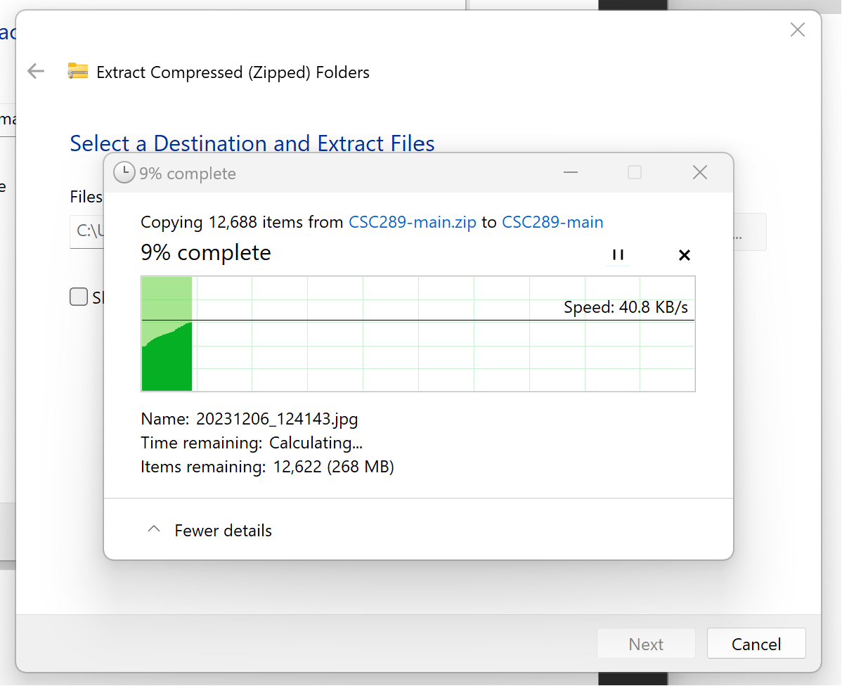

1. Once the files have been extracted, double-click on the new folder to open it and view the contents.

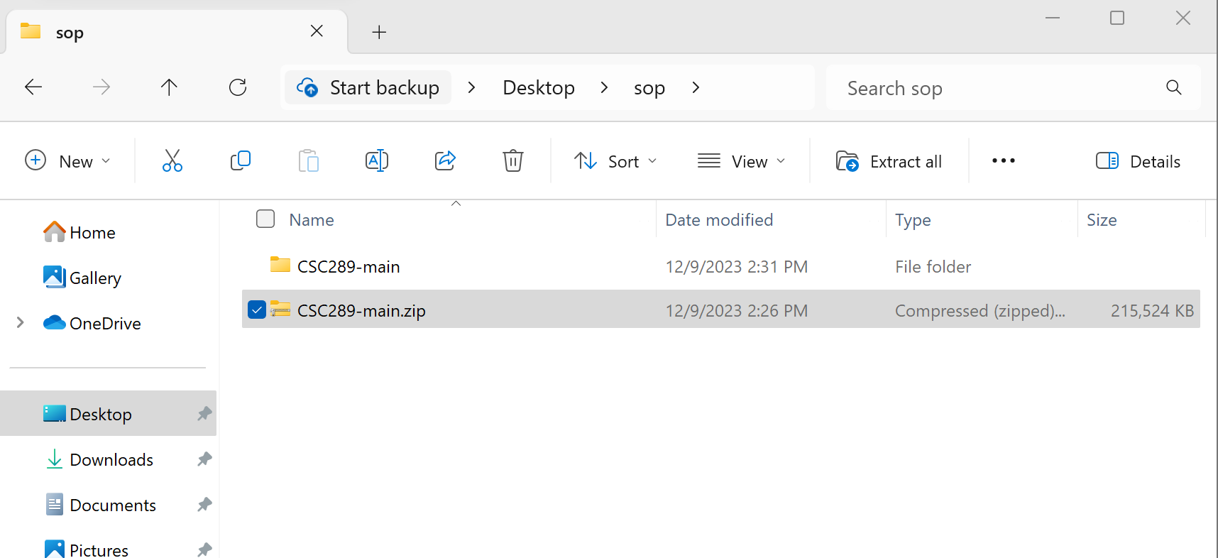

1. Double-click on the following folder to open it and view the contents.

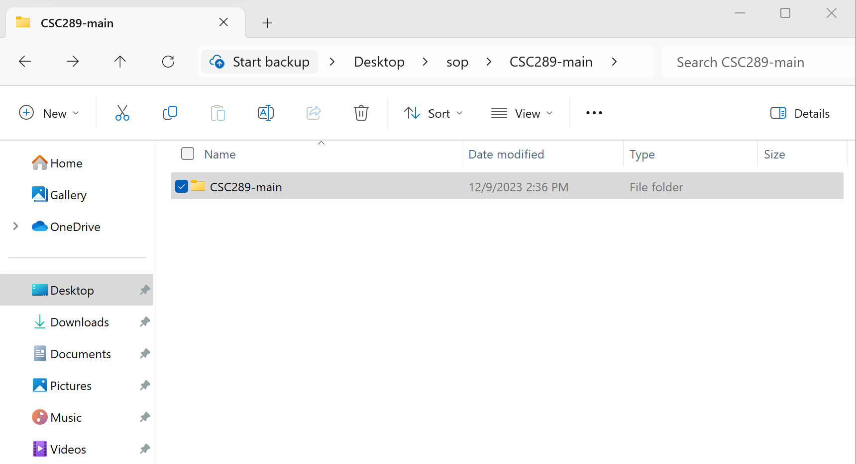

1. Now, you will verify that all files have been downloaded. Once verified, you can open the project inside Visual Studio Code and create your virtual environment.

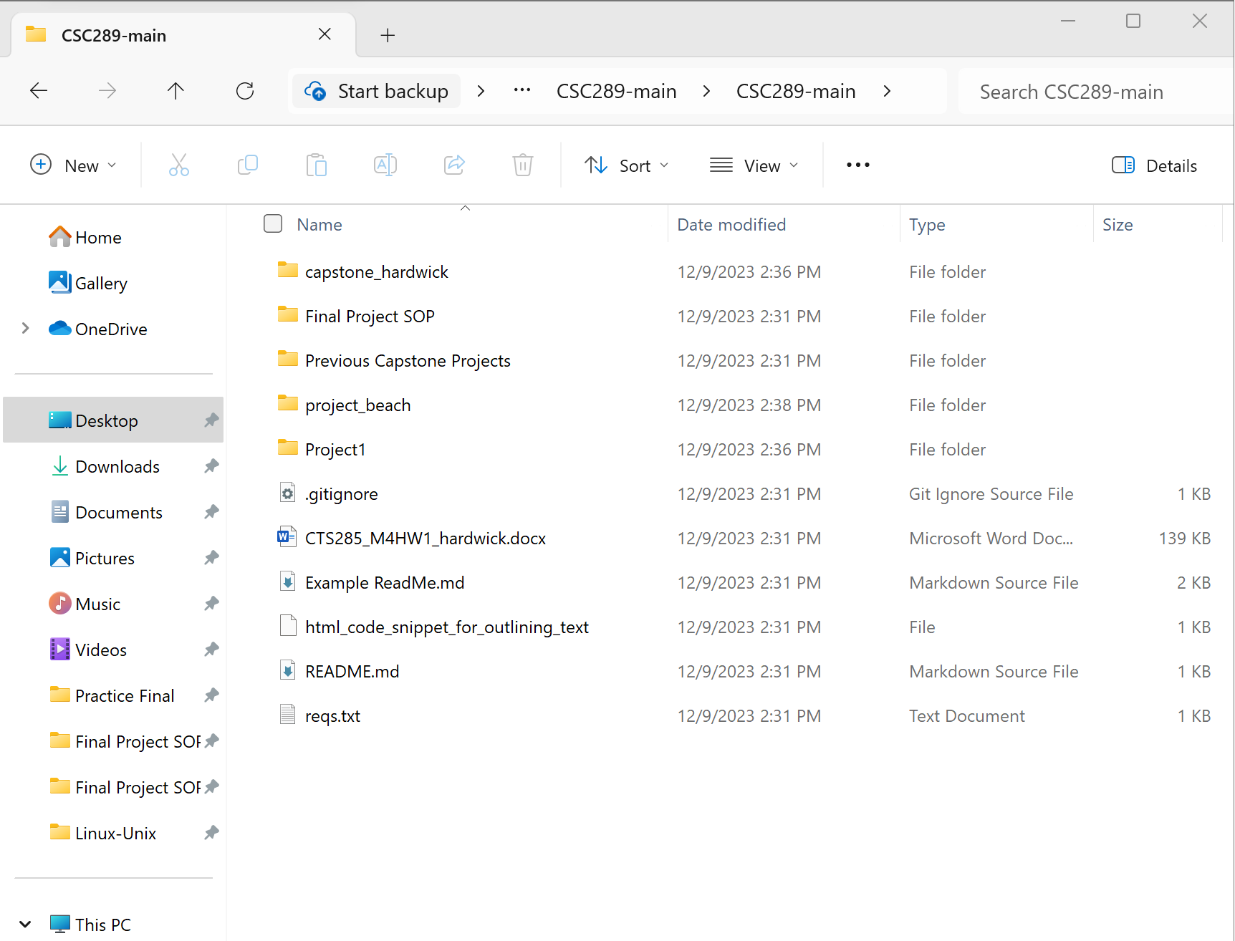

# **Download and Install MySQL Workbench**

1. Go to the following URL: http:mysql.com/downloads/ Then click on the MySQL Community (GPL) Downloads

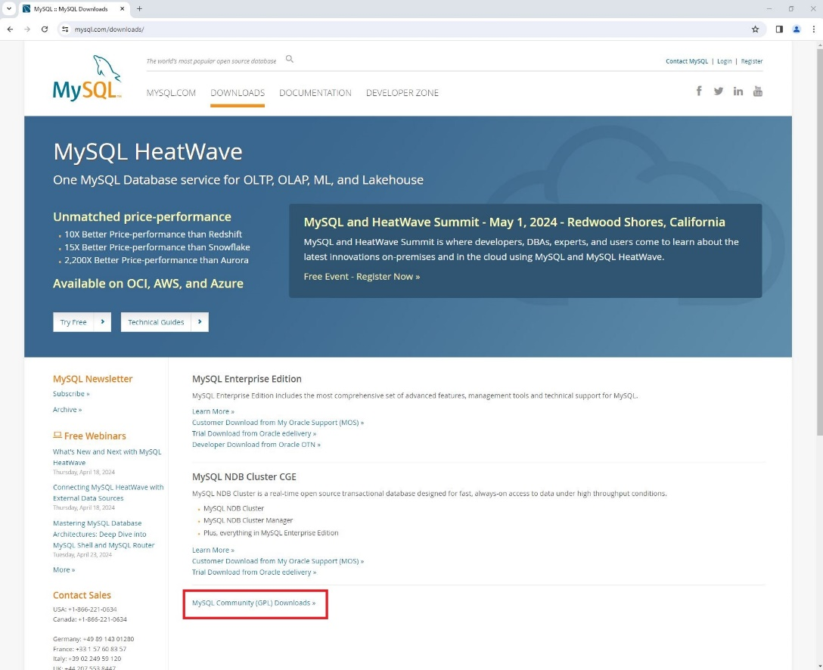

2. Click on MySQL Workbench

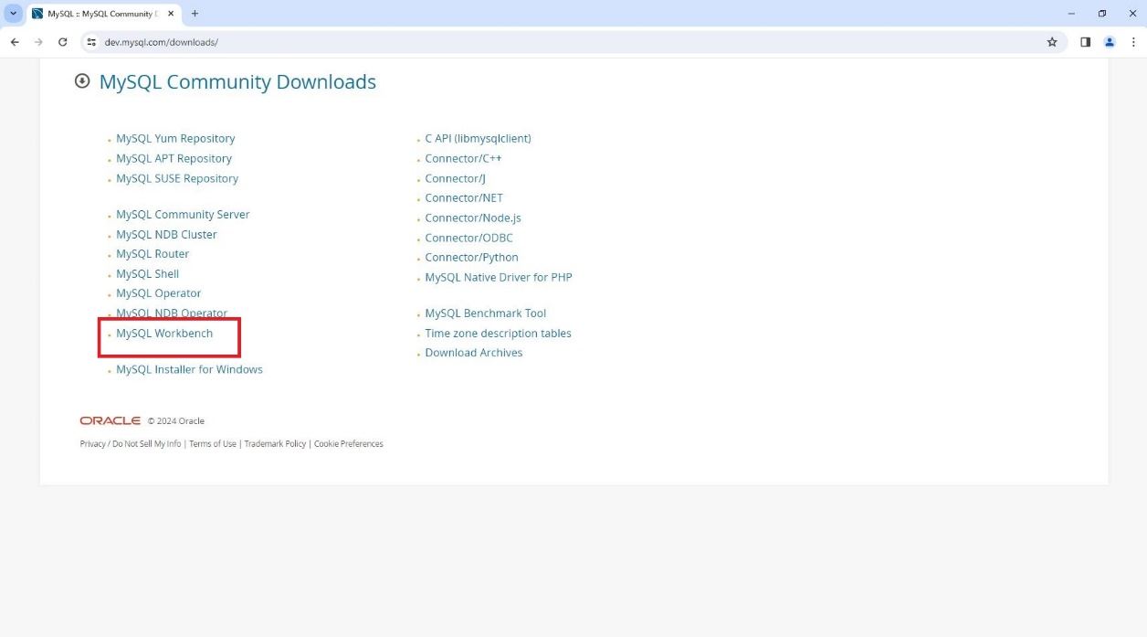

3. Select your operating system then click on Go to Download Page

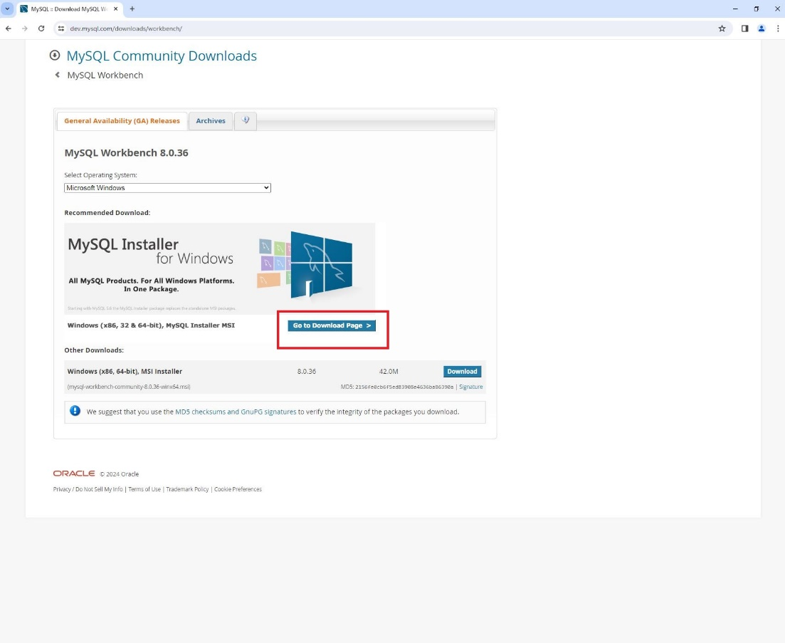

4. Click on the Download button that has the larger file size. This will download the entire program.

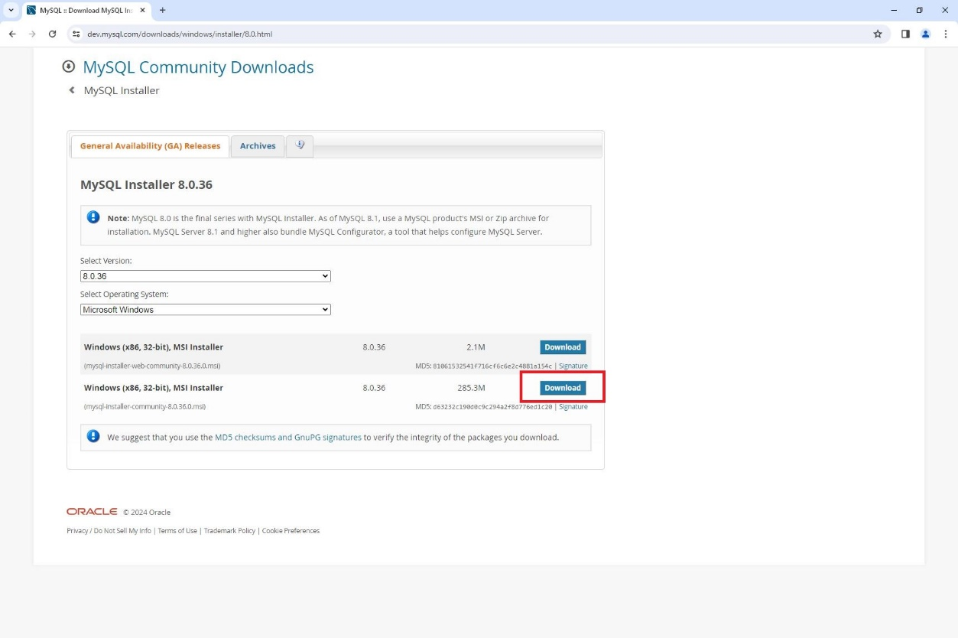

5. Click on No thanks, just start my download.

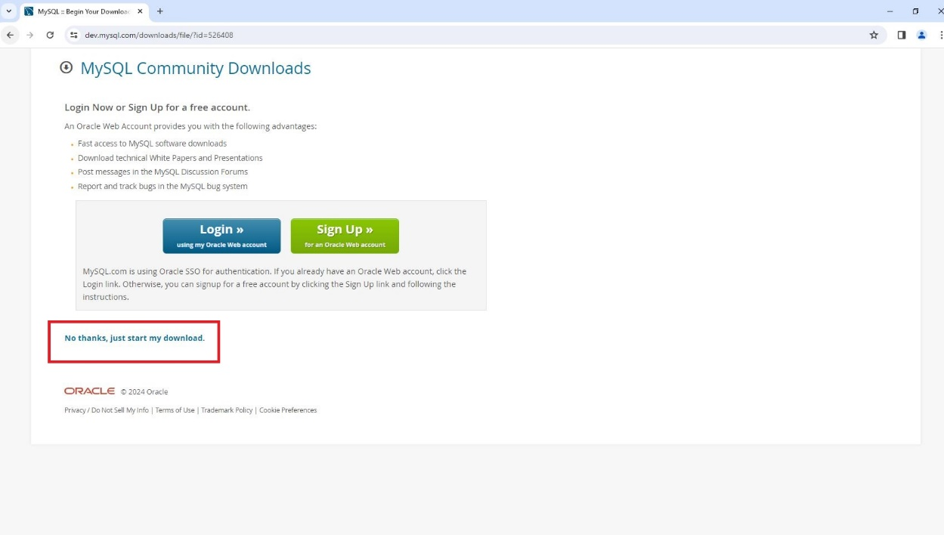

6. Click on Run.

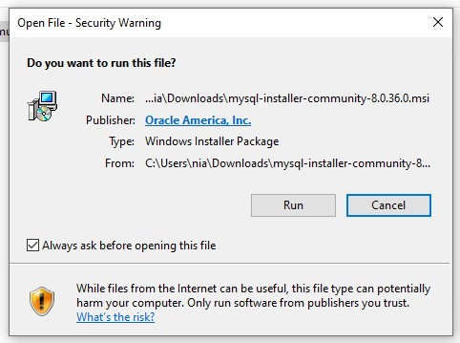

7. Make sure Full is selected and then click on Next

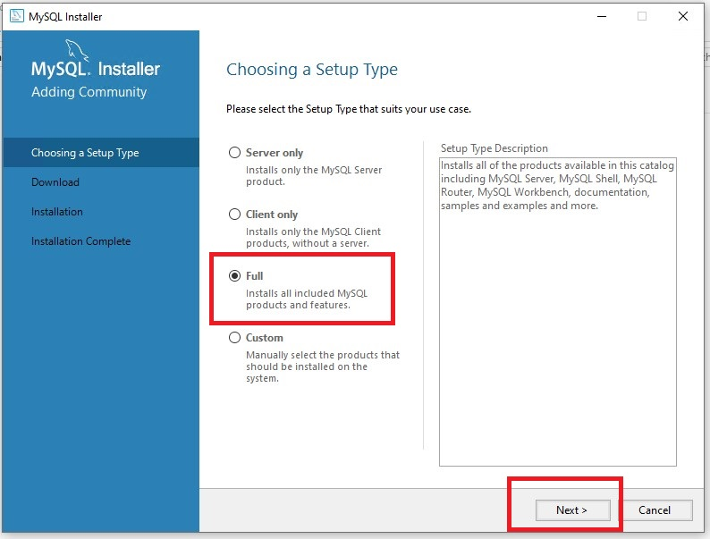

8. Click on Execute.

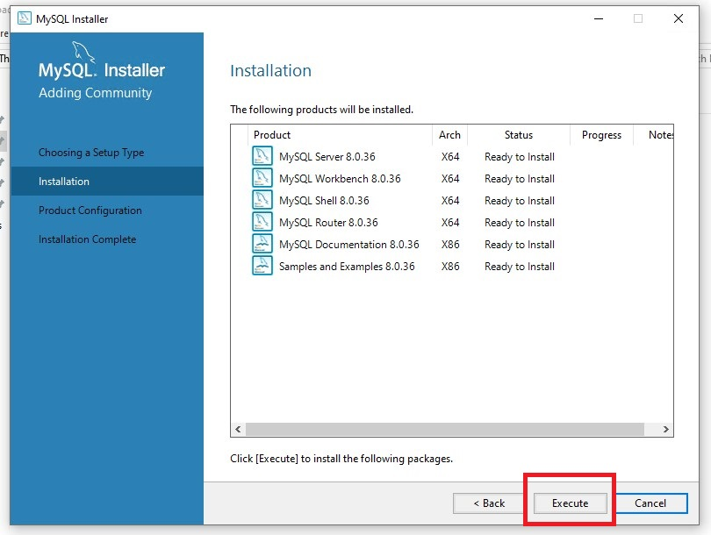

9. It will go through and install all necessary programs.

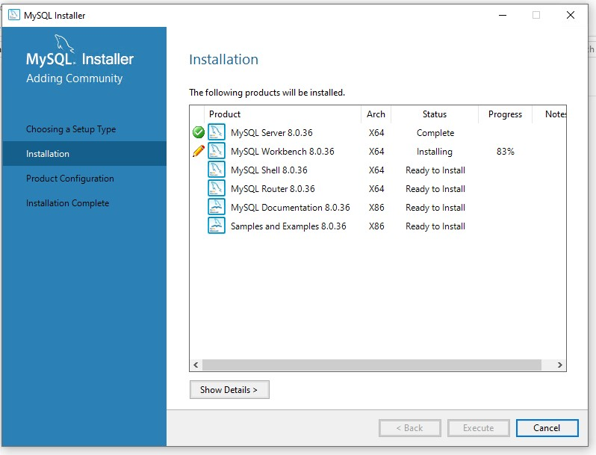

10. Once everything is installed, click on Next.

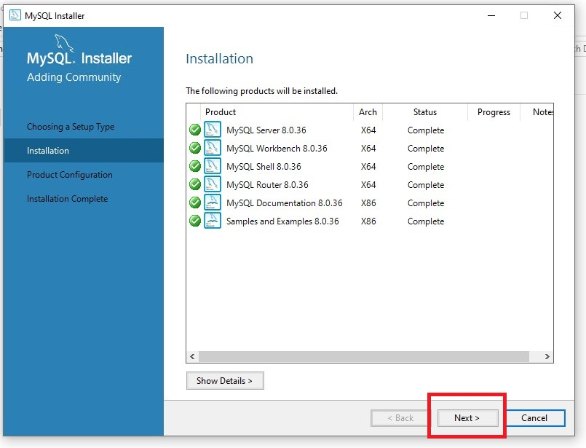

11. Click Next.

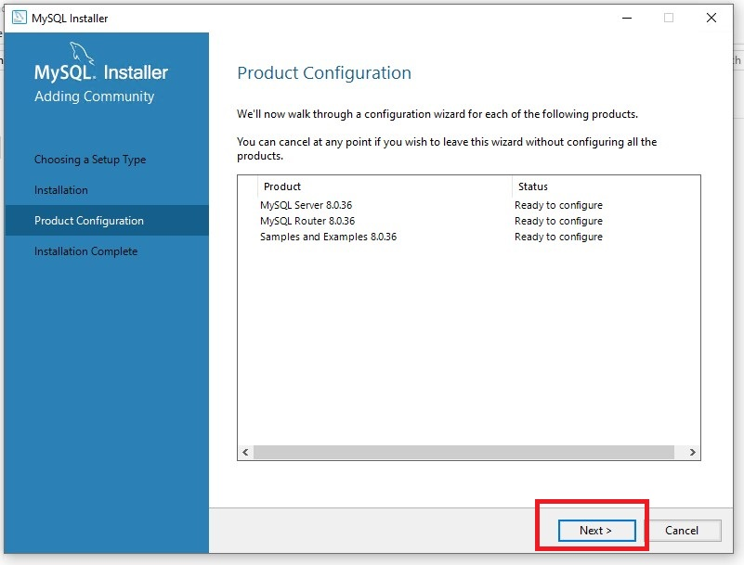

12. Leave at Development Computer and current settings and click next.

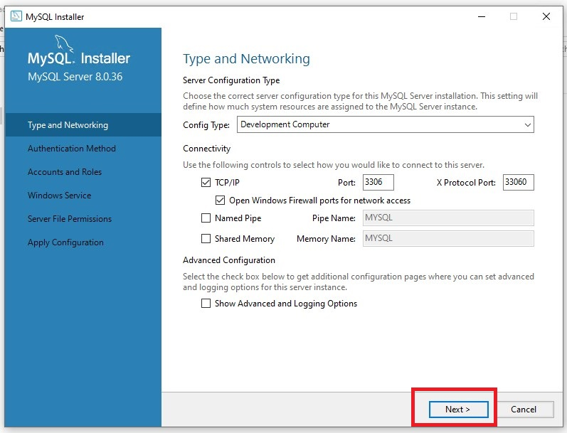

13. Leave Use Strong Password selected then click next.

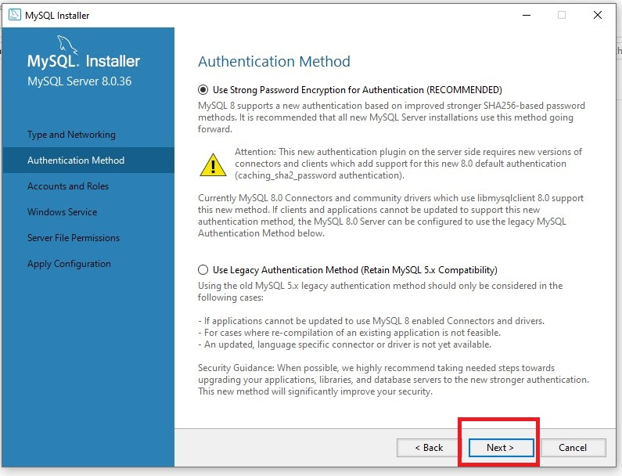

14. Type the password of password123 then repeat the password then click next.

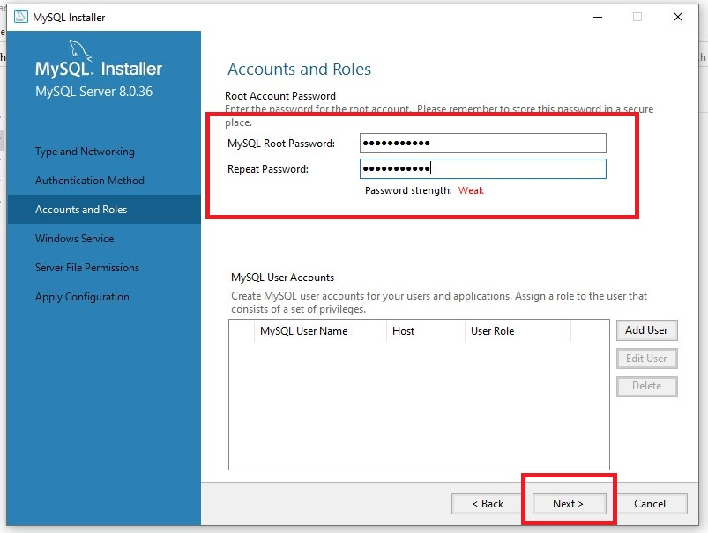

15. Leave default settings selected then click Next.

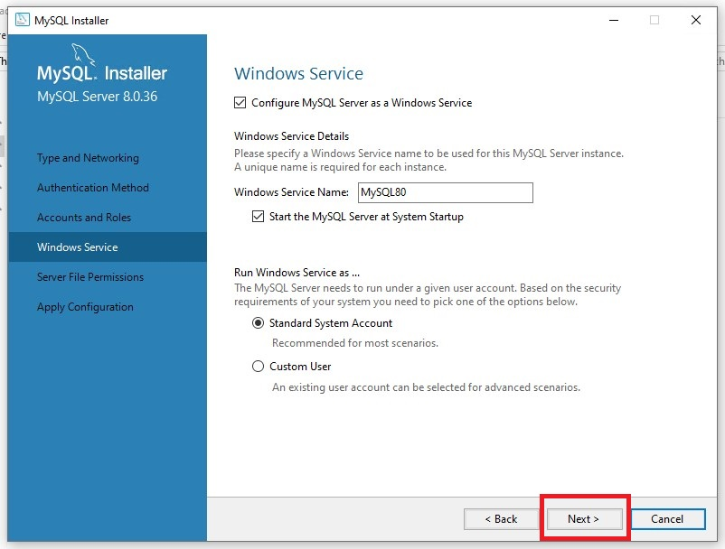

16. Make sure Yes, grant full access selected then click Next.

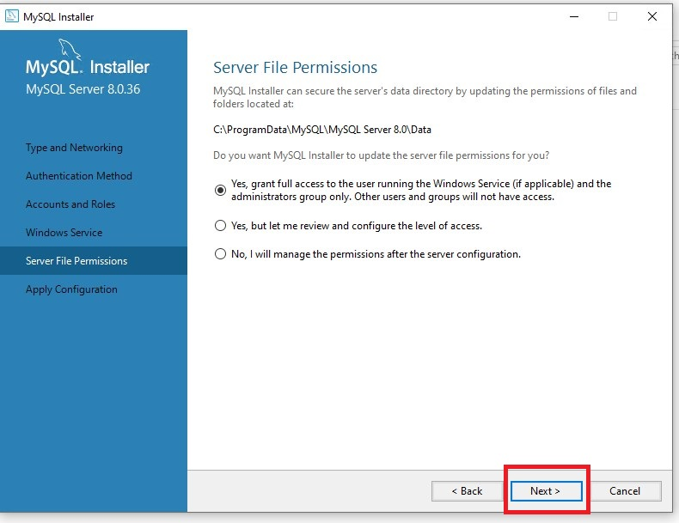

17. Click on Execute.

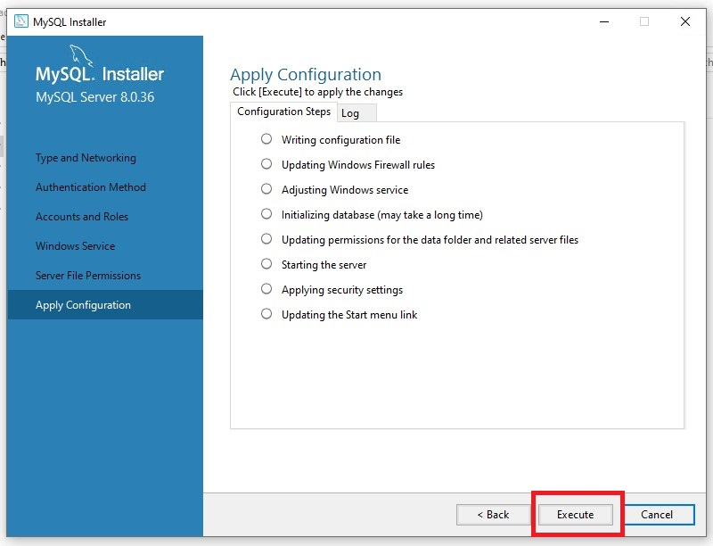

18. Everything will be installed that needs to be installed.

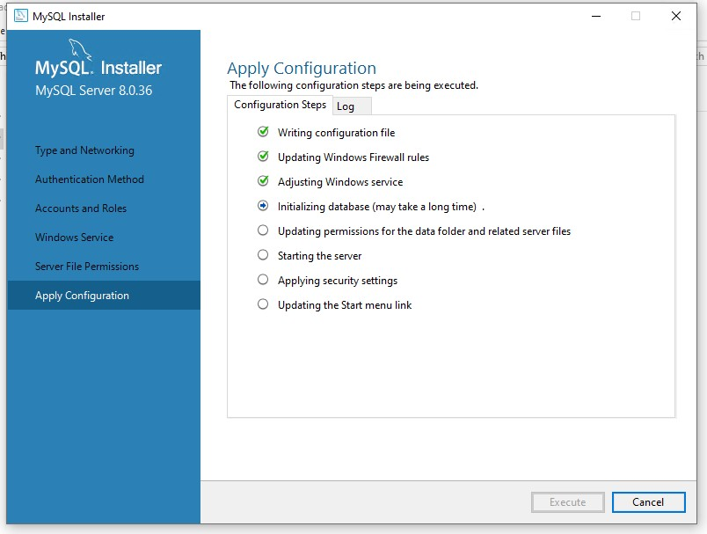

19. After everything is installed, click on Finish.

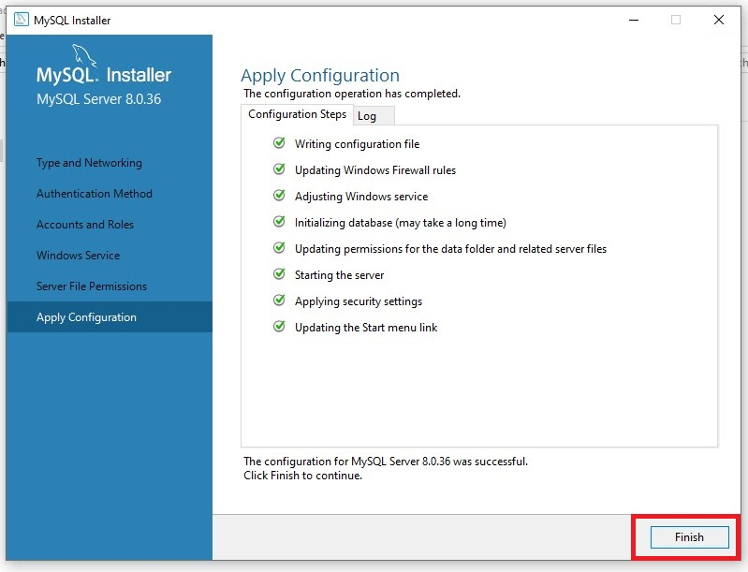

20. It will get ready to finish installing everything else after you click Next.

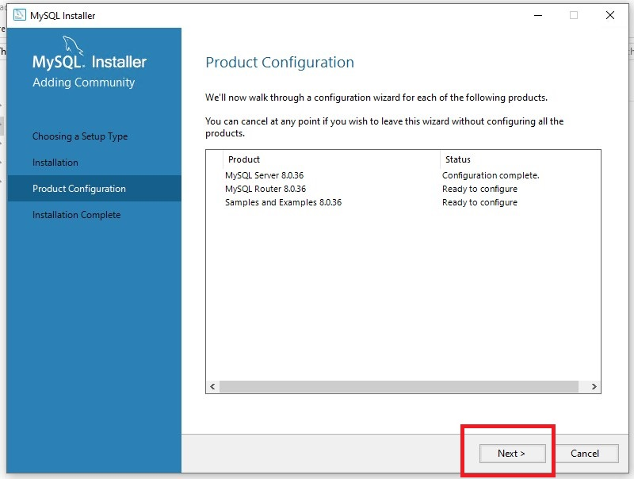

21. Leave default settings then click Finish.

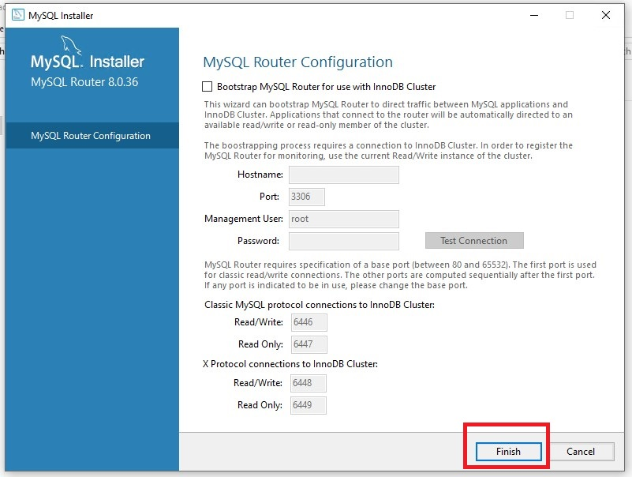

22. Click on Next.

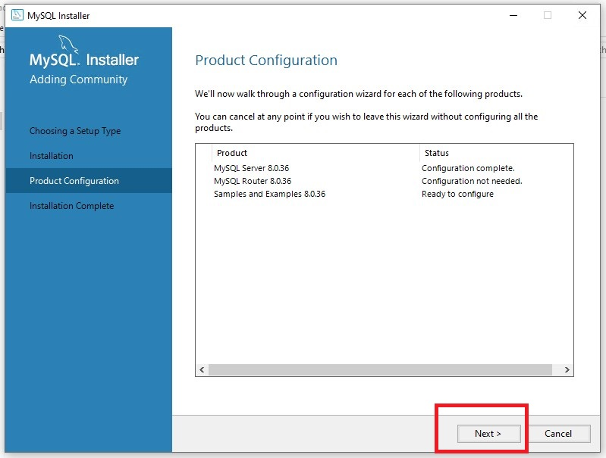

23. If the root password is not typed in, type it in here then click on Check.

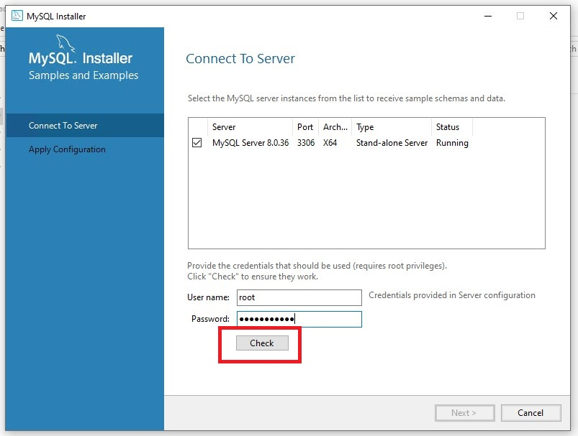

24. Once you get the green check mark, click on Next.

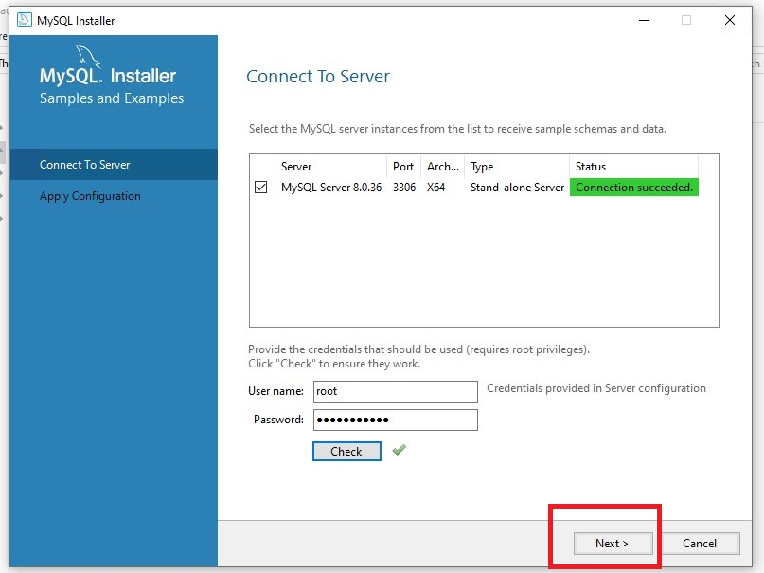

25. Click on Execute.

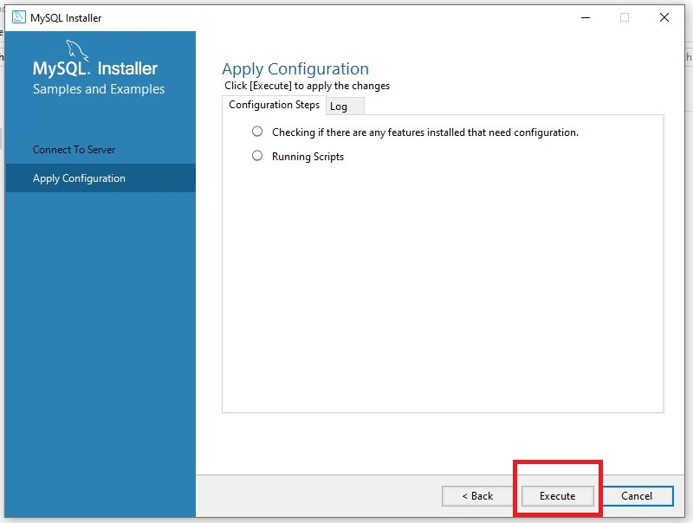

26. Click on Finish.

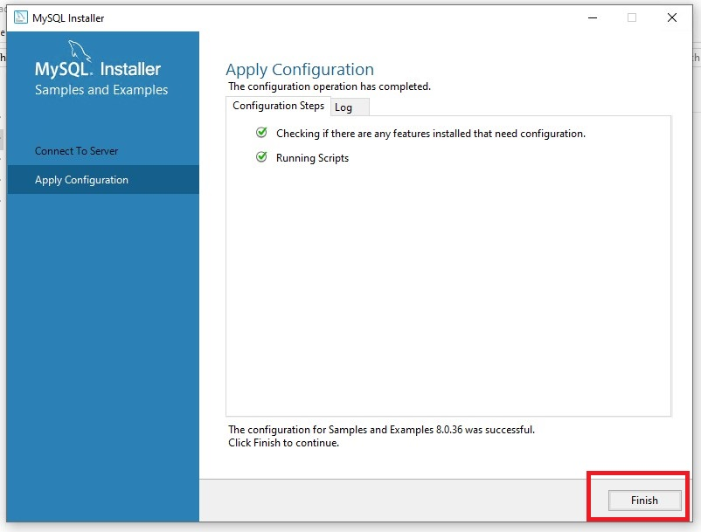

27. Click on Next.

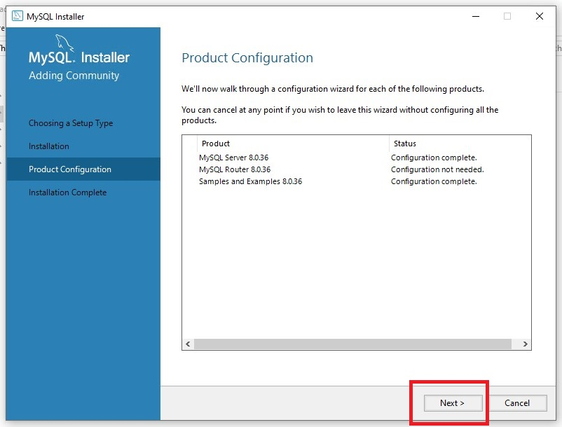

28. Click on Finish.

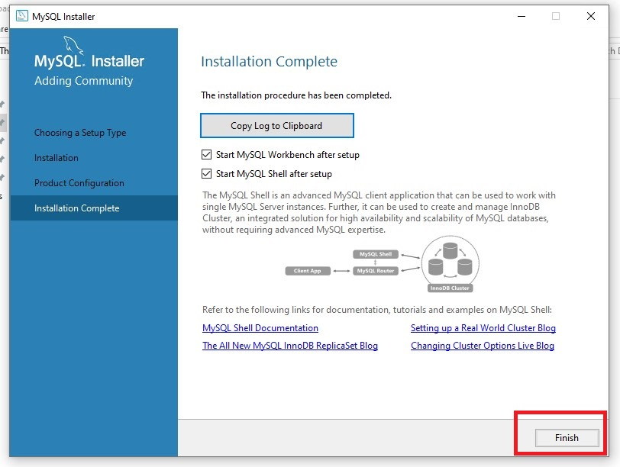

29. Now we are going to upload the database to the MySQL Workbench. Click on the Local Instance.

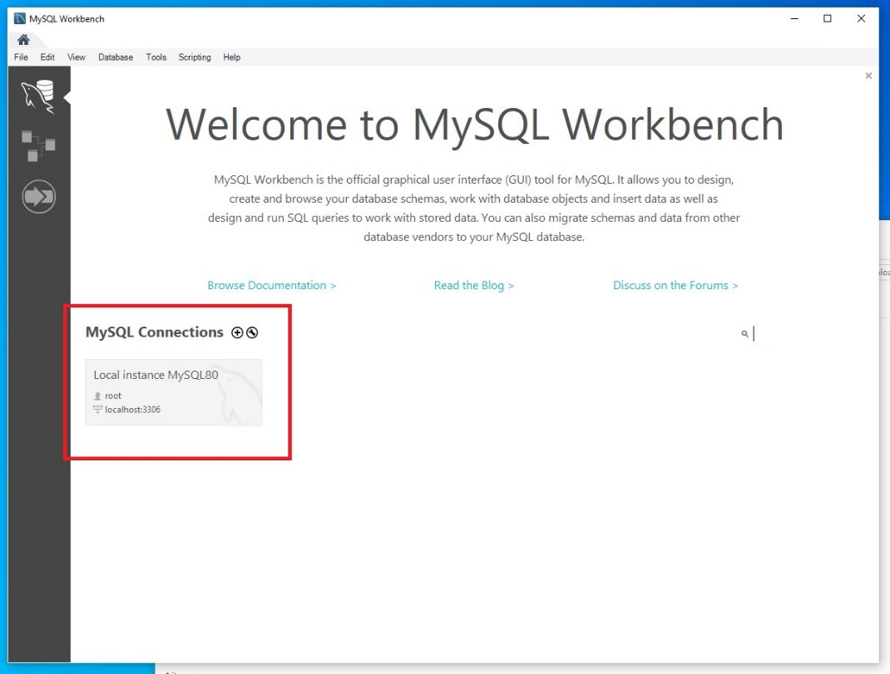

30. Type in the root password then click on OK.

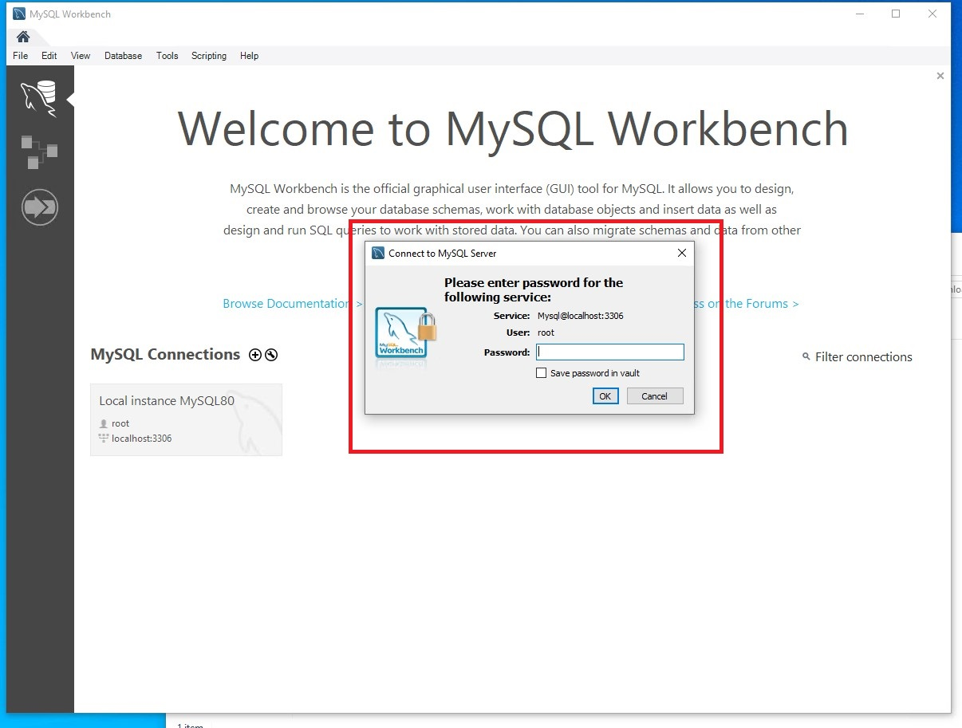

31. Click on Server.

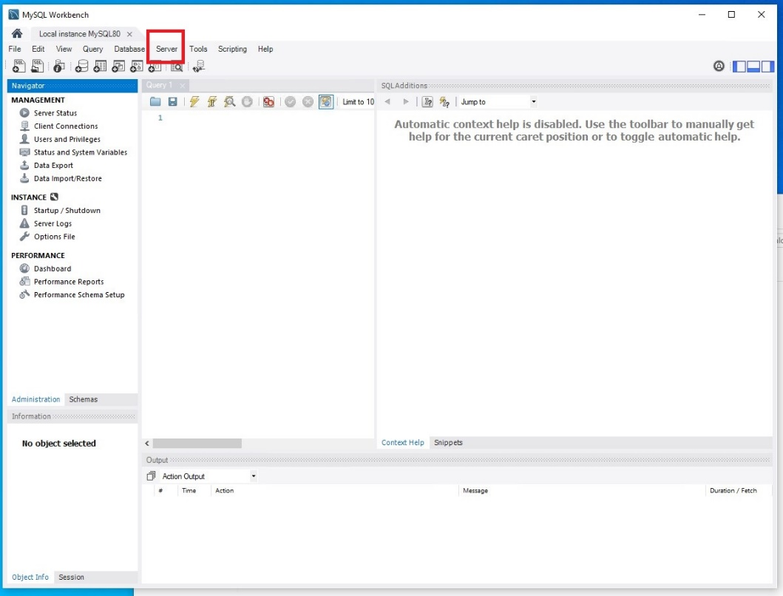

32. Click on Data Import.

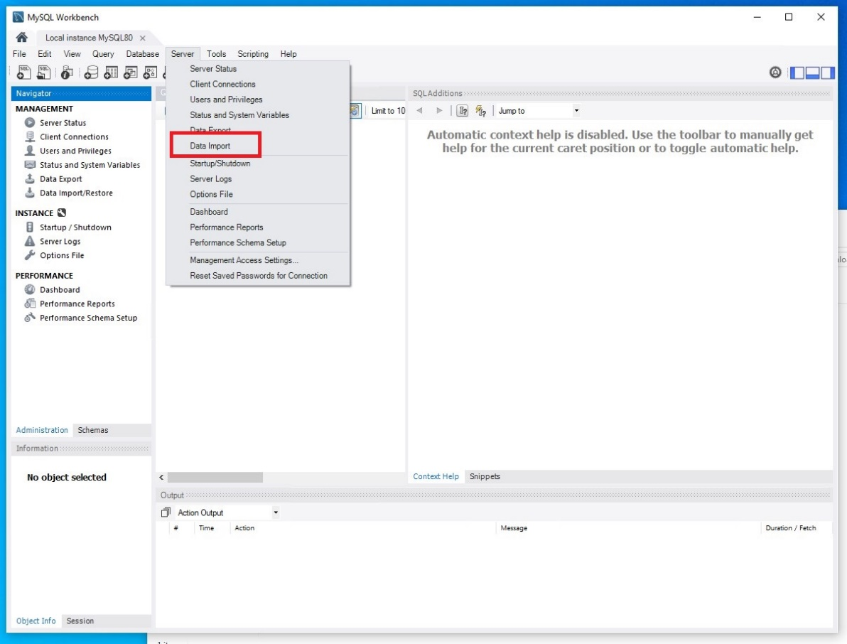

33. Select Import from Self-Contained File, then select the location of the .sql file, then click on New.

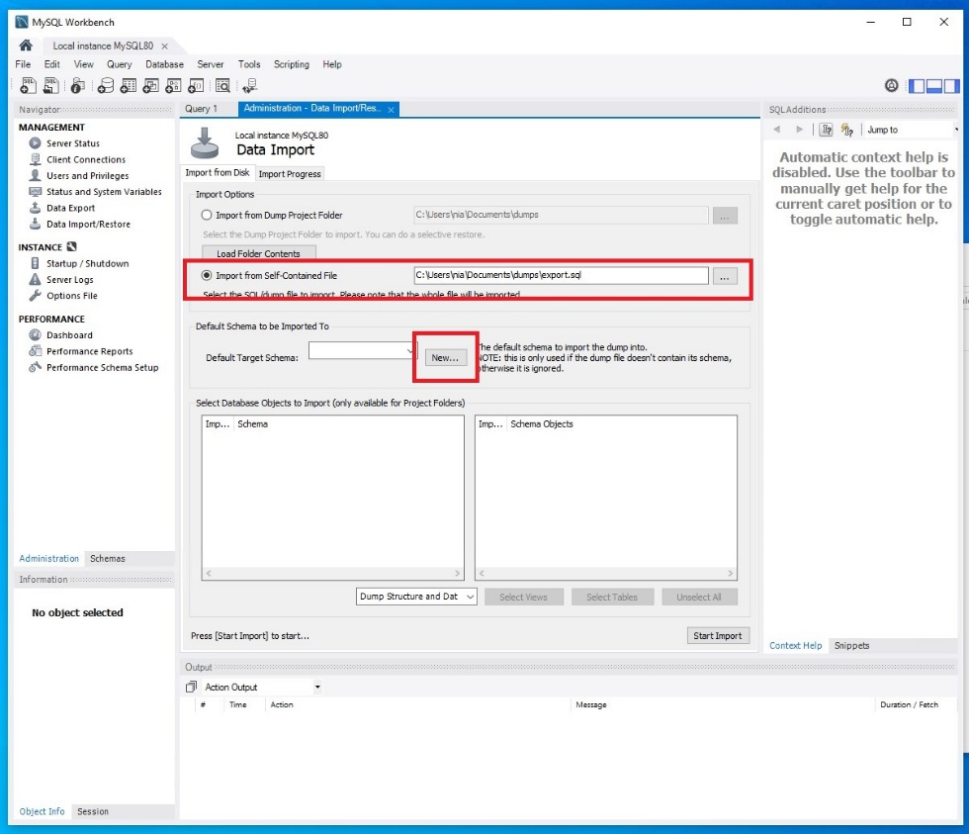

34. Type VGLS then click OK.

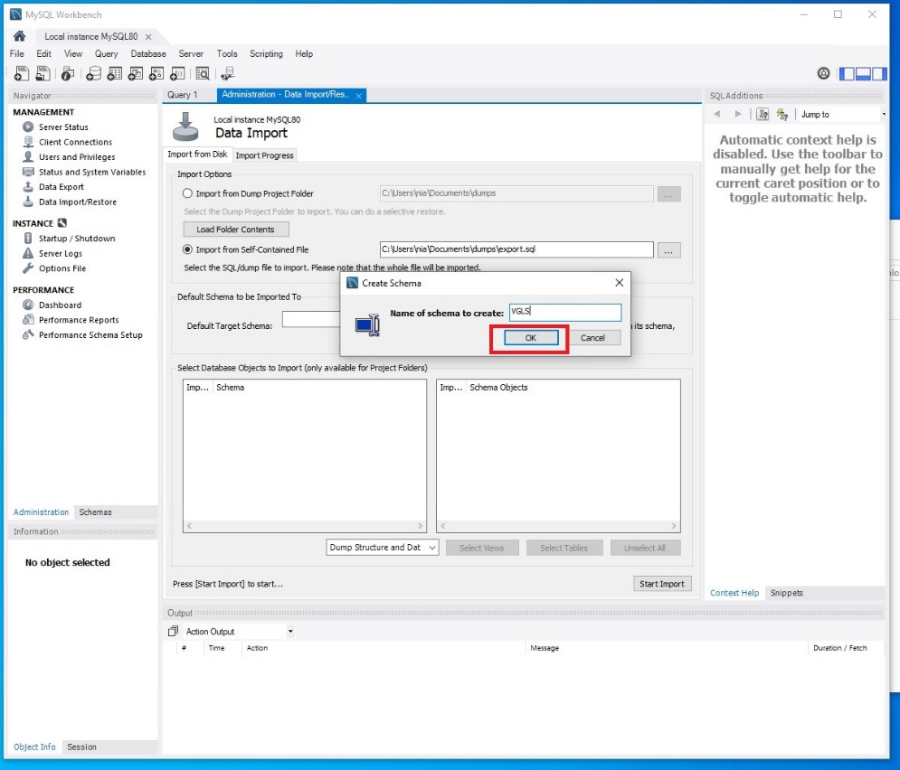

35. Select VGLS for Default Target Schema.

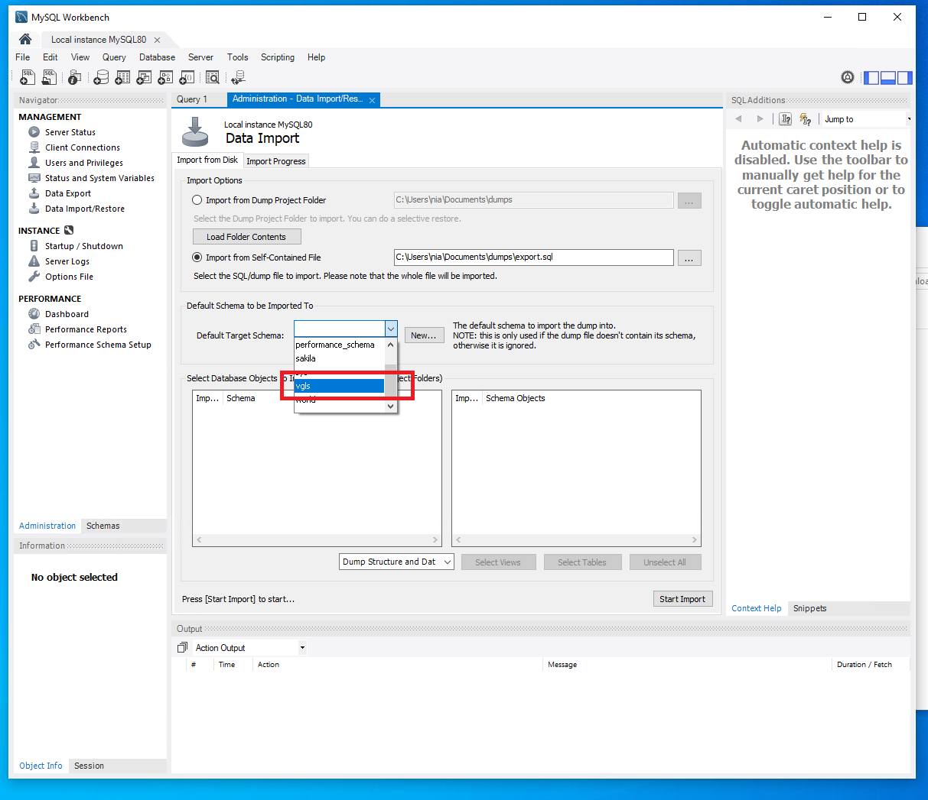

36. Click on Start Import.

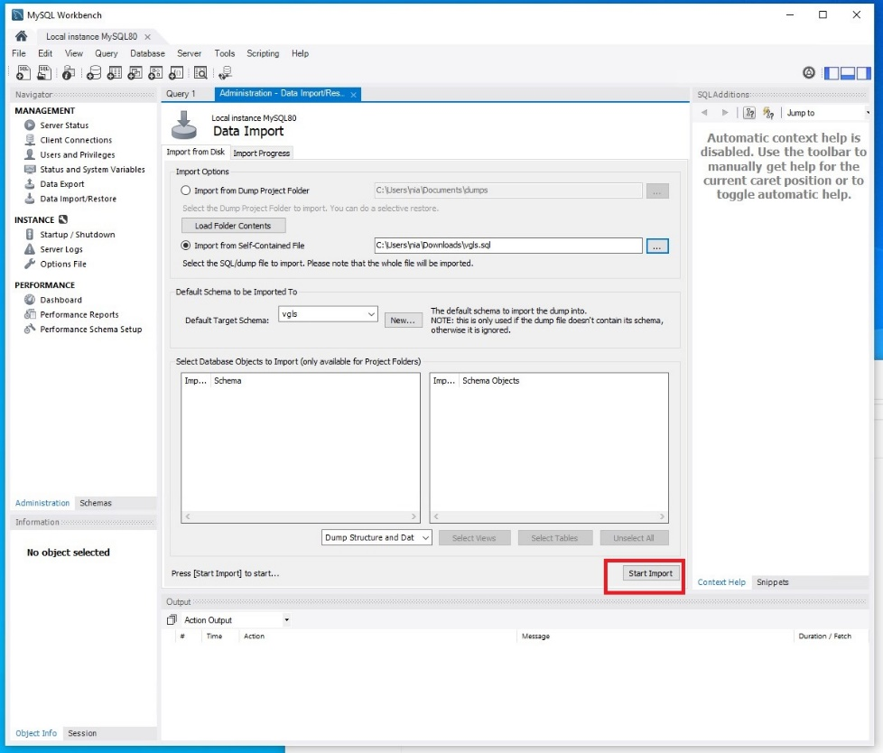

37. Once it is uploaded, click on Schemas.

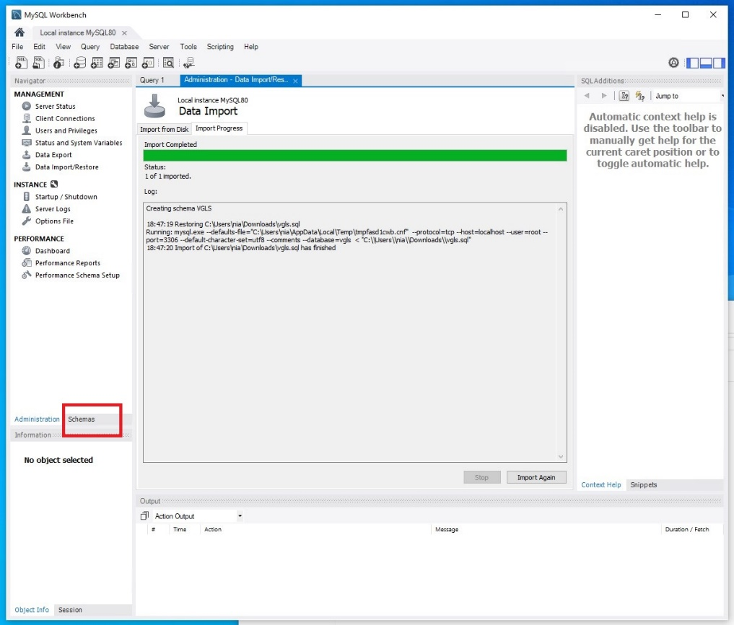

38. Click on the refresh button.

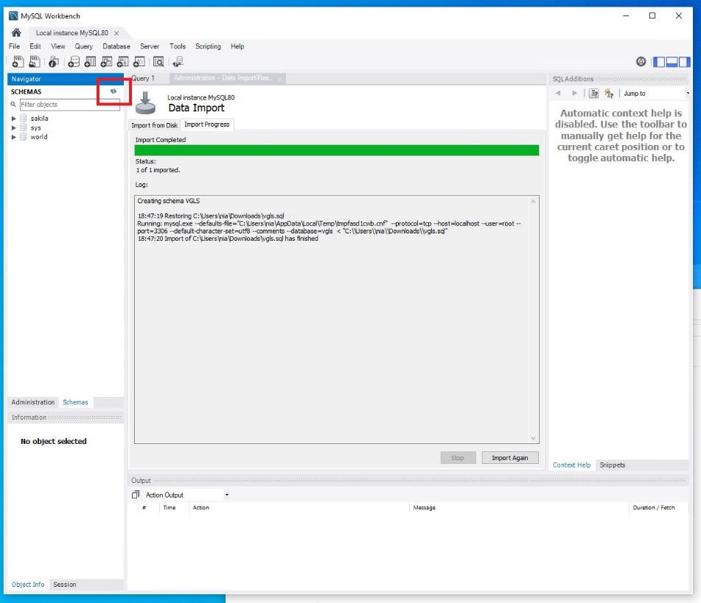

39. You should now see the VGLS database inside your schema.

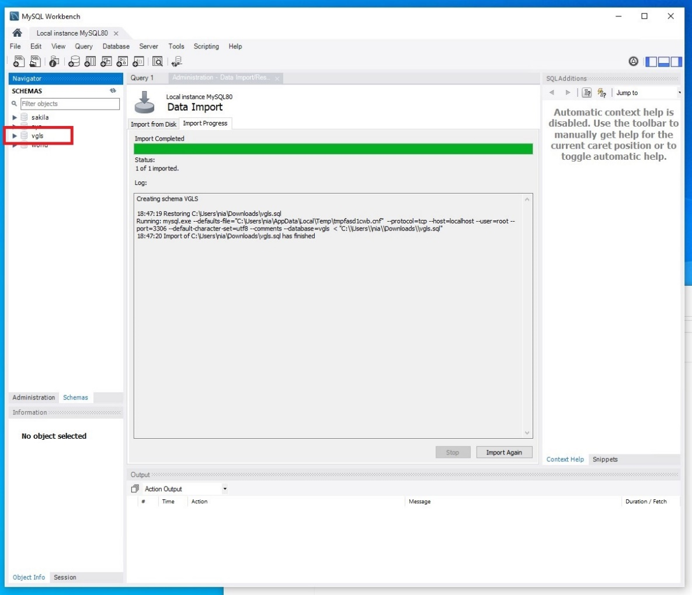

# **Open the Project in Visual Studio Code and Activate the Virtual Environment**

1. If you still have Visual Studio Code open from when you installed it, all you will need to do is click on File, then click on Open Folder.

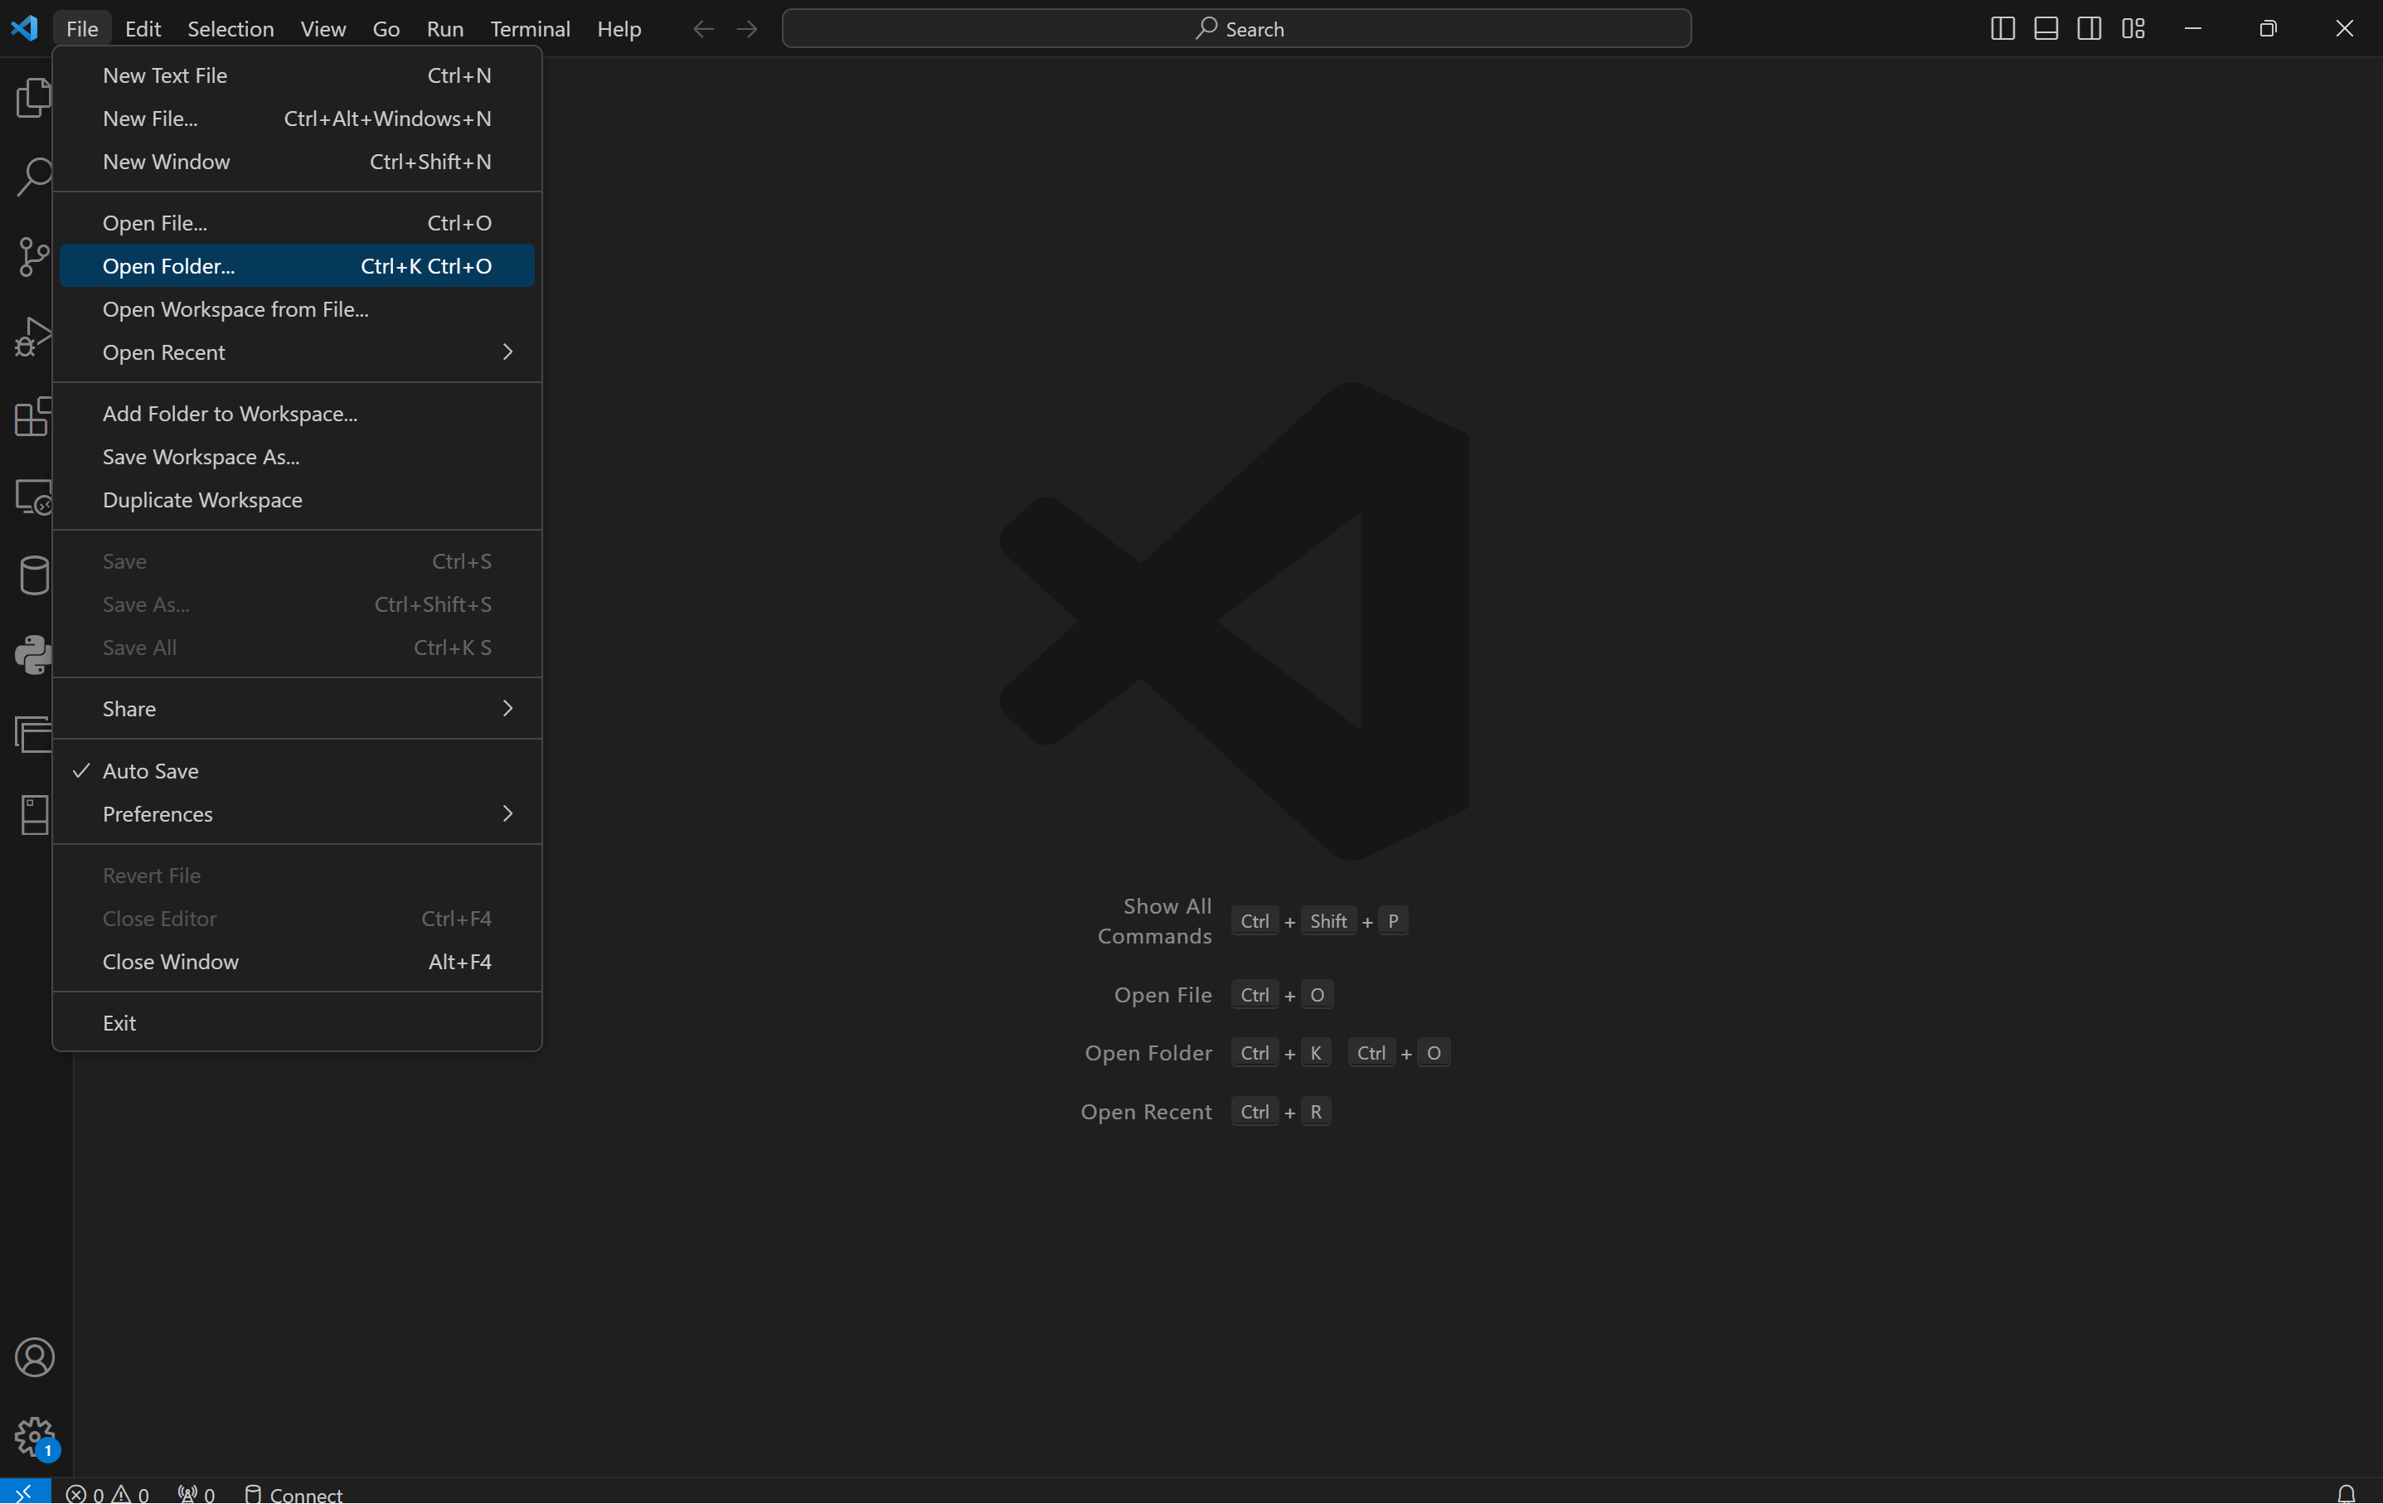

1. Navigate to the folder of the project you want to open. Only click on the main folder, then click on Select Folder.

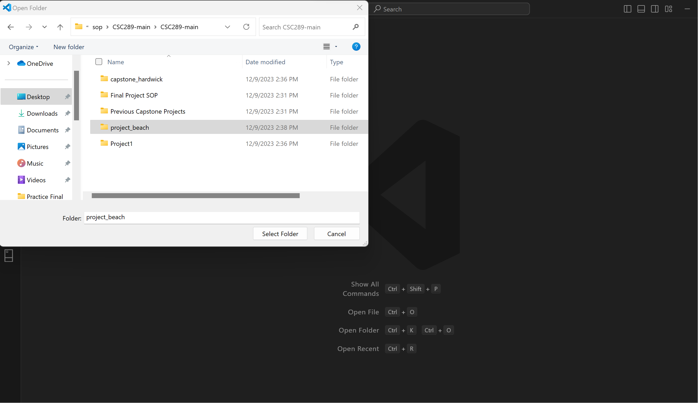

1. At the top of the screen, click Terminal, then New Terminal.

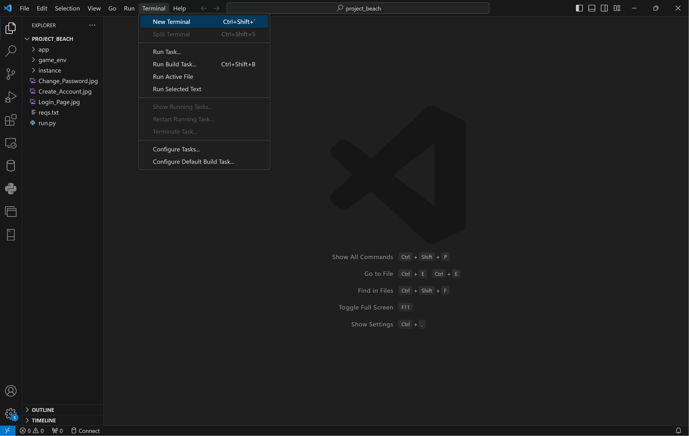

1. Click on the arrow by the plus symbol, then click on Command Prompt to open a command prompt where we will create our virtual environment.

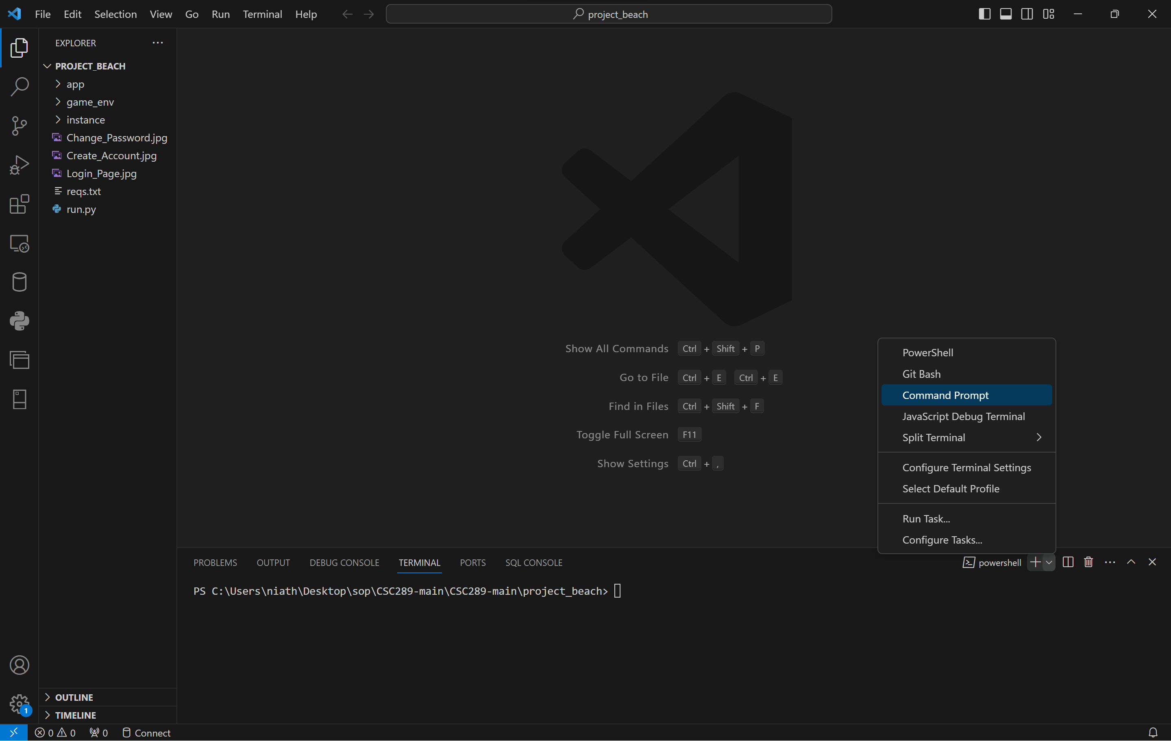

1. Now, we need to remove the Power Shell terminal by clicking on the trash can icon next to the Power Shell terminal.

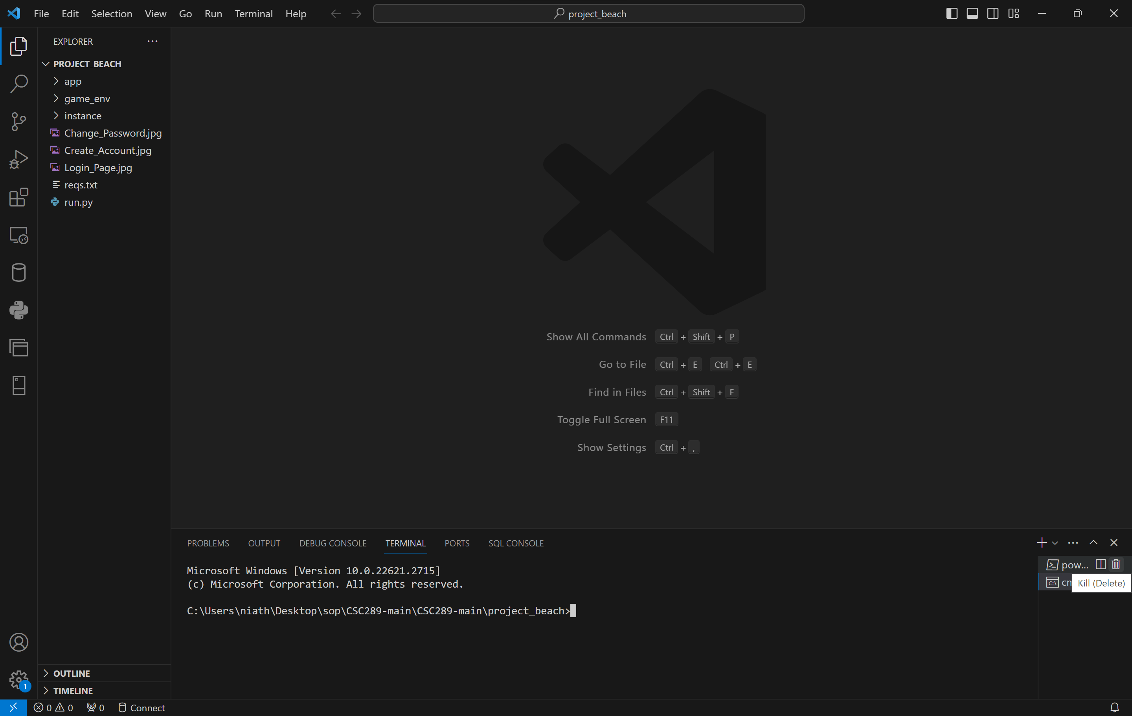

1. Use the command python -m virtualenv “your environment name.” An example would be:

python -m virtualenv vgls_env

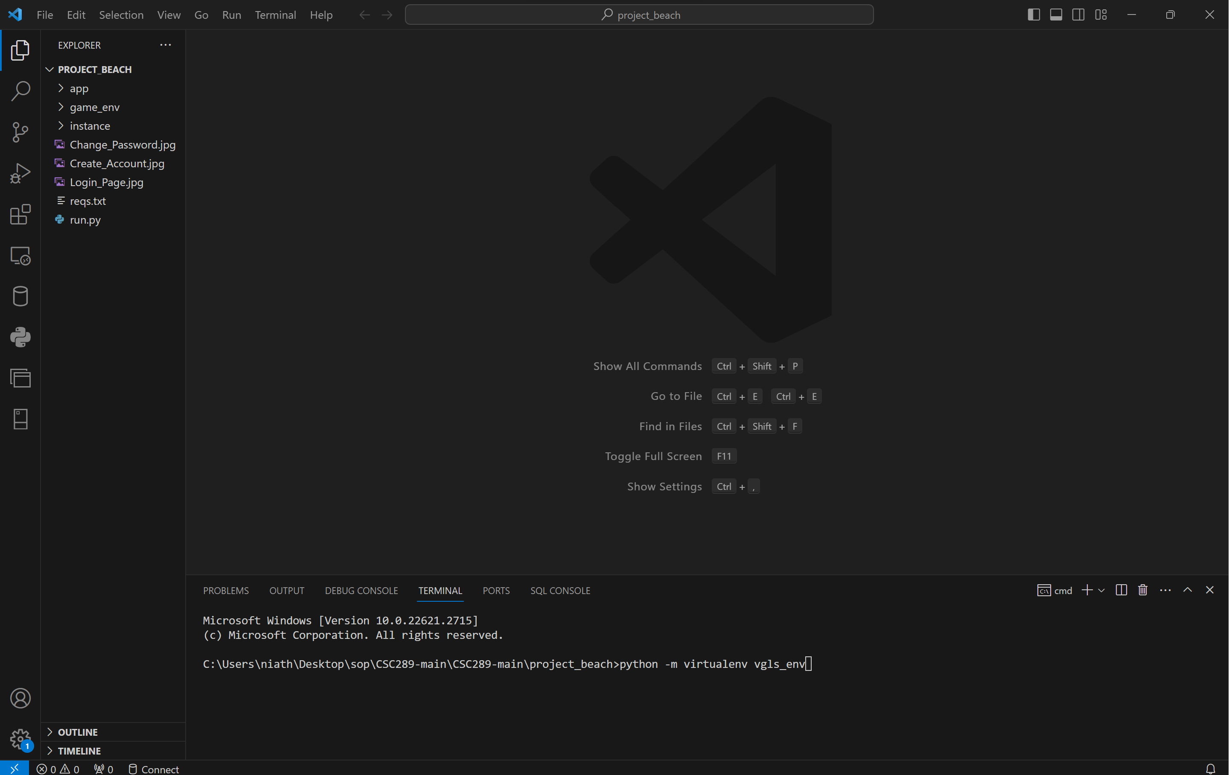

1. Once you press Enter, it will create the virtual environment, and the folder will populate on the left side of the screen.

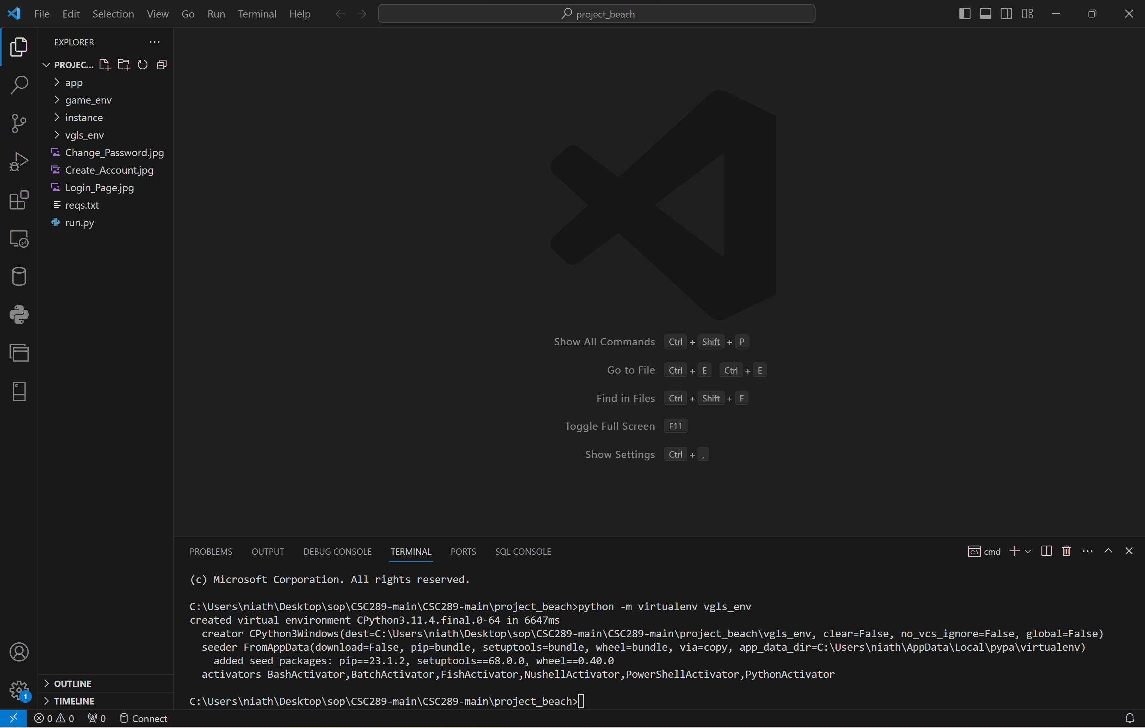

1. You must type “your environment name”\Scripts\Activate. An example would be:

Vgls_env\Scripts\Activate. You will then see the virtual environment name within these brackets(). This will let you know that you are now in your virtual environment.

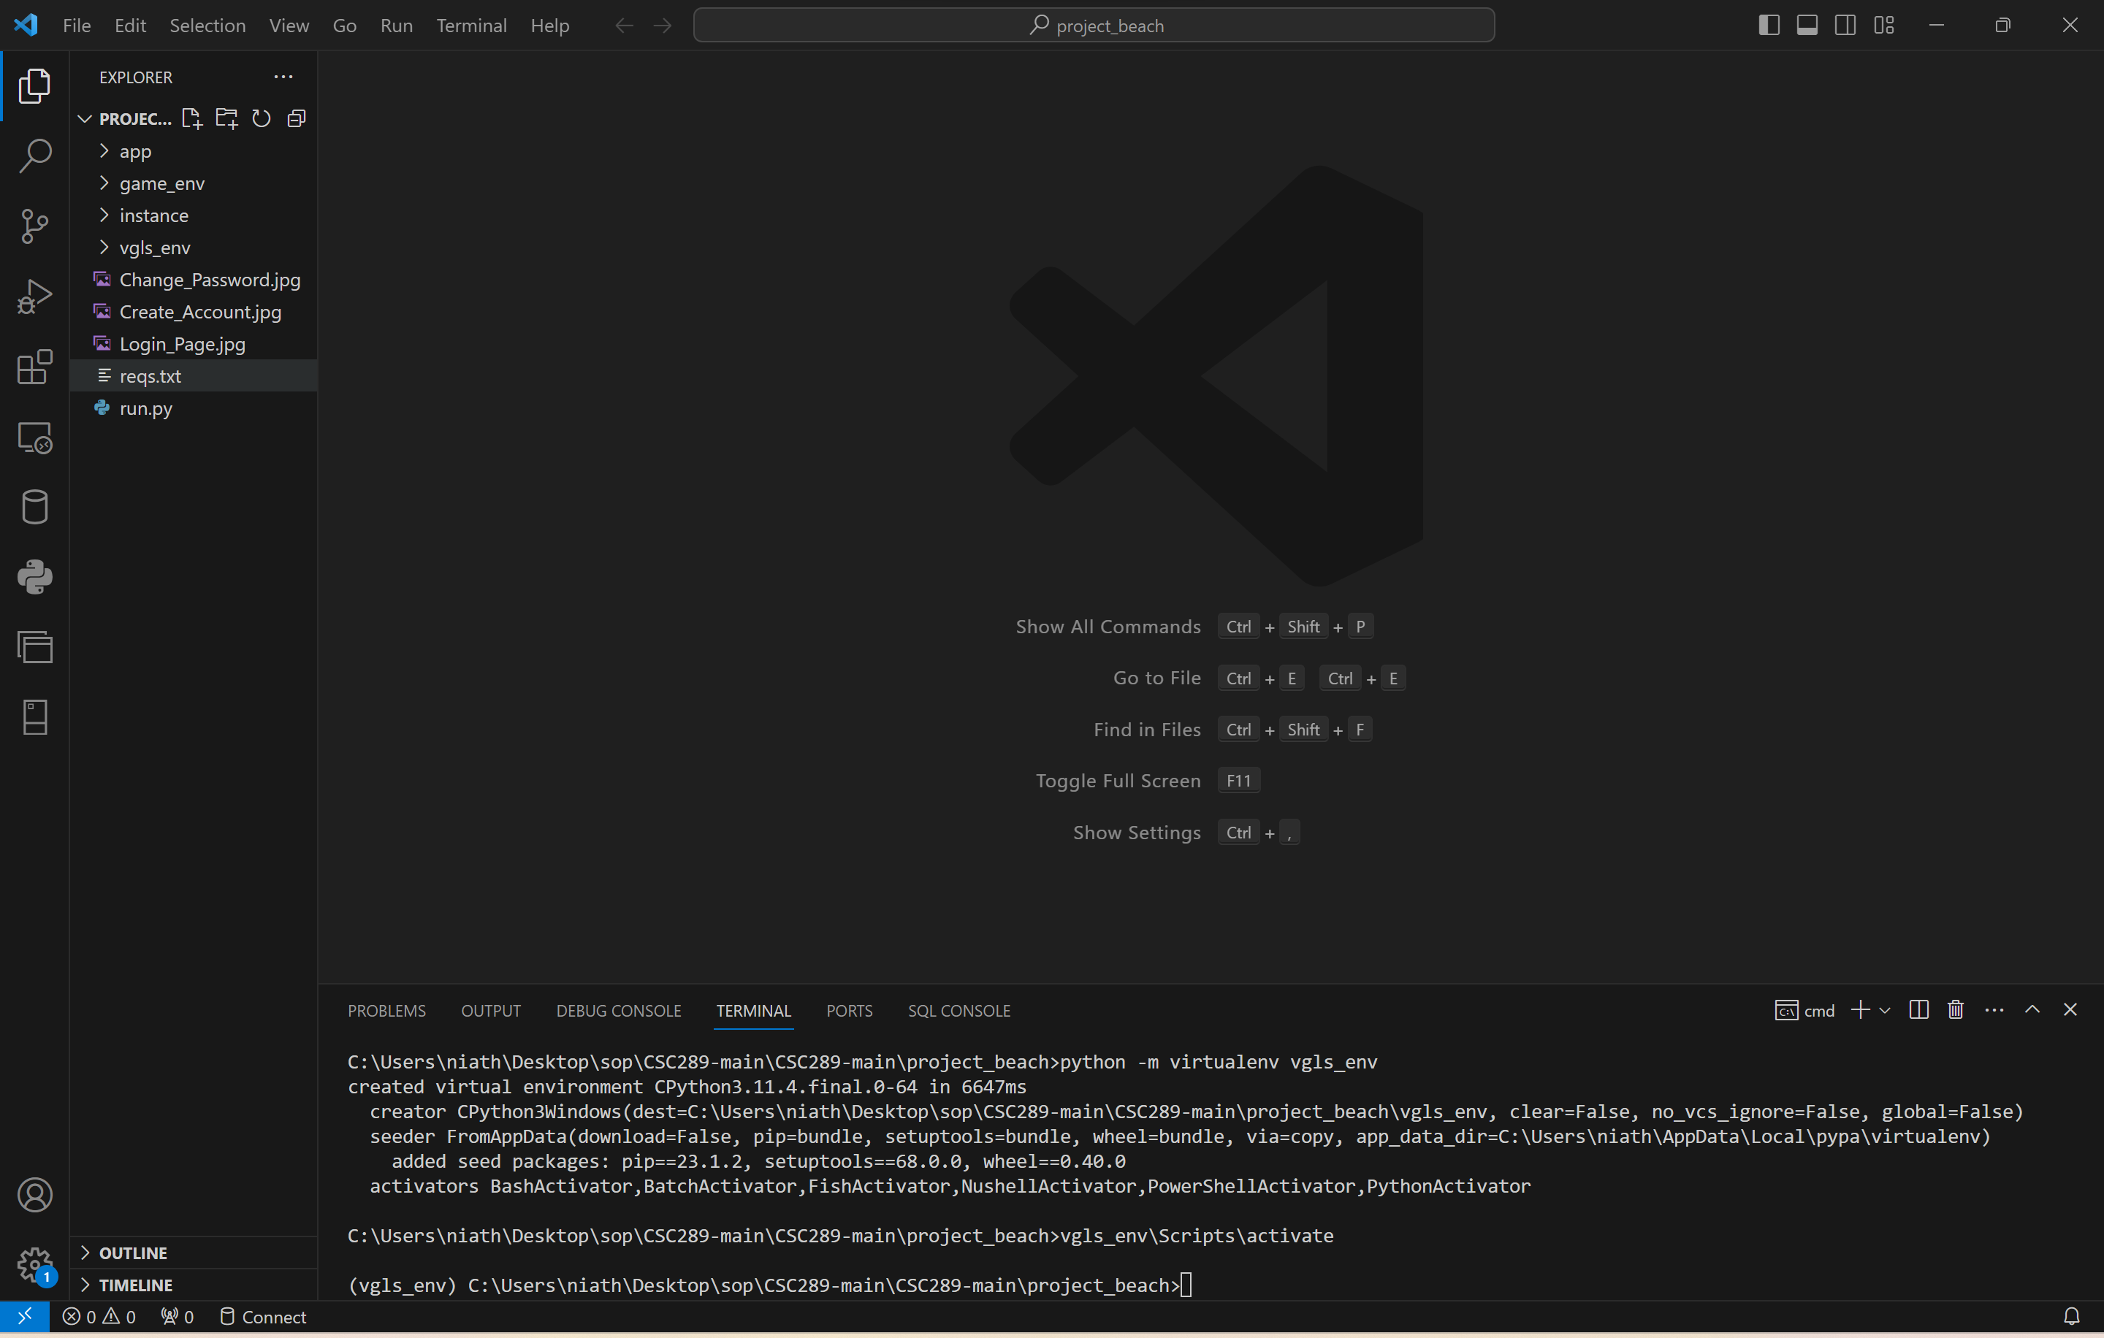

# **Install All Necessary Modules inside the Virtual Environment**

1. Type the following command pip install -r reqs.text. The reqs.text is the file name with all the modules required to run this program. You may get an error if a newer version of pip has been released.

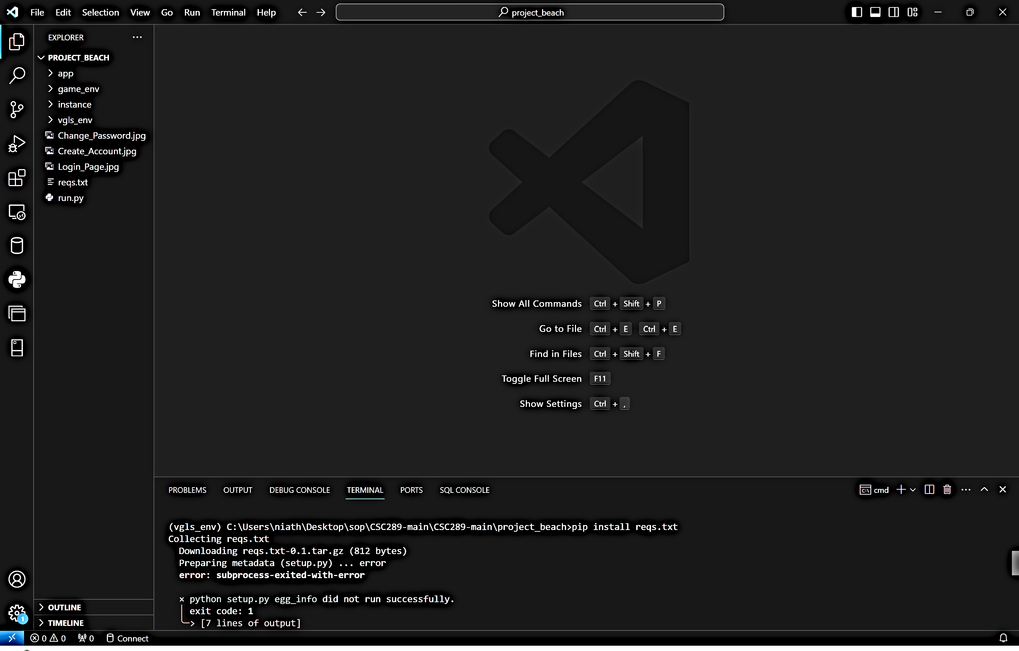

1. If you get an error, you will type the following command: python .exe -m pip install –upgrade pip. This will install the latest version of pip into your virtual machine. Then try again with the pip install -r reqs.txt to install all the needed files.

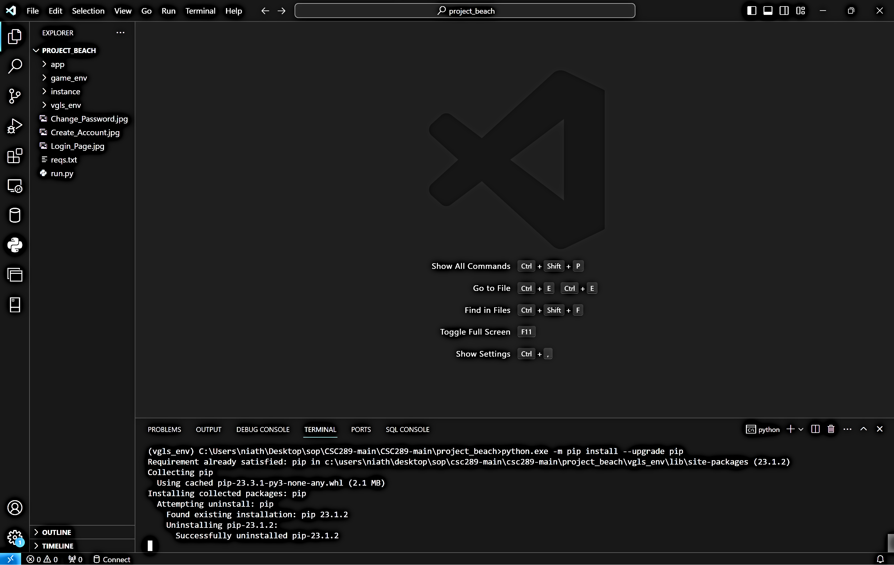

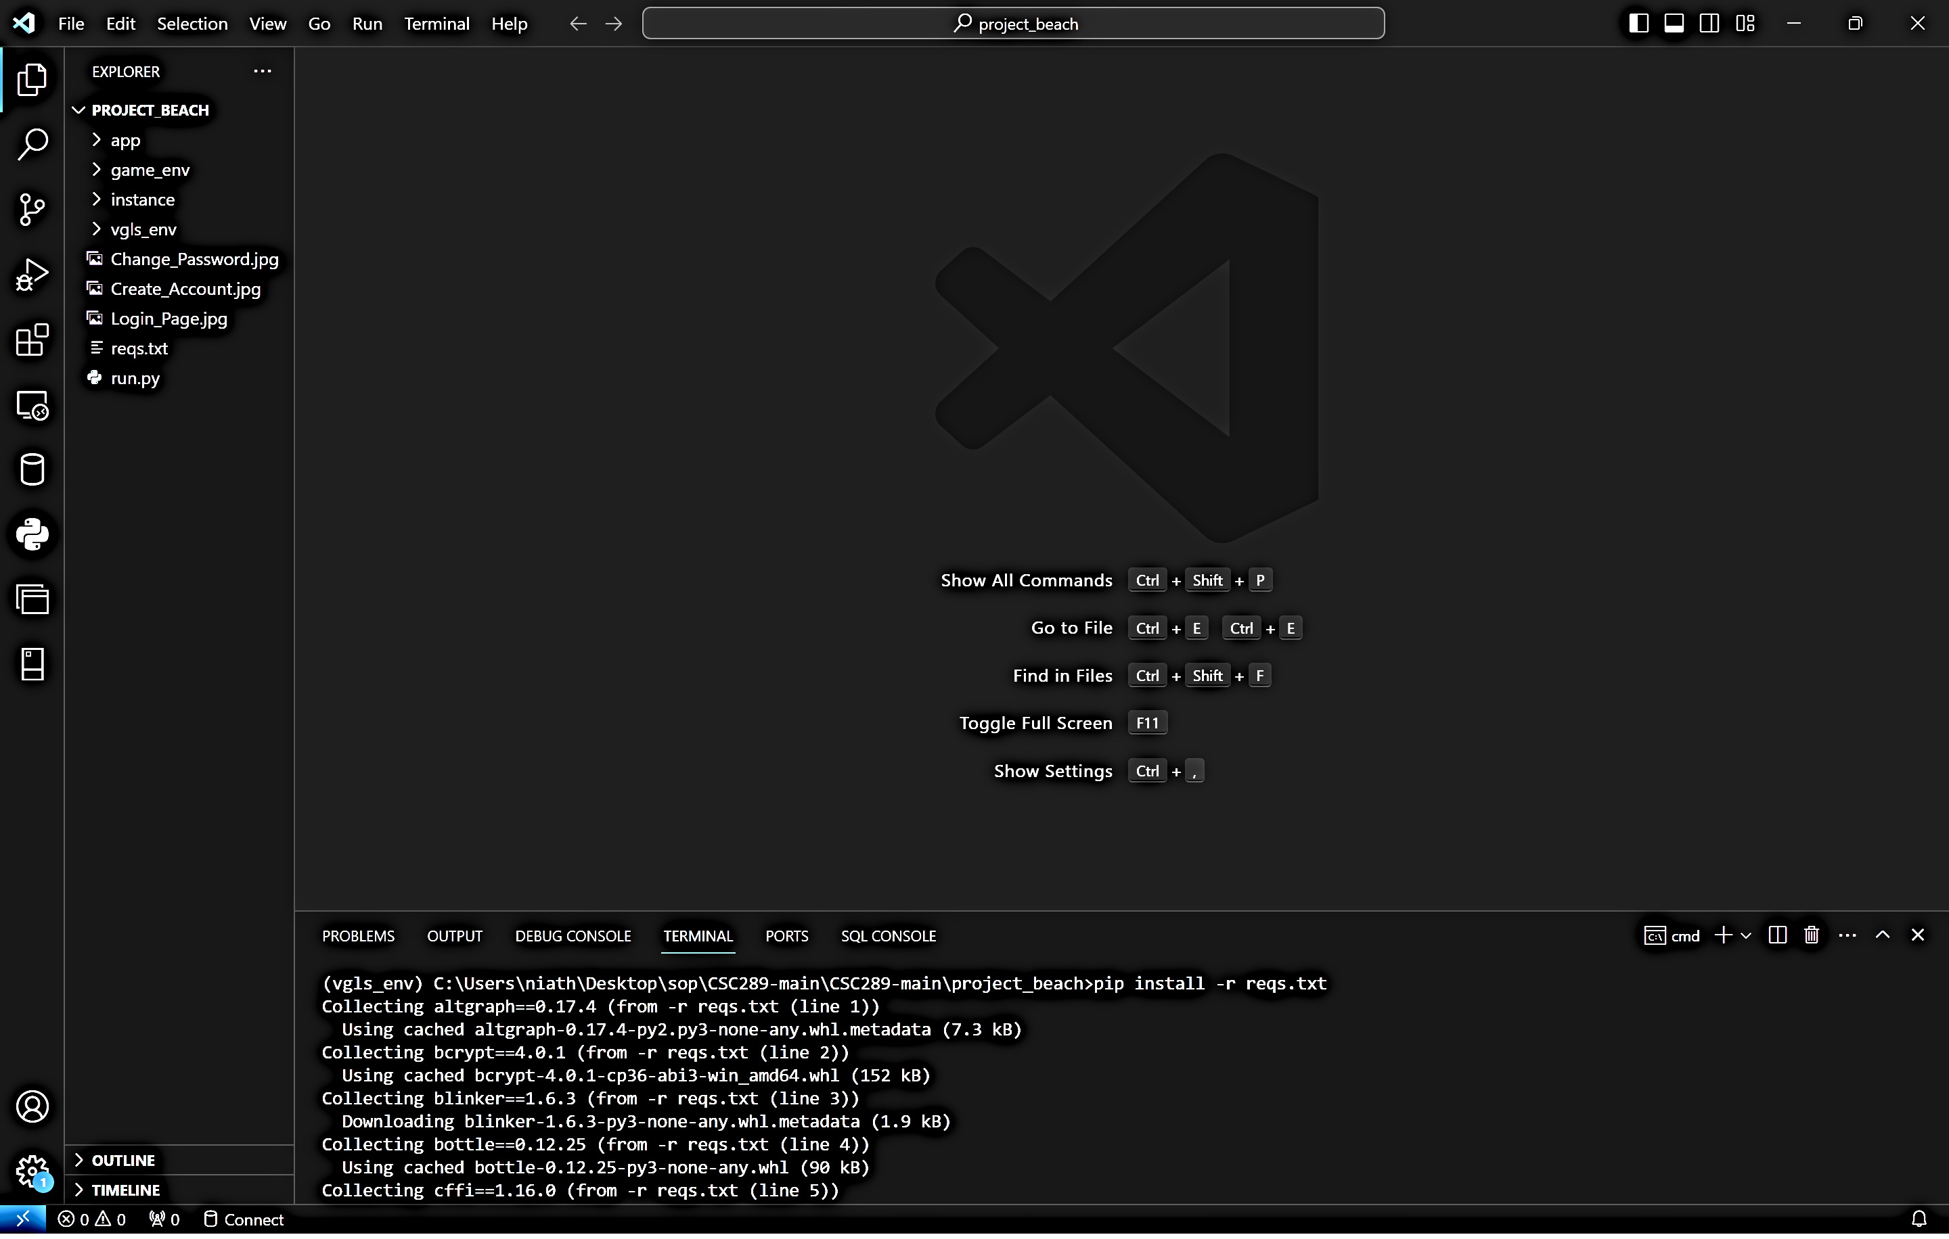

1. To verify that all of the files are downloaded, you will type pip freeze, then press the Enter key. It will then show all of the modules that are installed.

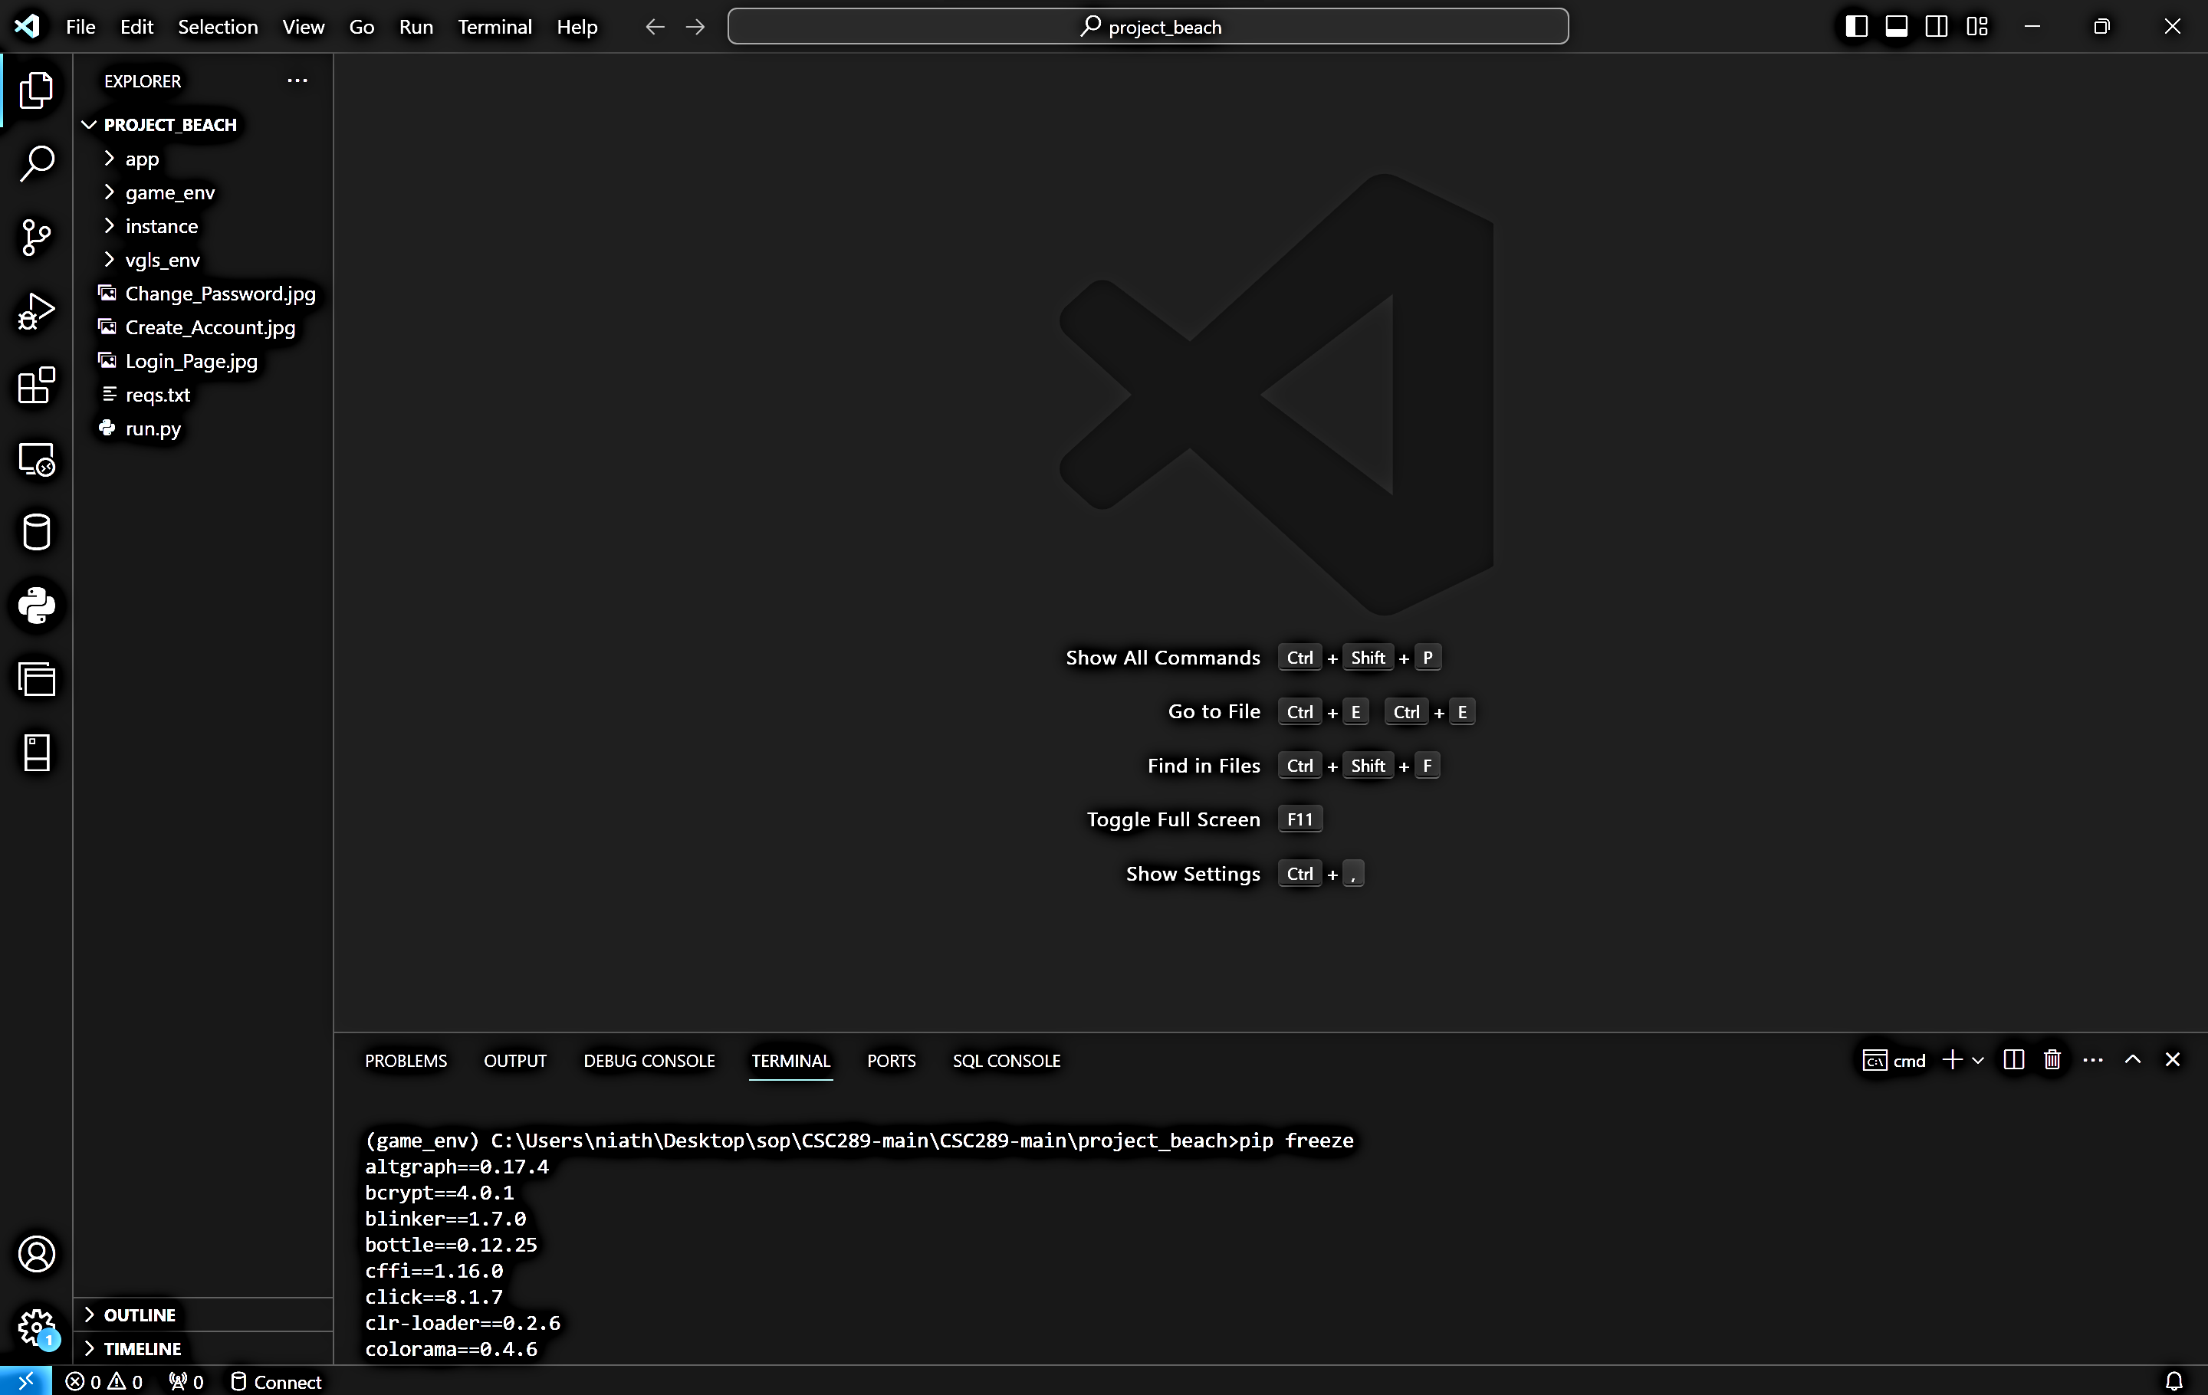

1. There are issues with the current version of the Werkzeug module. You will then need to uninstall the Werkzeug module and install a previous version, Werkzeug 2.3.7, by typing pip uninstall werkzeug. You will type y, then press the Enter key to verify you want to uninstall the module.

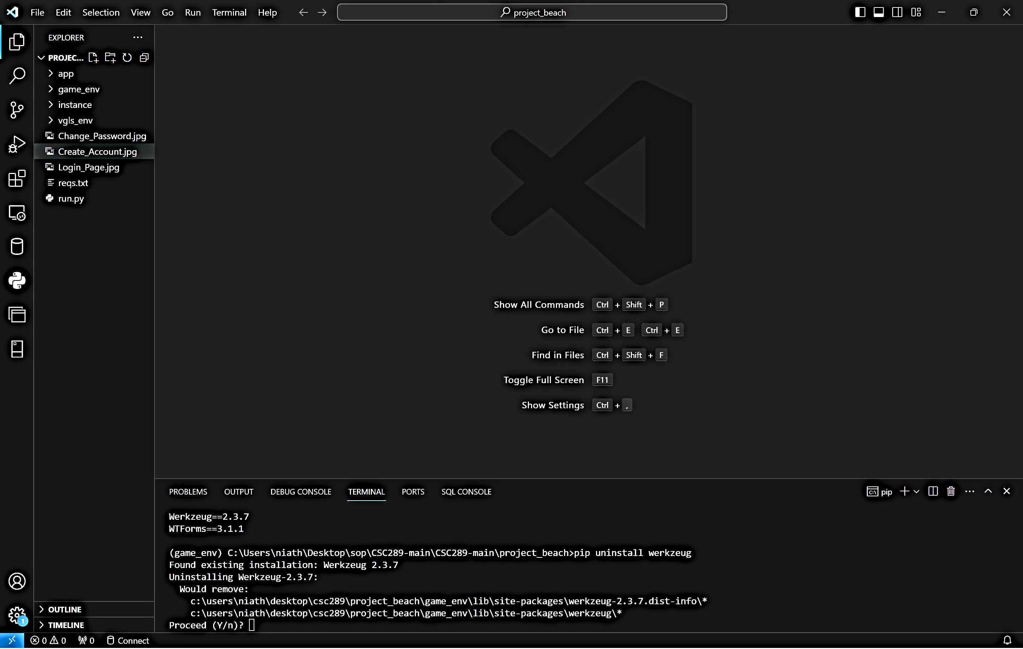

1. You will now need to install werkzeug version 2.3.7 by typing pip install werkzeug==2.3.7. It will then install Werkzeug version 2.3.7.

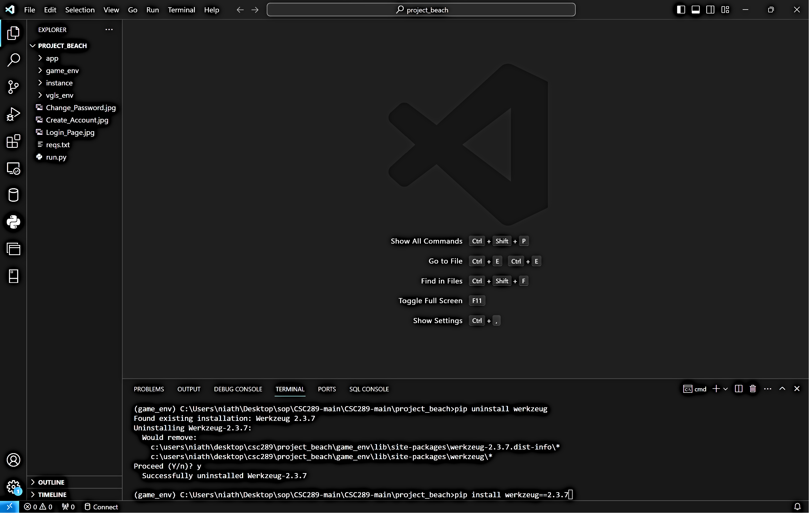

# **Initialize the Website**

1. Type the following command: python run.py to bring up the link you will click on to open a web browser.

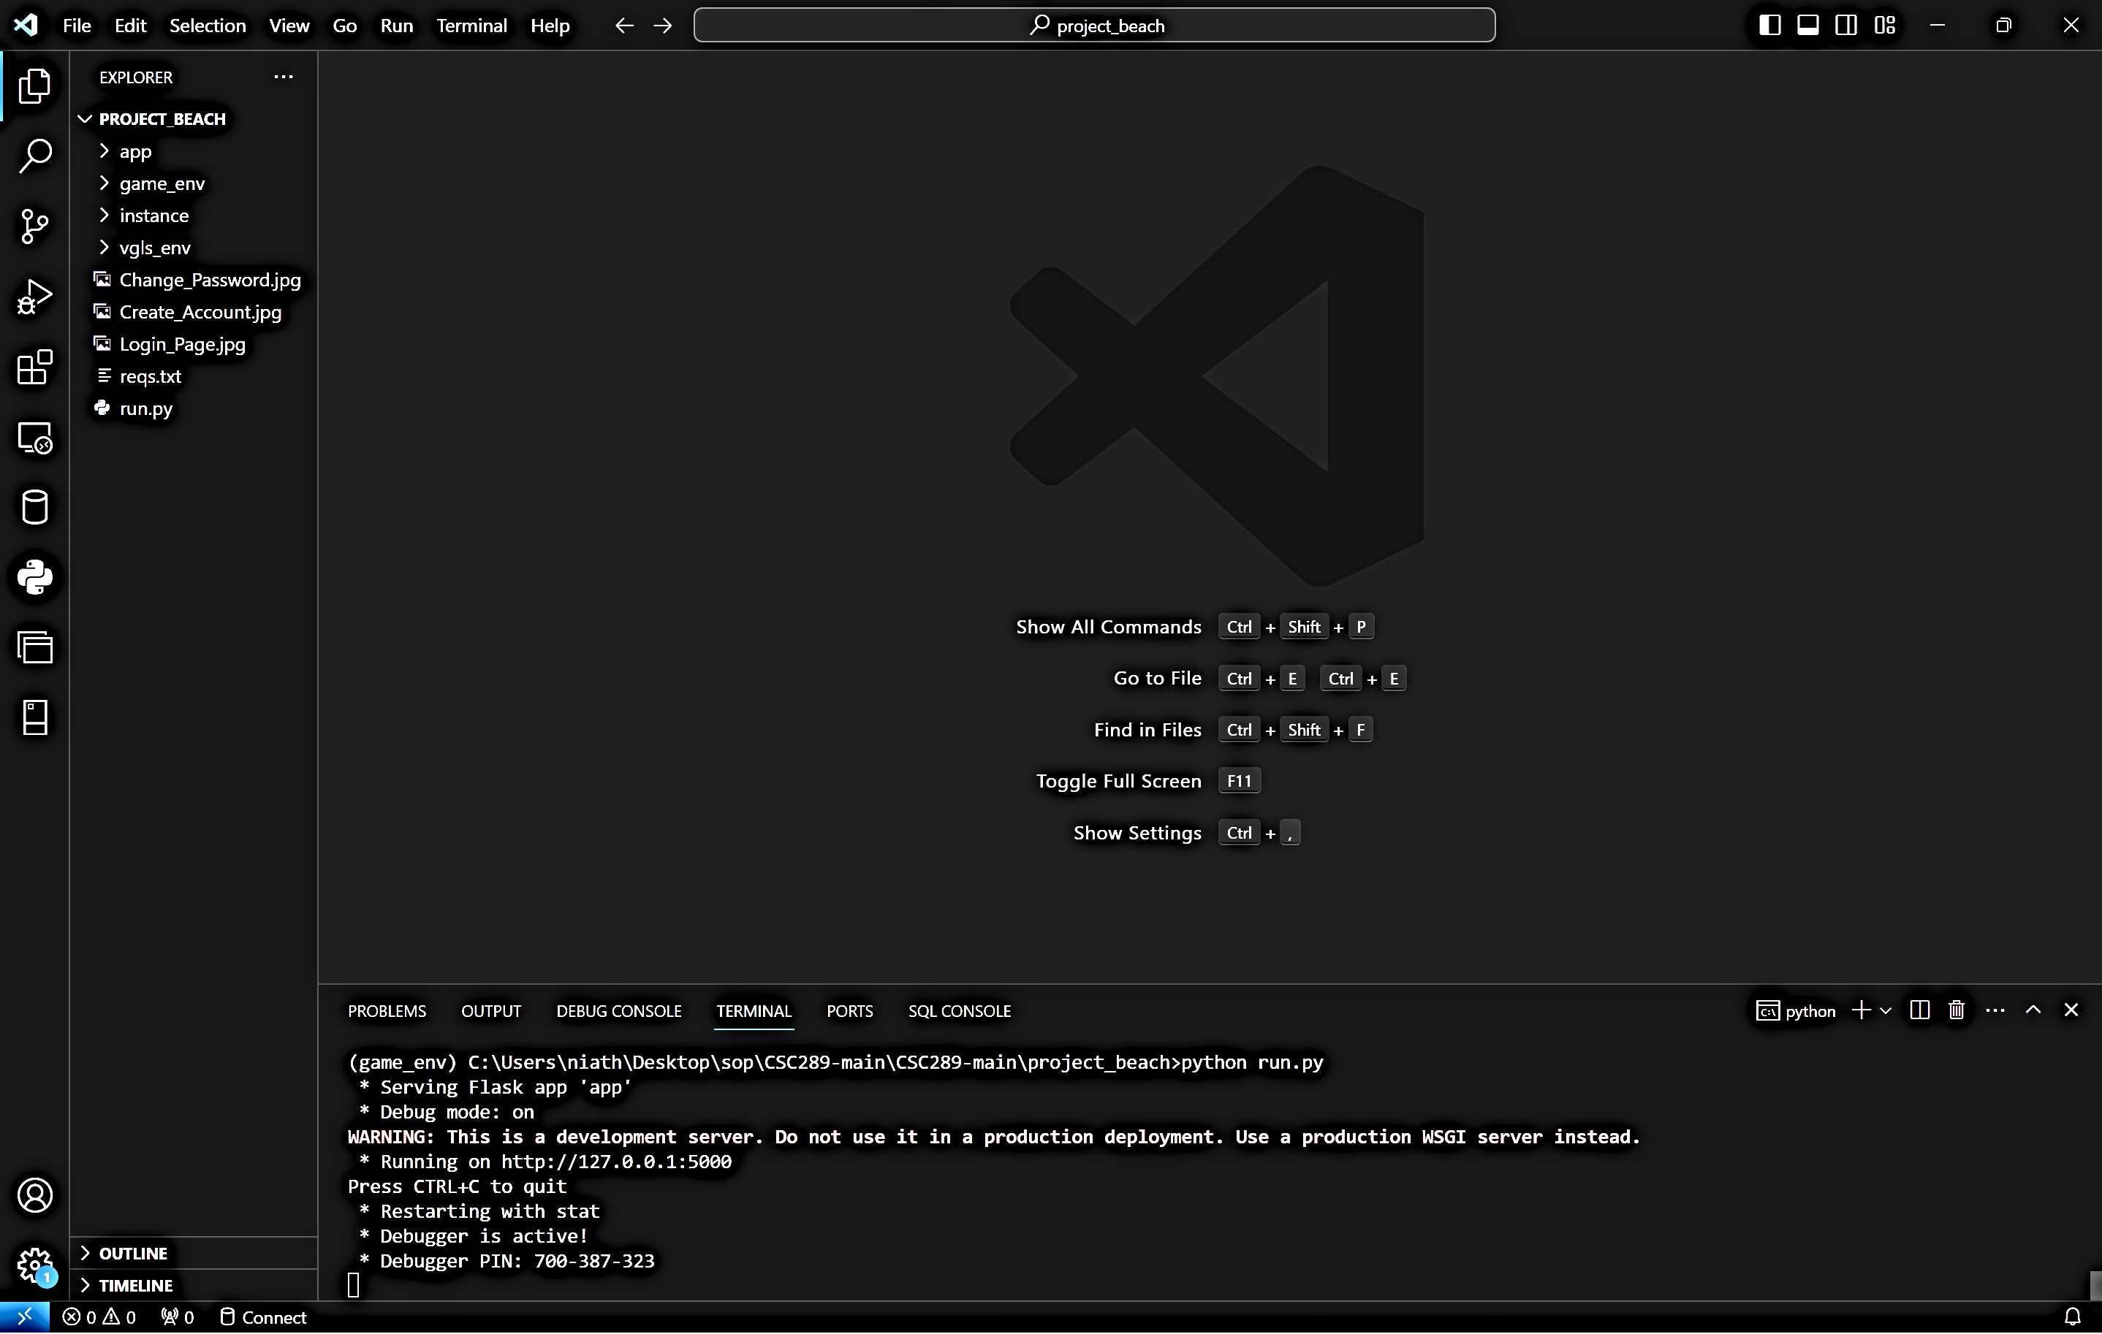

1. Press the Ctrl button and click on the IP address <http://127.0.0.1:5000>. It will then pull up the welcome page of the Video Game Library & Sales Website.

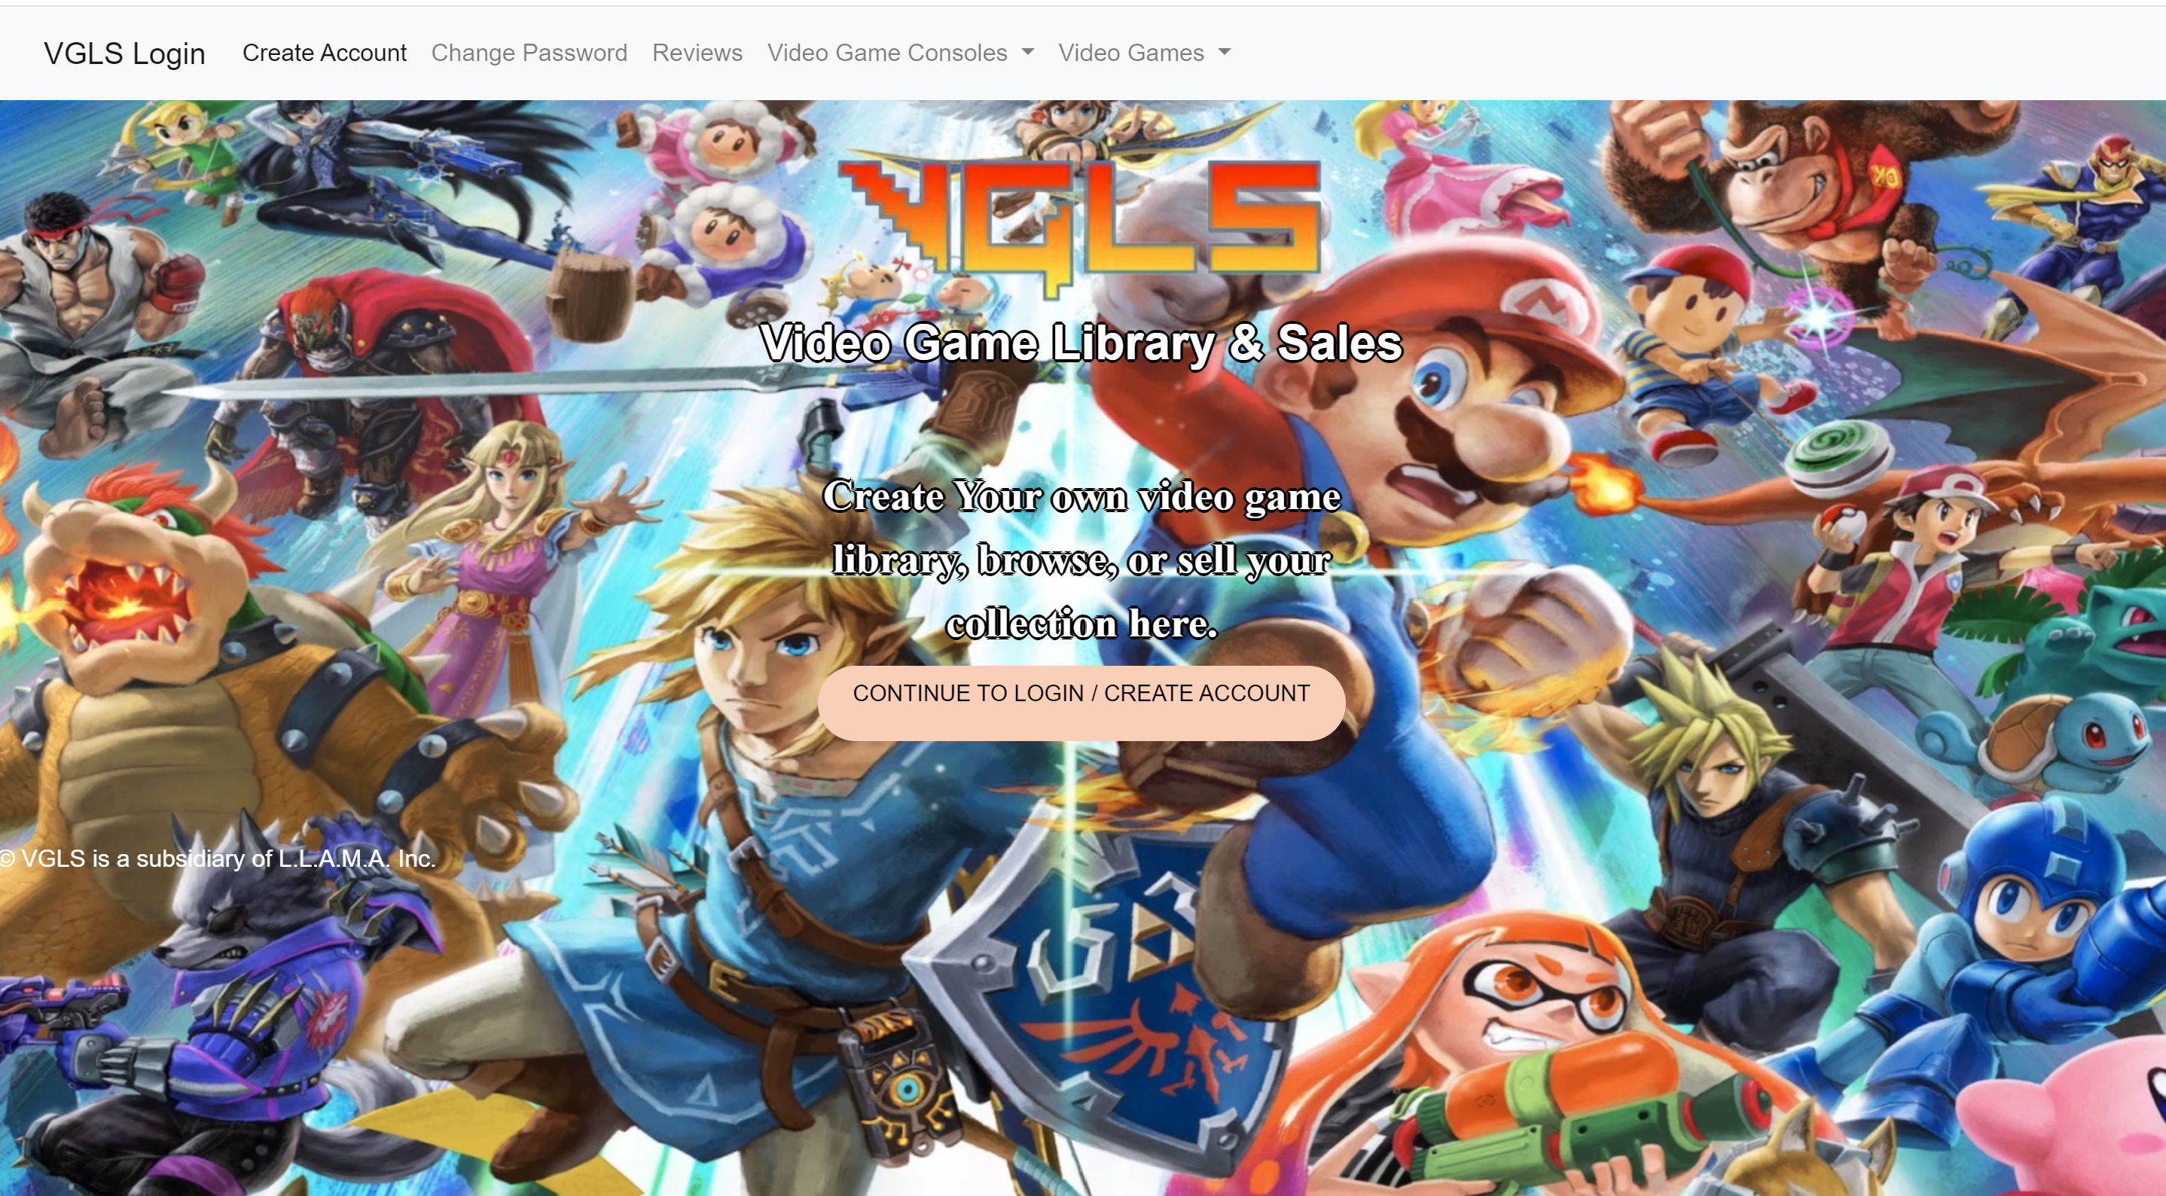

# **VGLS Website**

In this section, we will cover how to use the website. The website will be fully searchable for users that do not have an account. If the user wants to build a library of their video games and possibly wants to sell them one day, they can create a video game/console/accessory library and add items to this library.

## **Website Registration**

1. To get to the Registration/Login page, you will click on “Create Account” within the navigation bar, or you can click on Continue to Login to create your account.

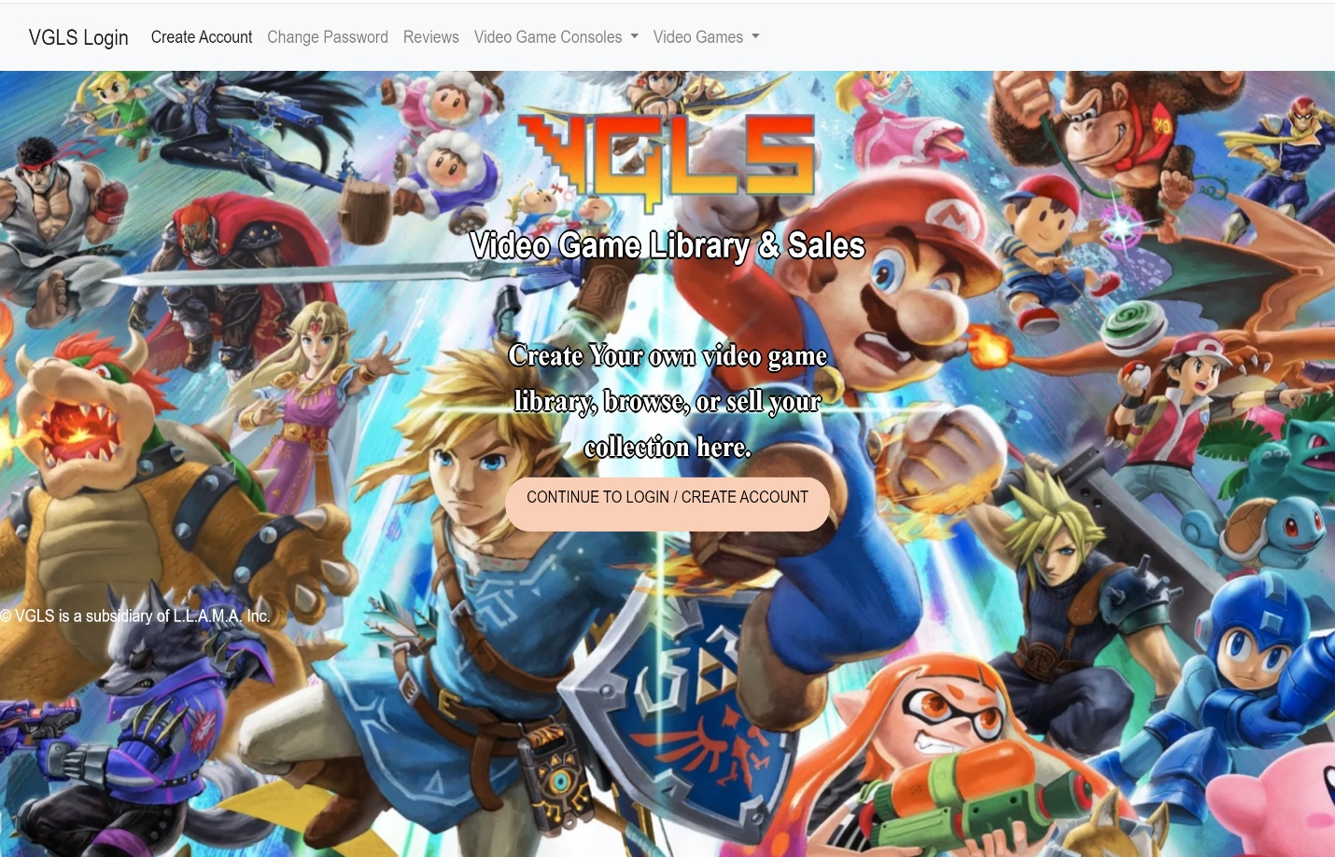

1. You will create a username and password and enter your first and last name. You will then click on Register Account. It will accept your input if the username is not already used and redirect you to the login page. You will get an error message to select a new username if the username already exists.

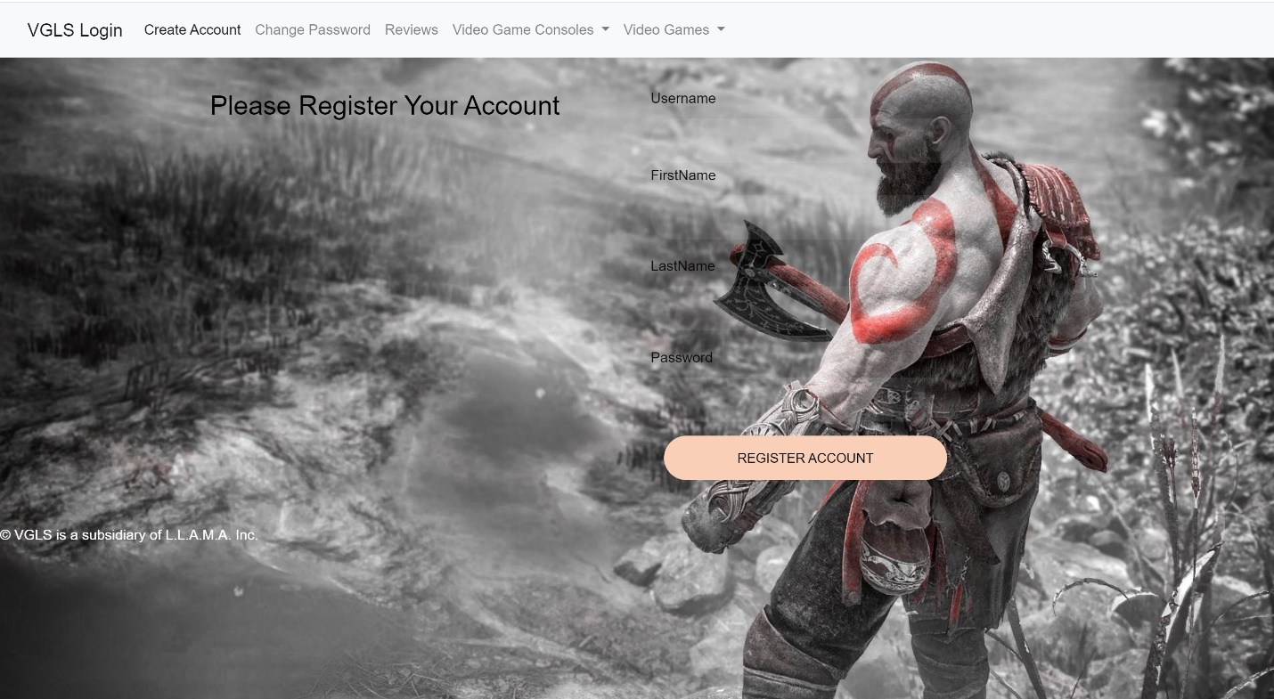

## **Password Reset**

1. Click on Change Password in the navigation bar to get to the Change Password screen. You can also click on Continue to Loin to get to the Change Password screen.

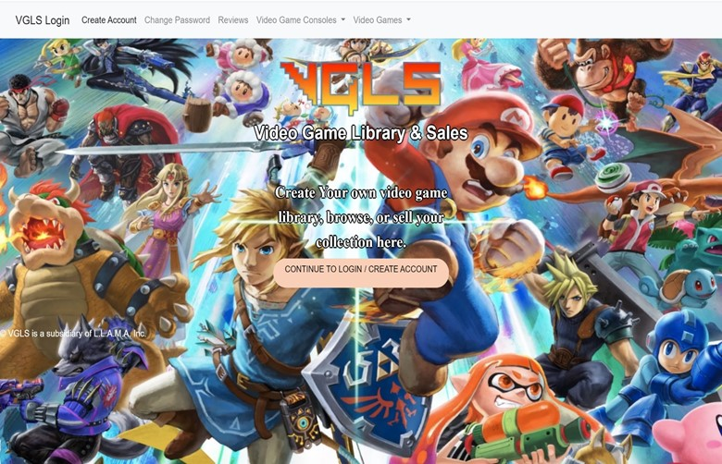

1. If you forgot your password to log in, you can input your username, type in your new password, and click Change Password. If the username exists, then you can change your password. If the username does not exist, you will get an error message.

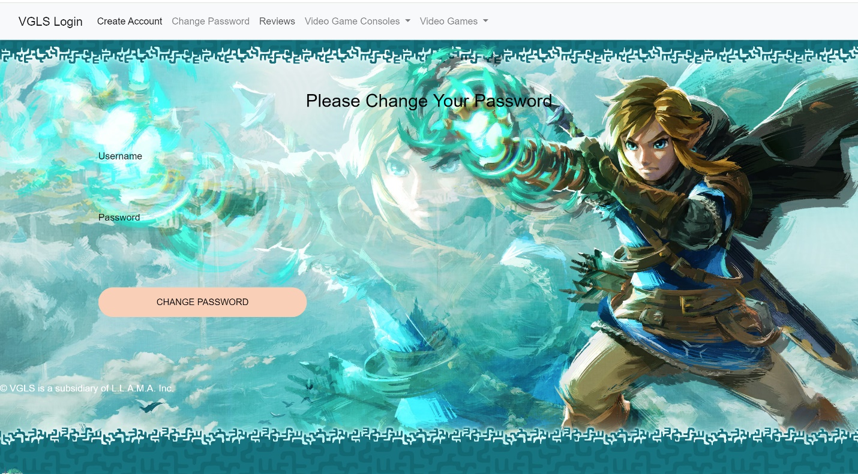

## **Login to the Website**

1. To log into the website, Click on Continue to Login/ Create Account

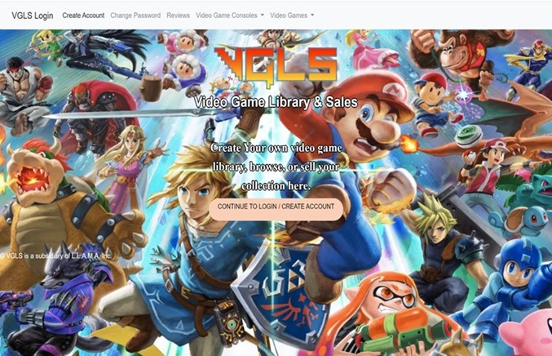

1. Type in your username and password then click on Sign In. If it is correct, it will take you to the home screen. If not, then it will give you an error that the username or password is incorrect.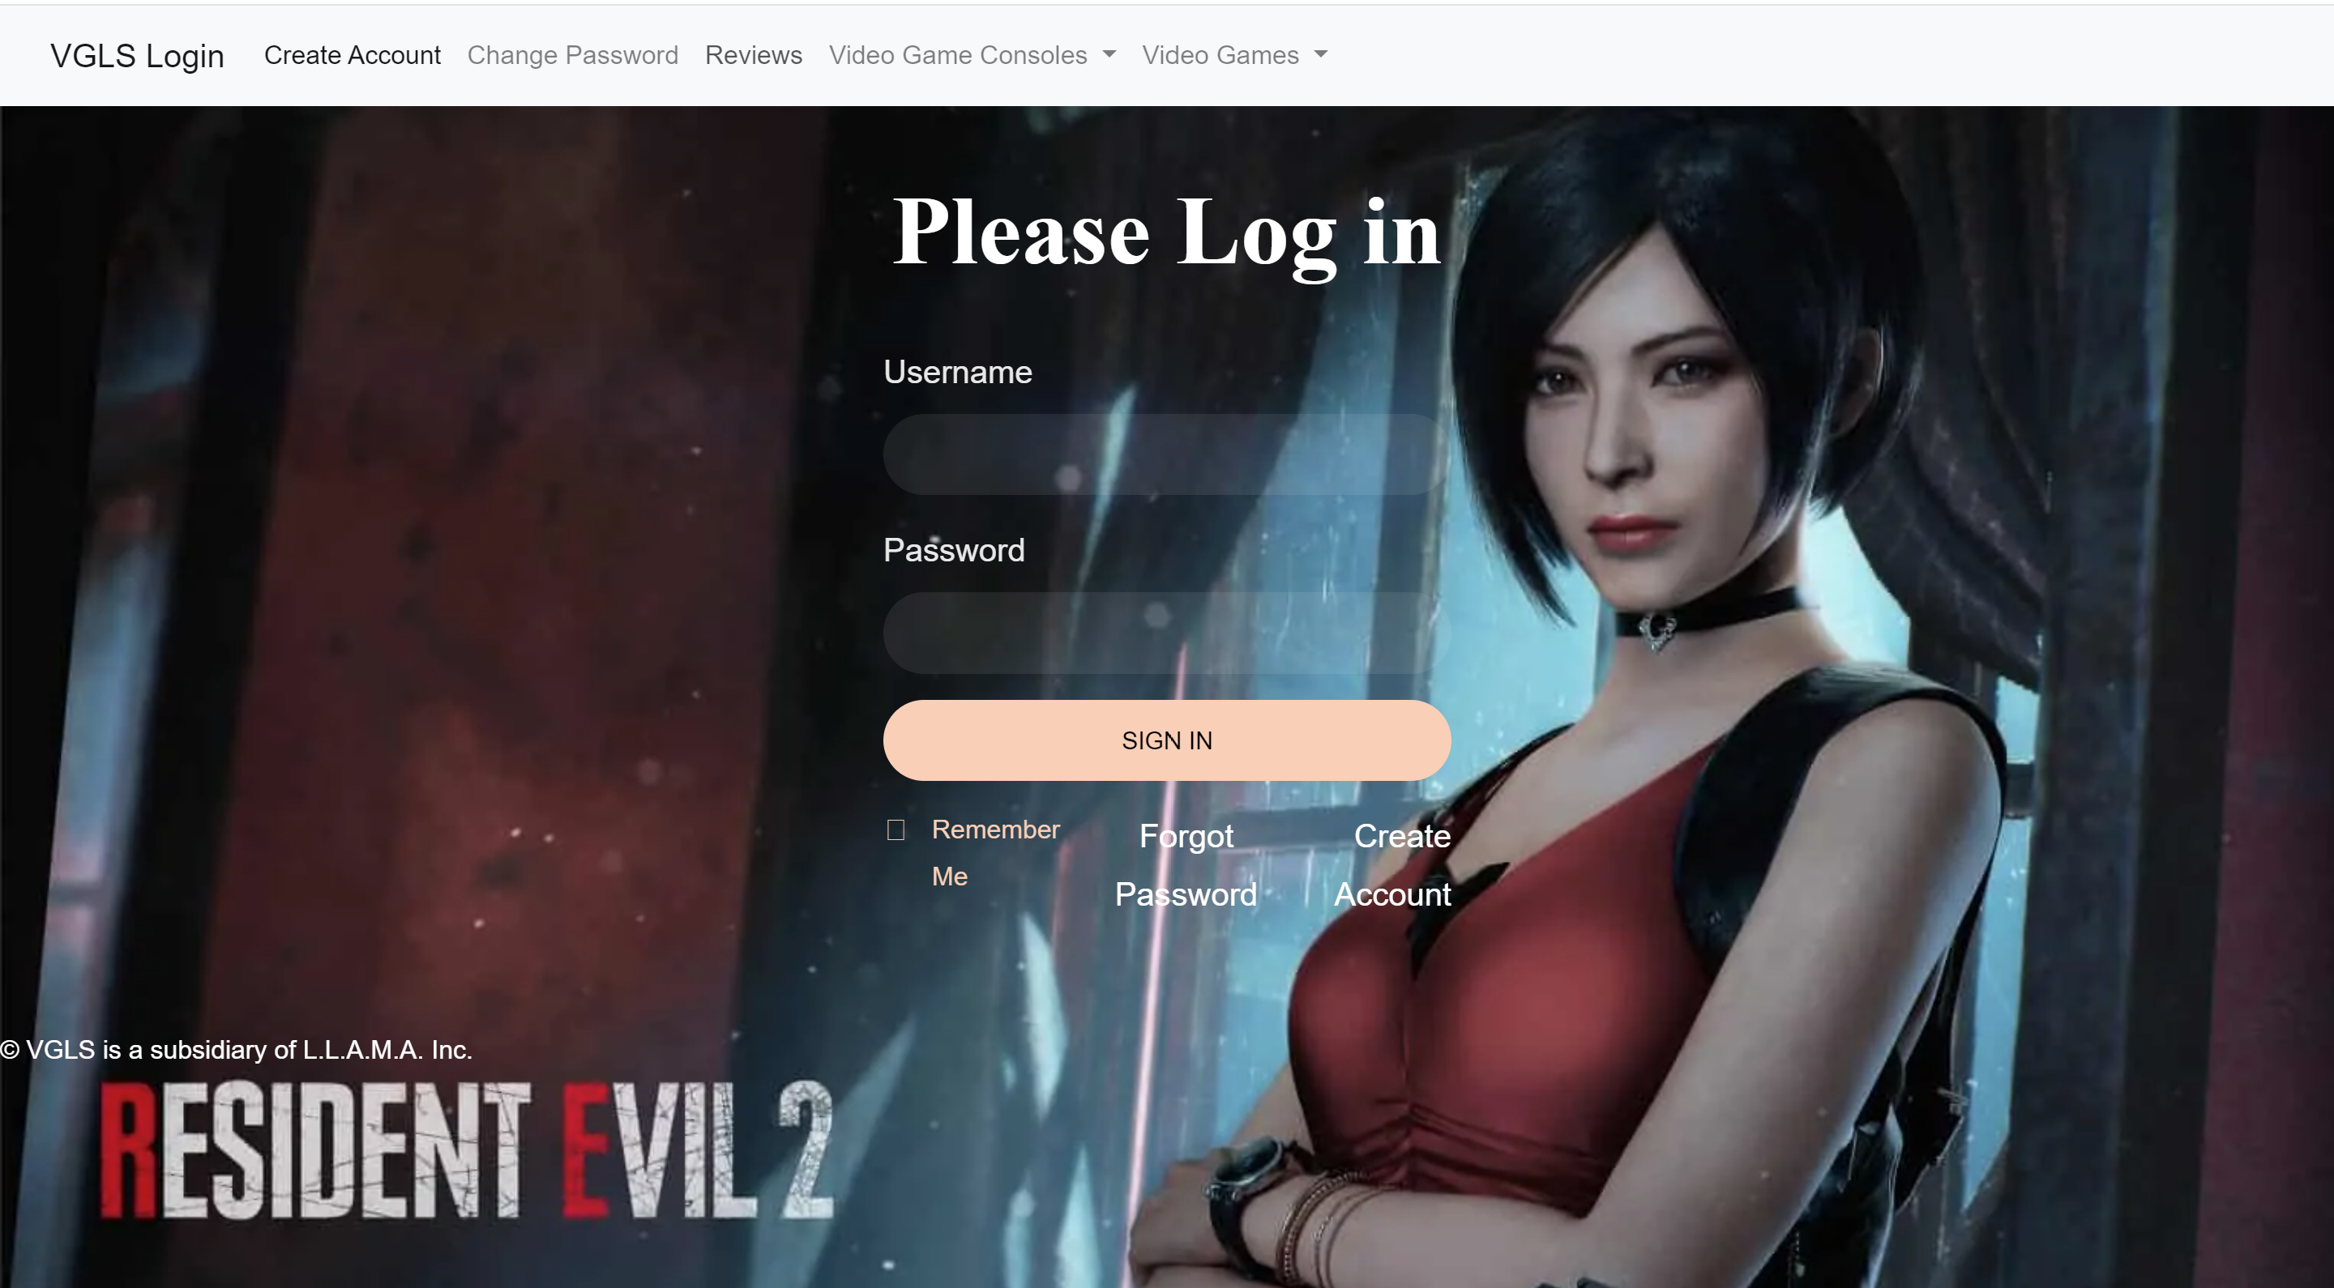
2. If your username and password are correct, it will then log you in and take you to the home screen. Here, you will be able to create your library, update your library, or sell your library. At this time, selling the library is currently under construction. You will also see who is currently logged in and notice that your navigation bar is showing different items than before.

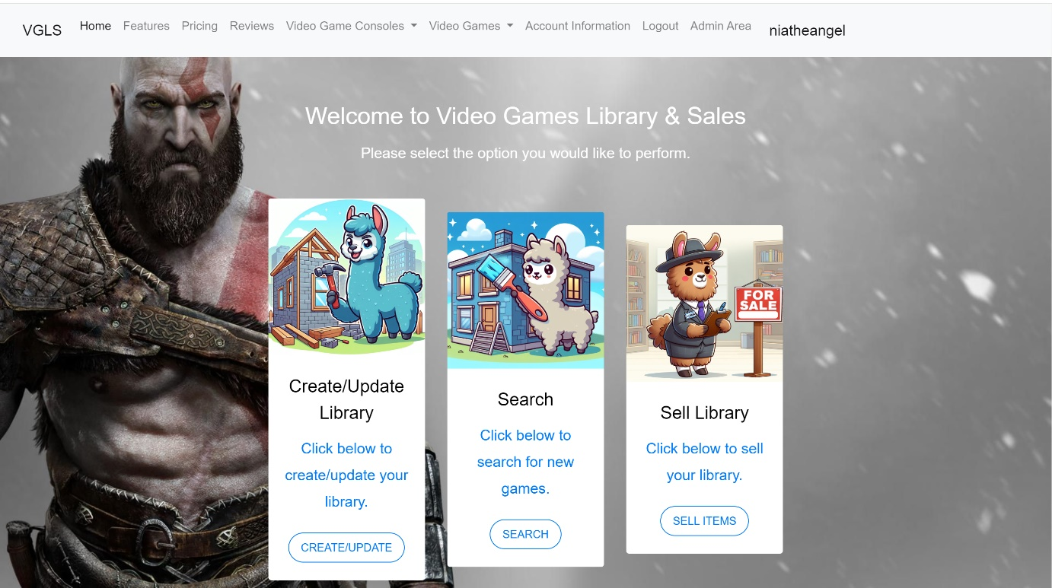

## **Select/Search for Specific Video Game**

1. To search for a specific video game, you will click on the Video Games link in the navigation bar, and then you will select the console on which the game can be played.

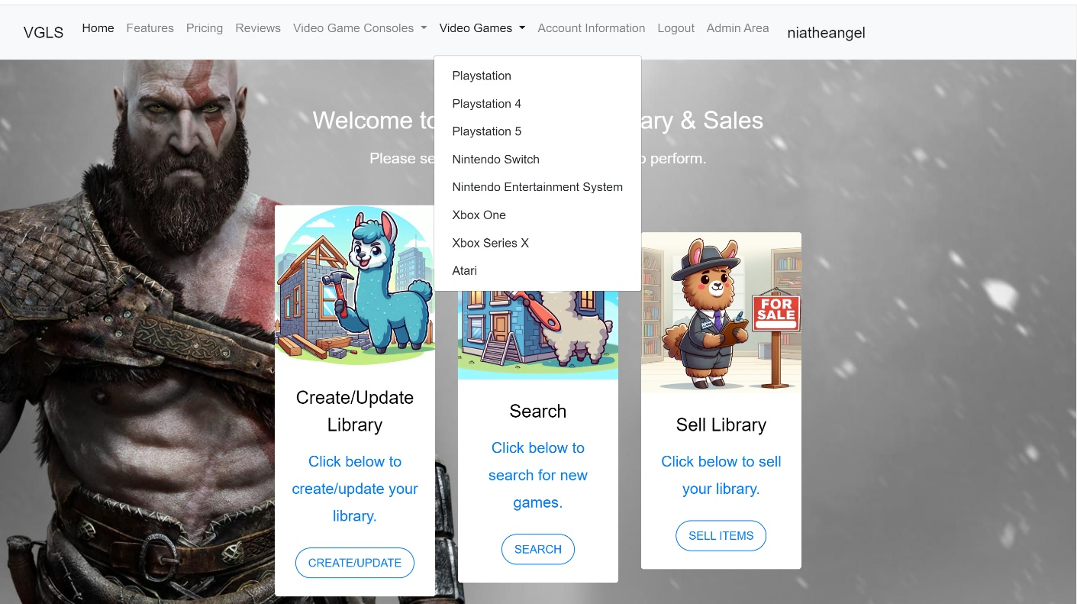

1. After you have selected the console, then a list of games will populate. You can then click on the Description and price which is currently under construction.

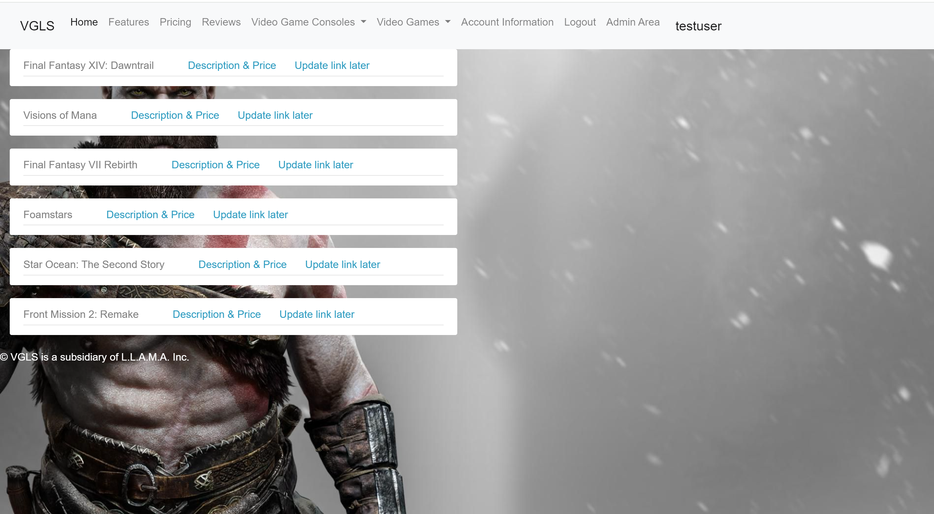

## **Creating a Video Game List on Account to Track Personal Collection**

1. To view your individual library, click on “Home” in the navbar and select “Create/Update Library”The website will check to see if you are logged in. The “Home link in the navbar only appears if the user is logged in to the website.

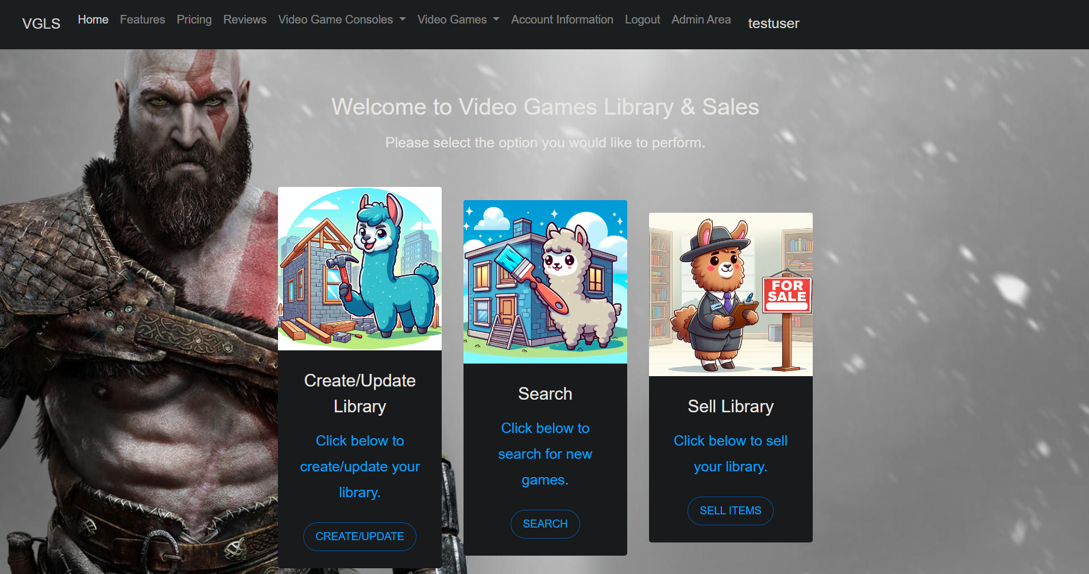

2. If you wanted to create a library of the video games/consoles you have, you will click on Create Library.

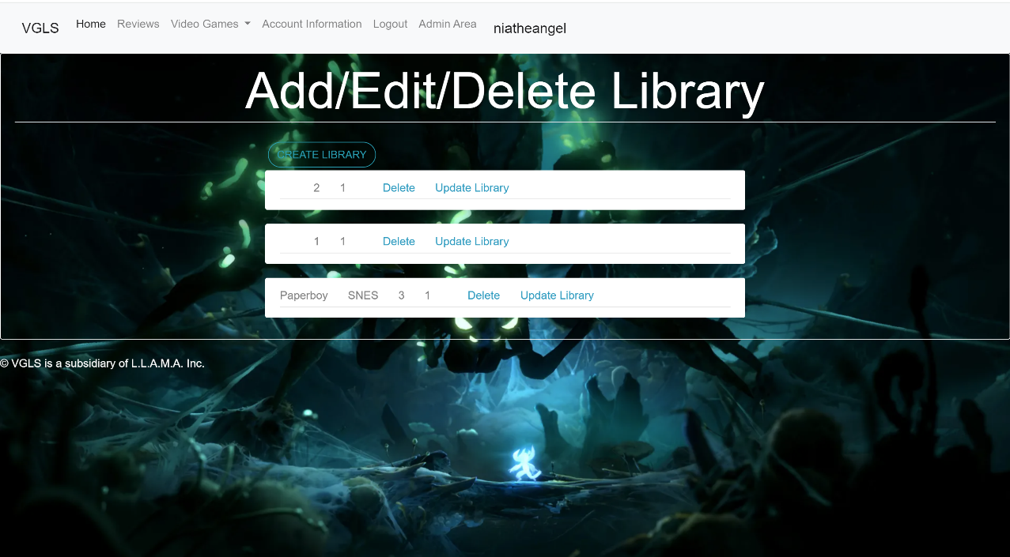

3. You will input the videogame name, the console it is for, and how many you have of that game. Then you will click on Create Library.

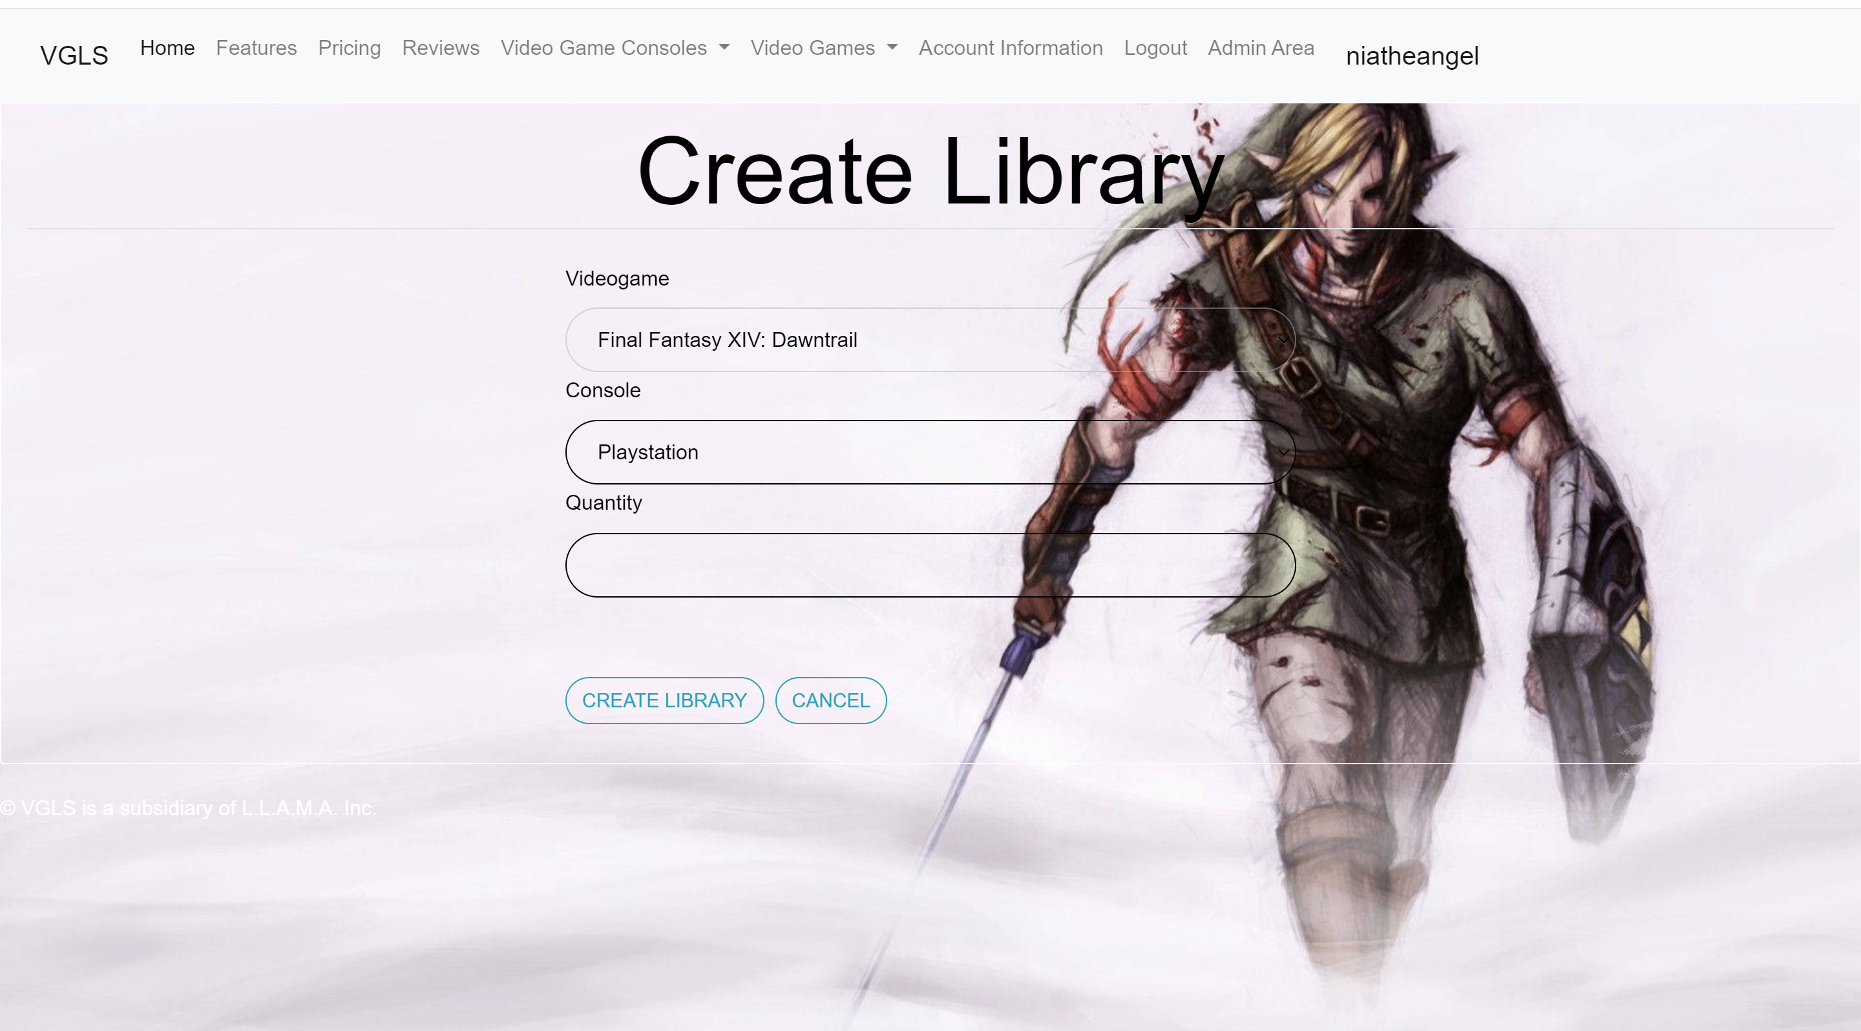

4. If you want to update your library, you would click on update library next to the game you need to update.

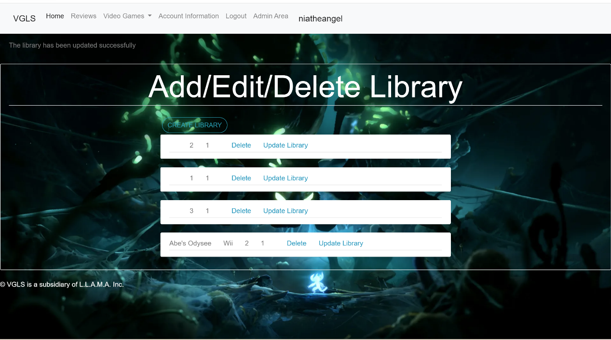

5. You can change the game name, the console the game is for, or the quantity of how many of that game you have. Once you have updated what you need to update, you will click on Update Library, and you will get a message that your game has been updated.

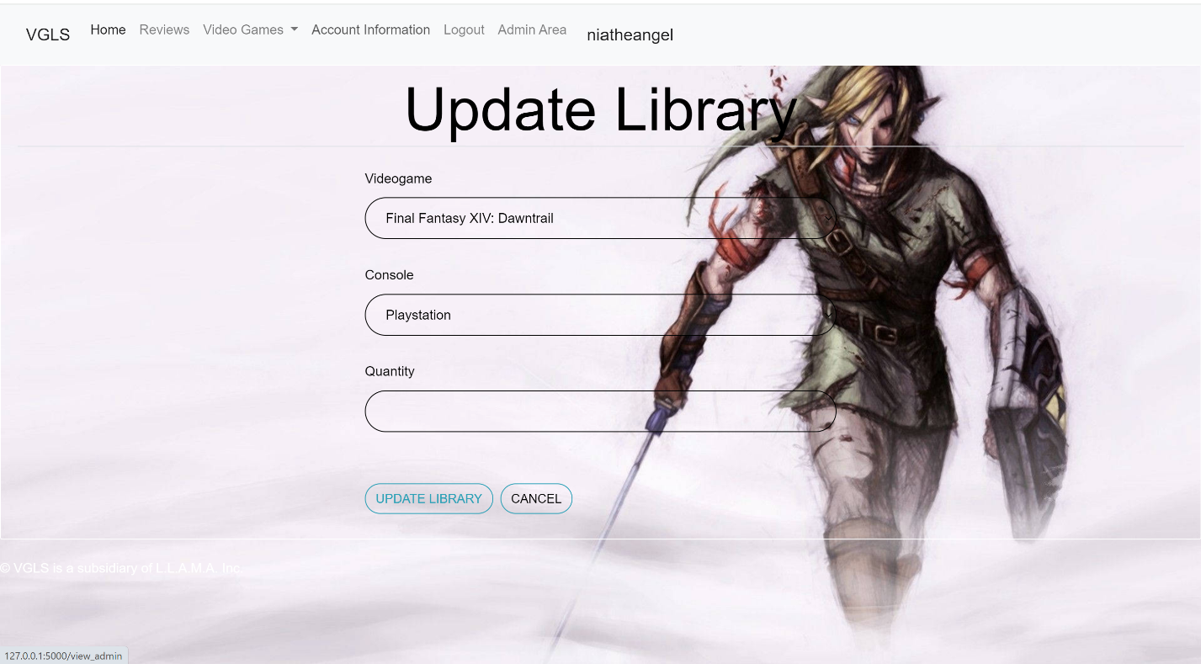

# **Search for New Games**

1. To search for new games, you will click on the search button. (Currently under construction).

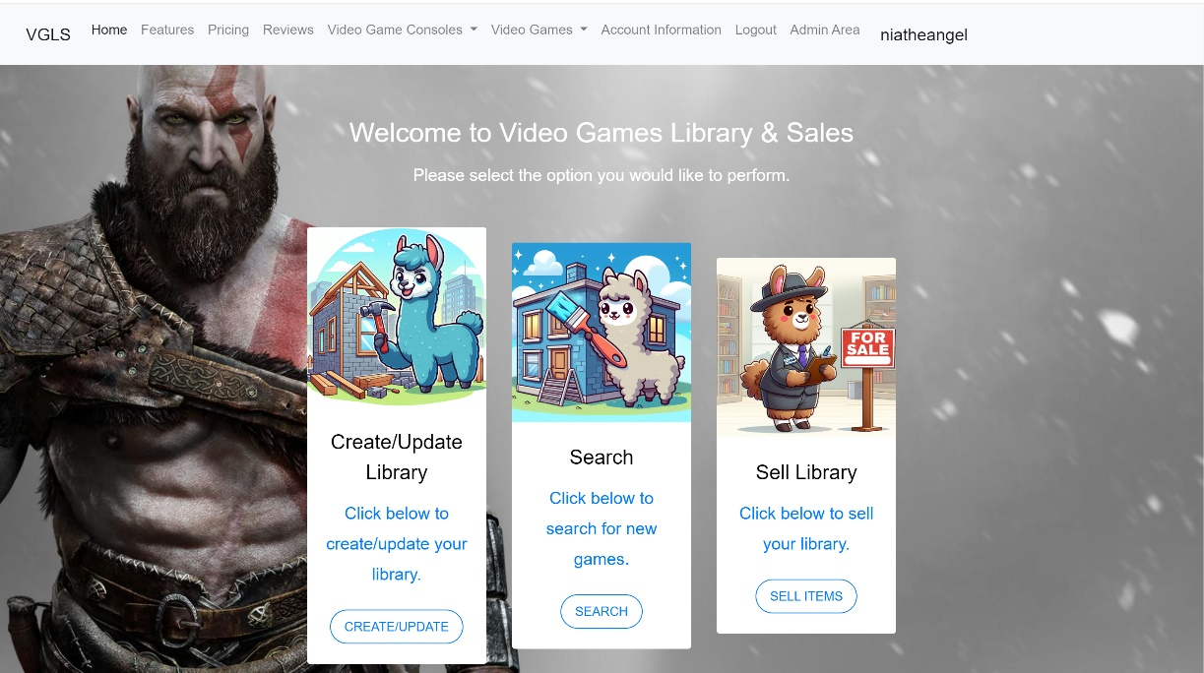

2. You will then type the name of the game you want to search for, then you will click on search.

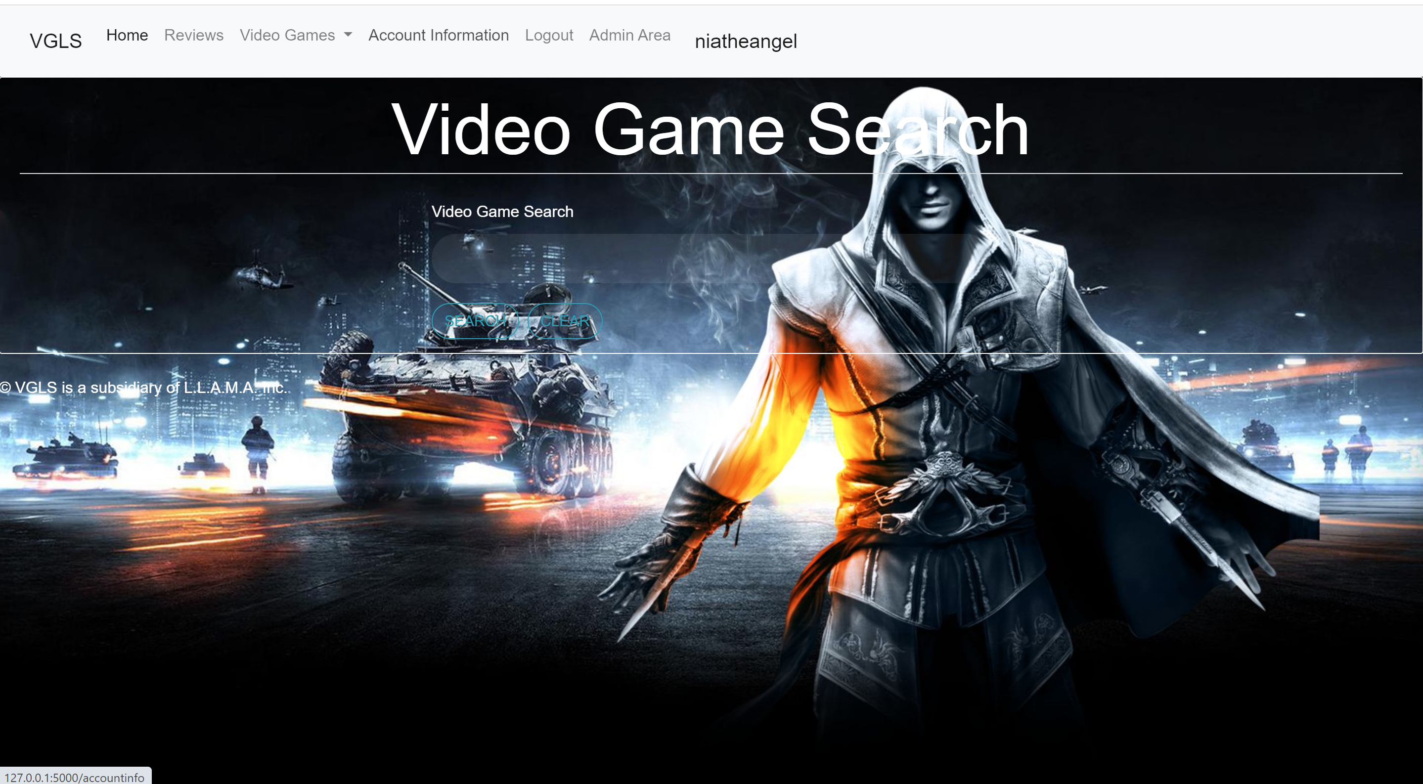

3. It will search the database and then will return with the results and will give a possible value for the game(currently under construction).

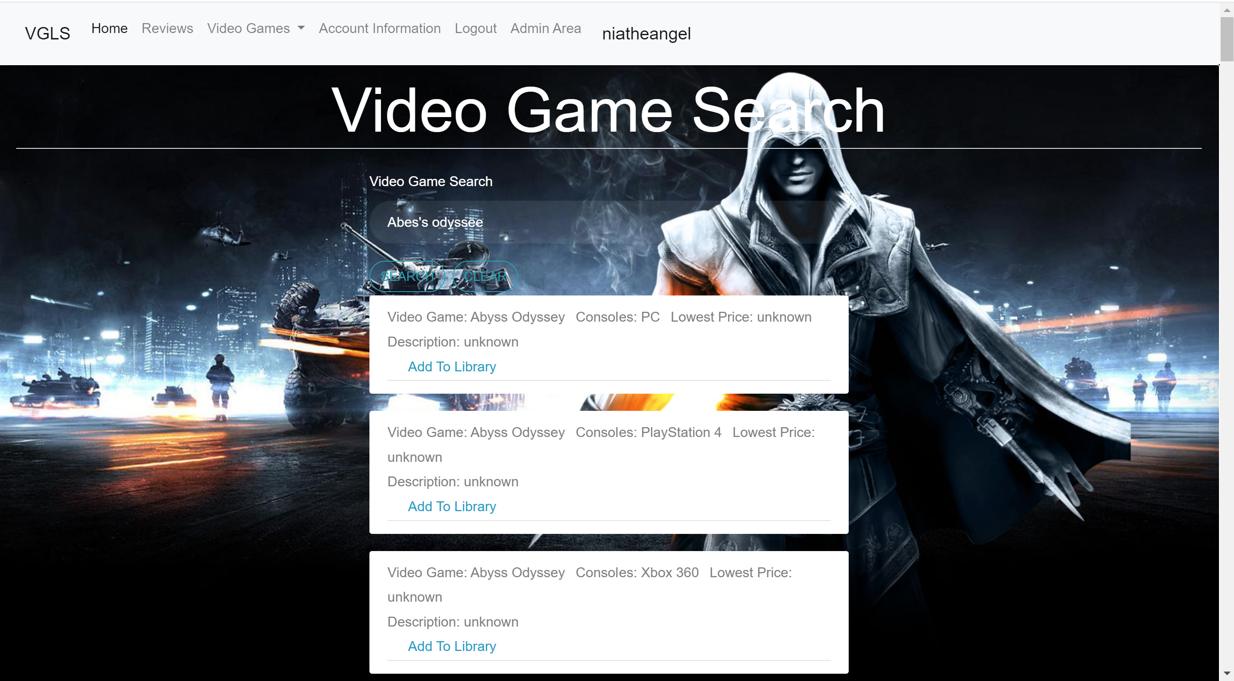

# **Sell Library Items**

1. To sell your library or items in your library, you will click on the sell button. (Currently under construction).



2. You will then to be able to sell items out of your library. (under construction).

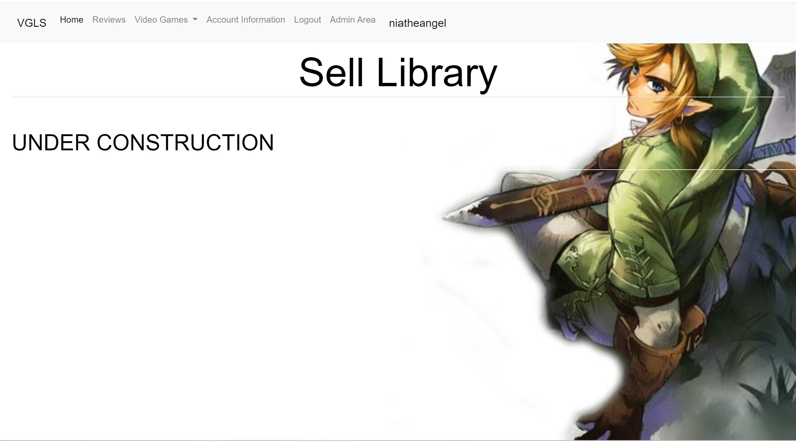

# **Admin Portal**

1. To access the admin portal, you must first be considered an Admin. You will click the “Admin” link in the navigation bar. This link will not populate on your navigation bar if you are not an Admin. You can make changes to the database, add others as an administrator, and add additional items to the database so the users can add that to their libraries. To Change a user from a user to an administrator or to make changes to the user’s account, you will click on Edit User Accounts.

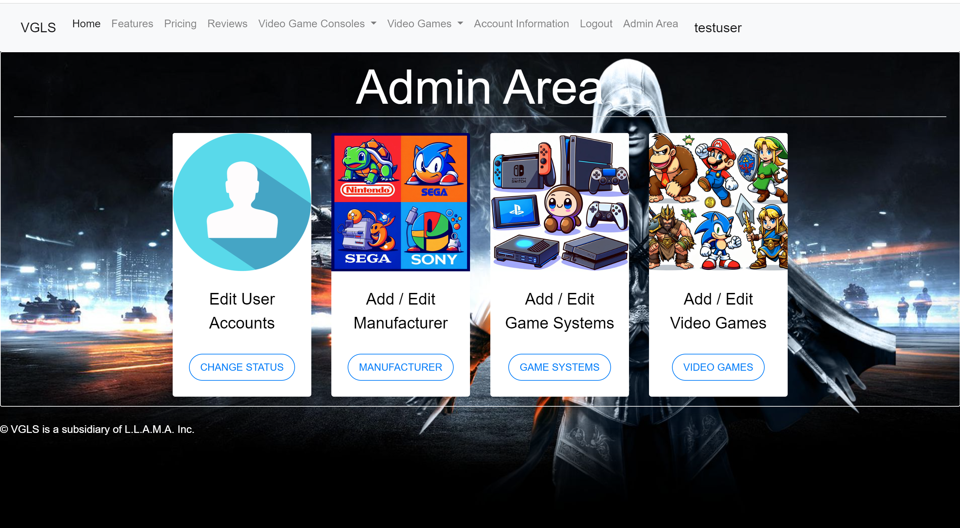

## **Edit User Accounts**

1. Click on Update Admin/User to make changes to the account, or click on delete to remove the account.

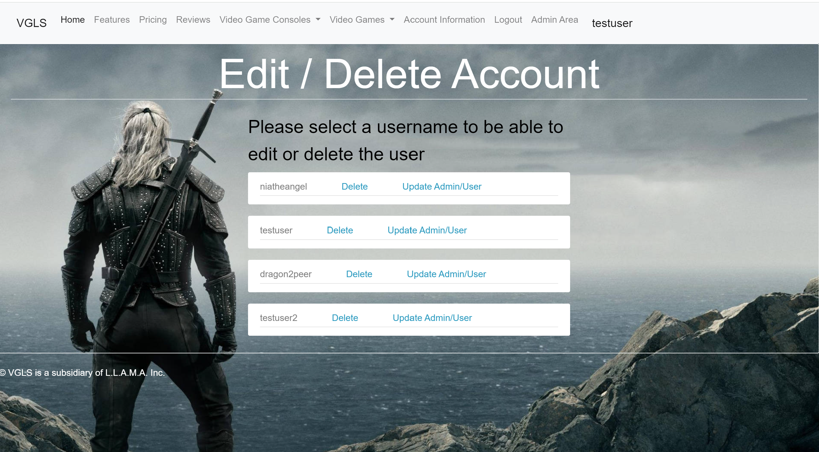

2. You Can change the account username, password, first name, and last name and determine if they will be a user or admin.

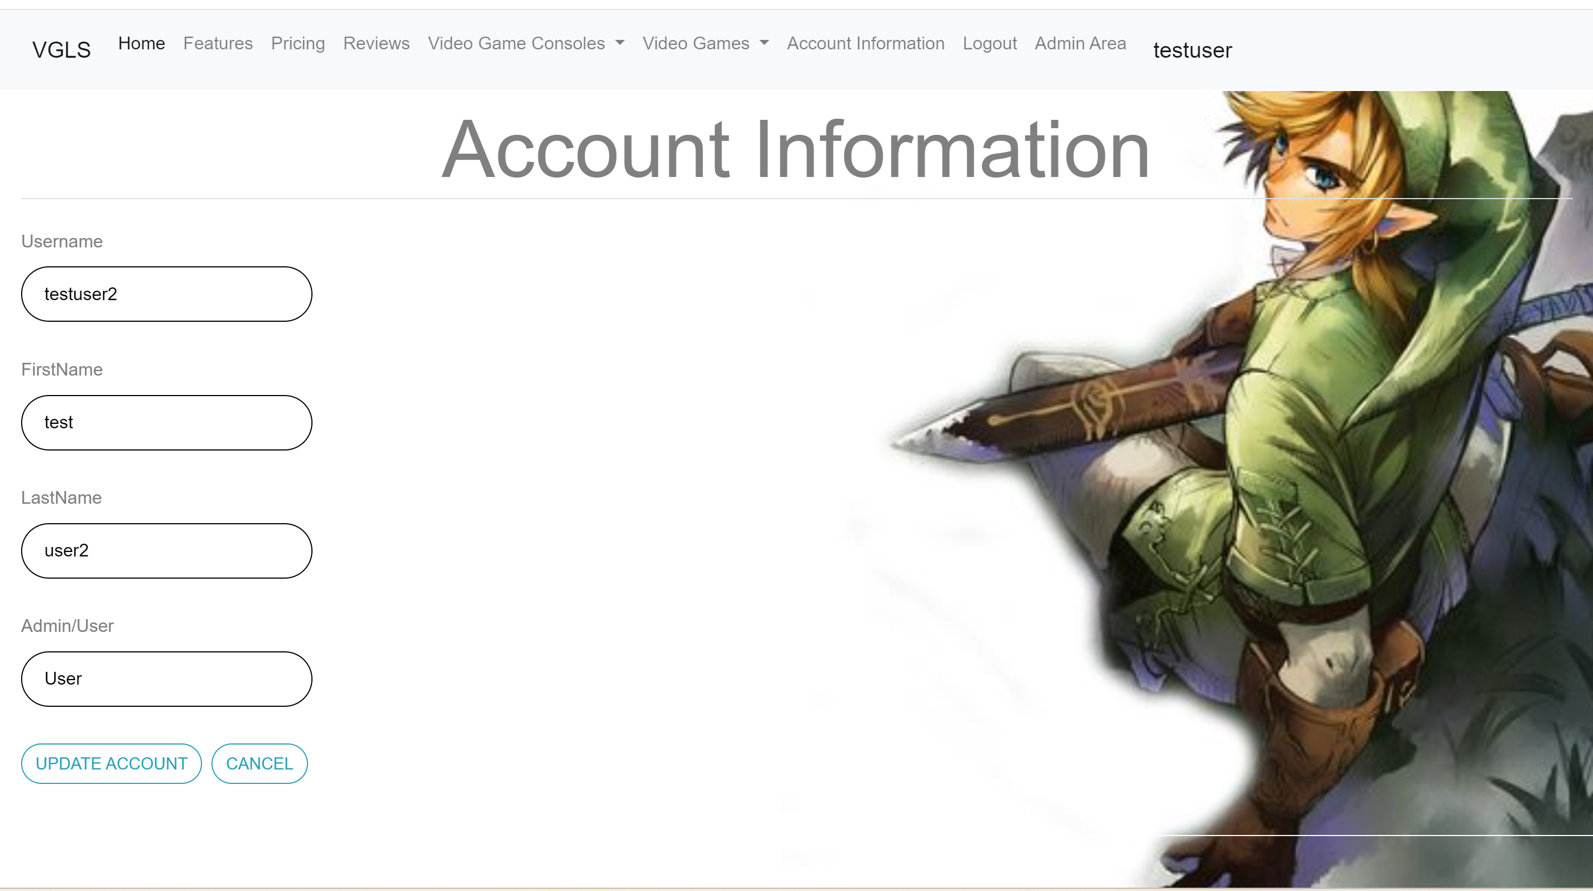

## **Add/Edit Manufacturer**

1. You can also add video game and video game console manufacturers to the database. To do that, you will click on Add/Edit Manufacturer

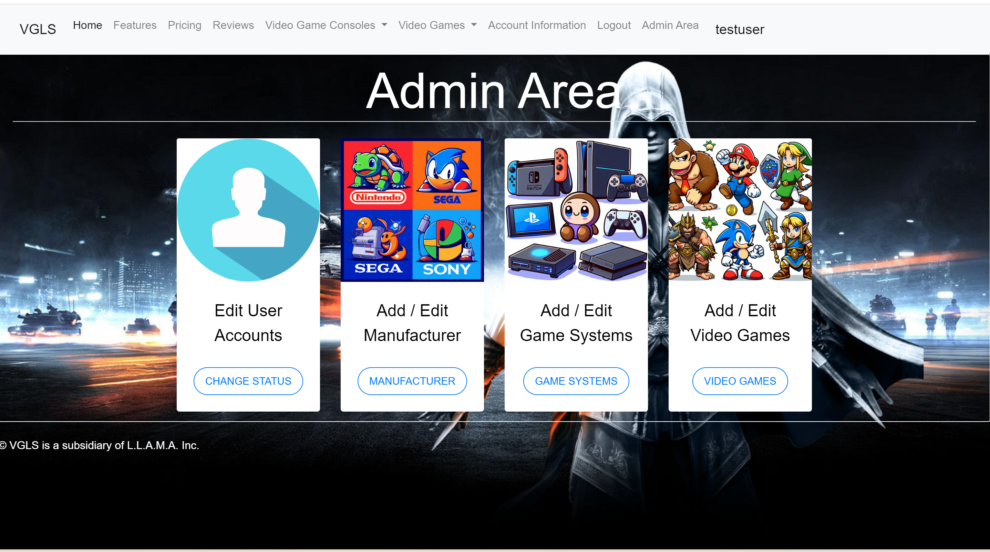

2. Here, you can view the manufacturers in the database, create manufacturers, delete or update them. To create the manufacturer, click on Create Manufacturer, to update the manufacturer, click on Update Manufacturer.

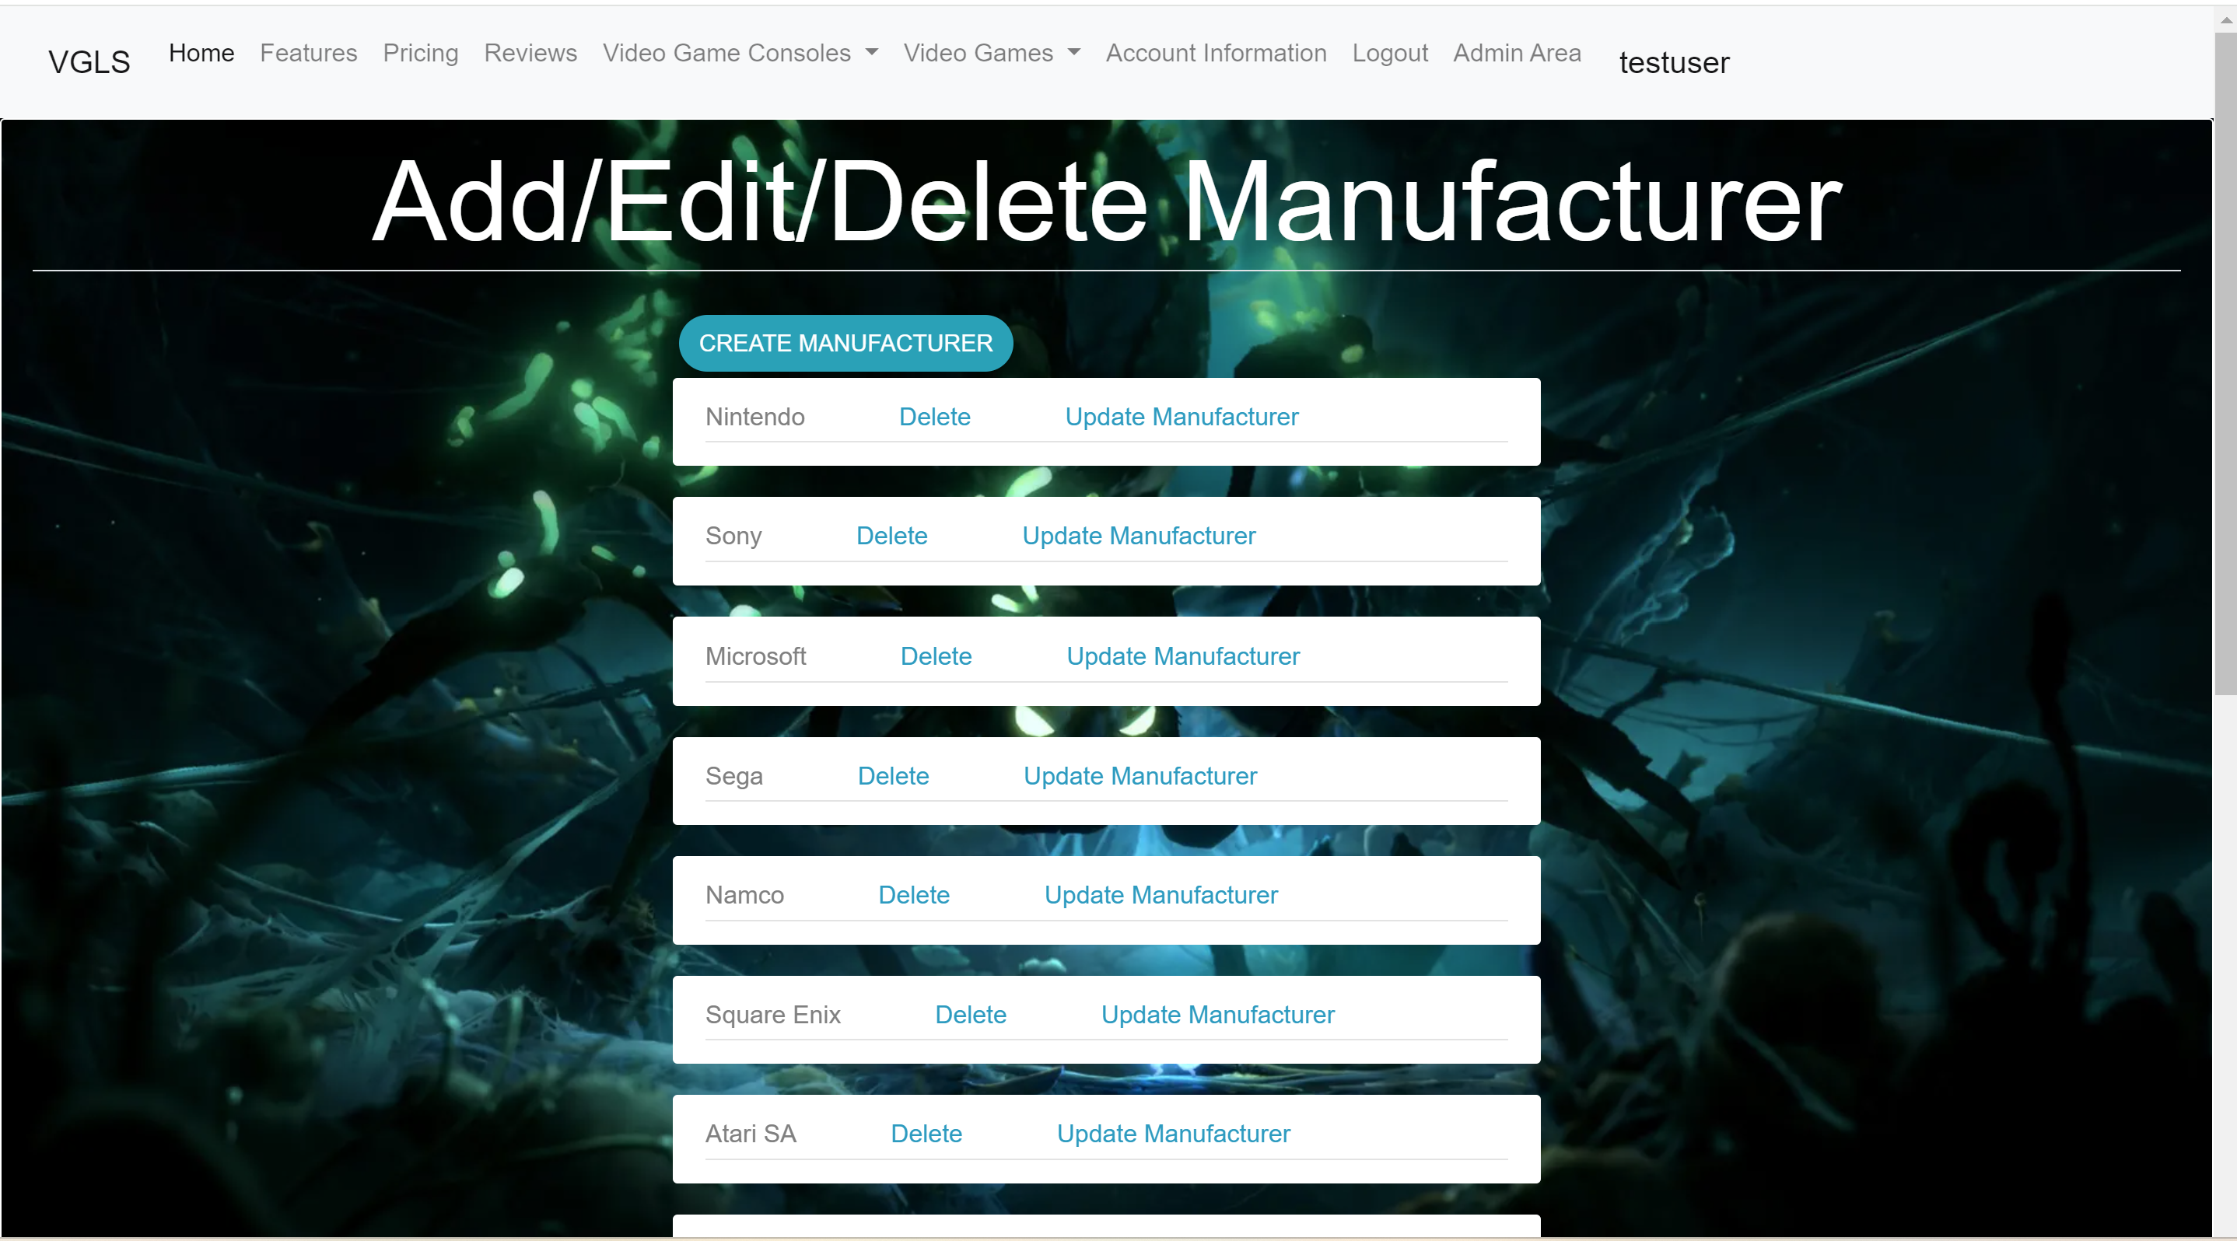

3. You will type in the manufacturer name to create the manufacturer. After you click Create Manufacturer, it will take you back to the main page of manufacturers where you can click on update.

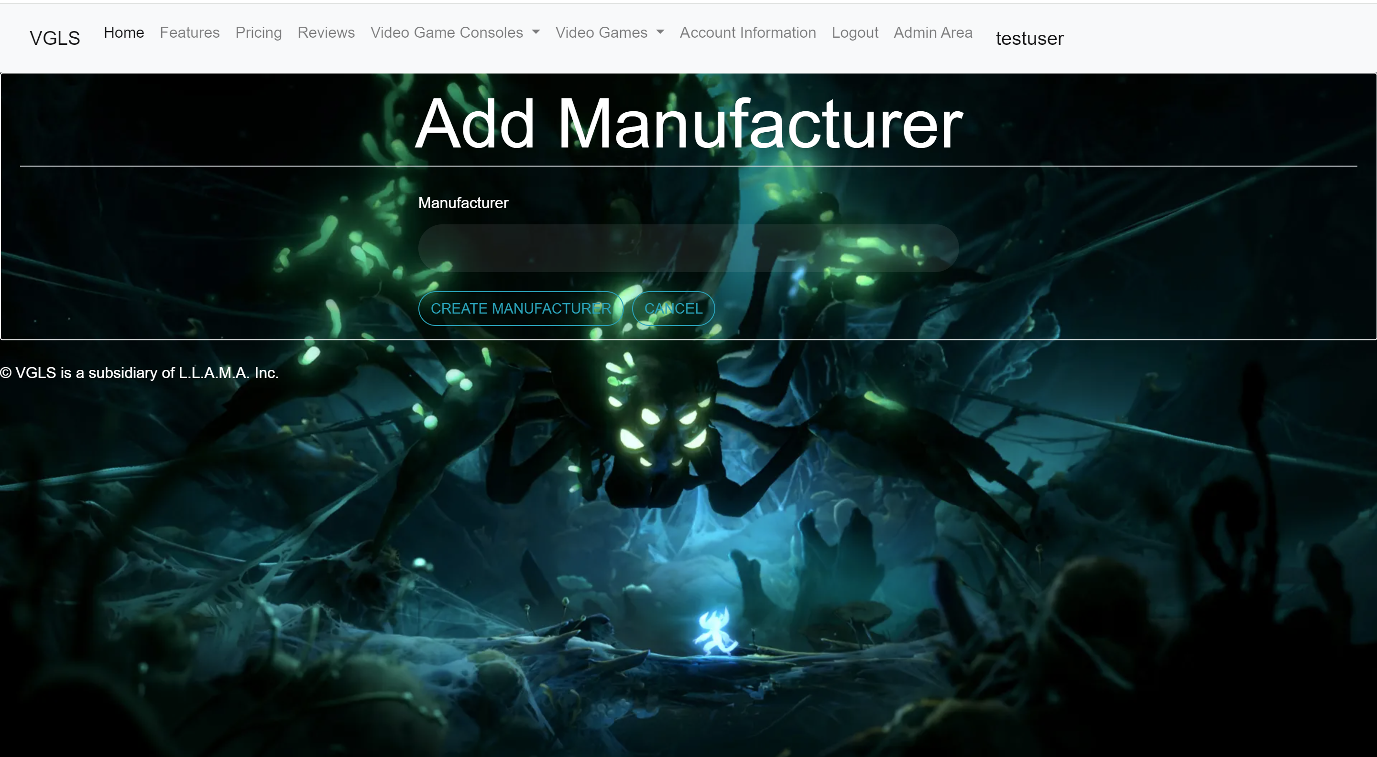

4. Type in the new name for the manufacturer, then click on Update Manufacturer.

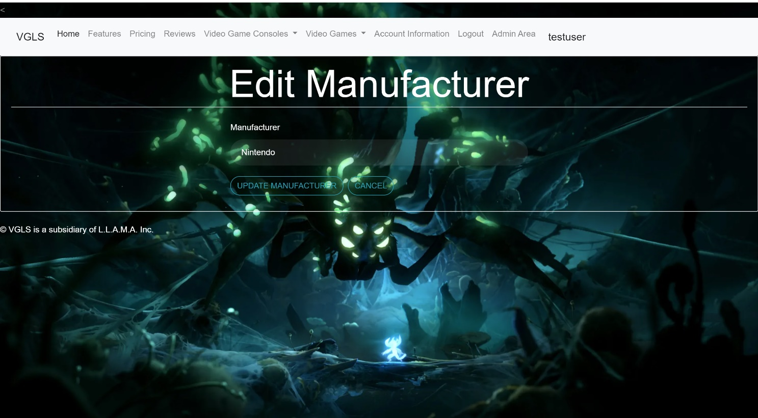

## **Add/Edit Game Systems**

1. You can also add video game consoles to the database. To do that, you will click on Add/Edit Manufacturer



2. you can see all the current consoles in the database here. You can create and delete consoles or update the console by changing the name or manufacturer. To create a console you will click Create Console.

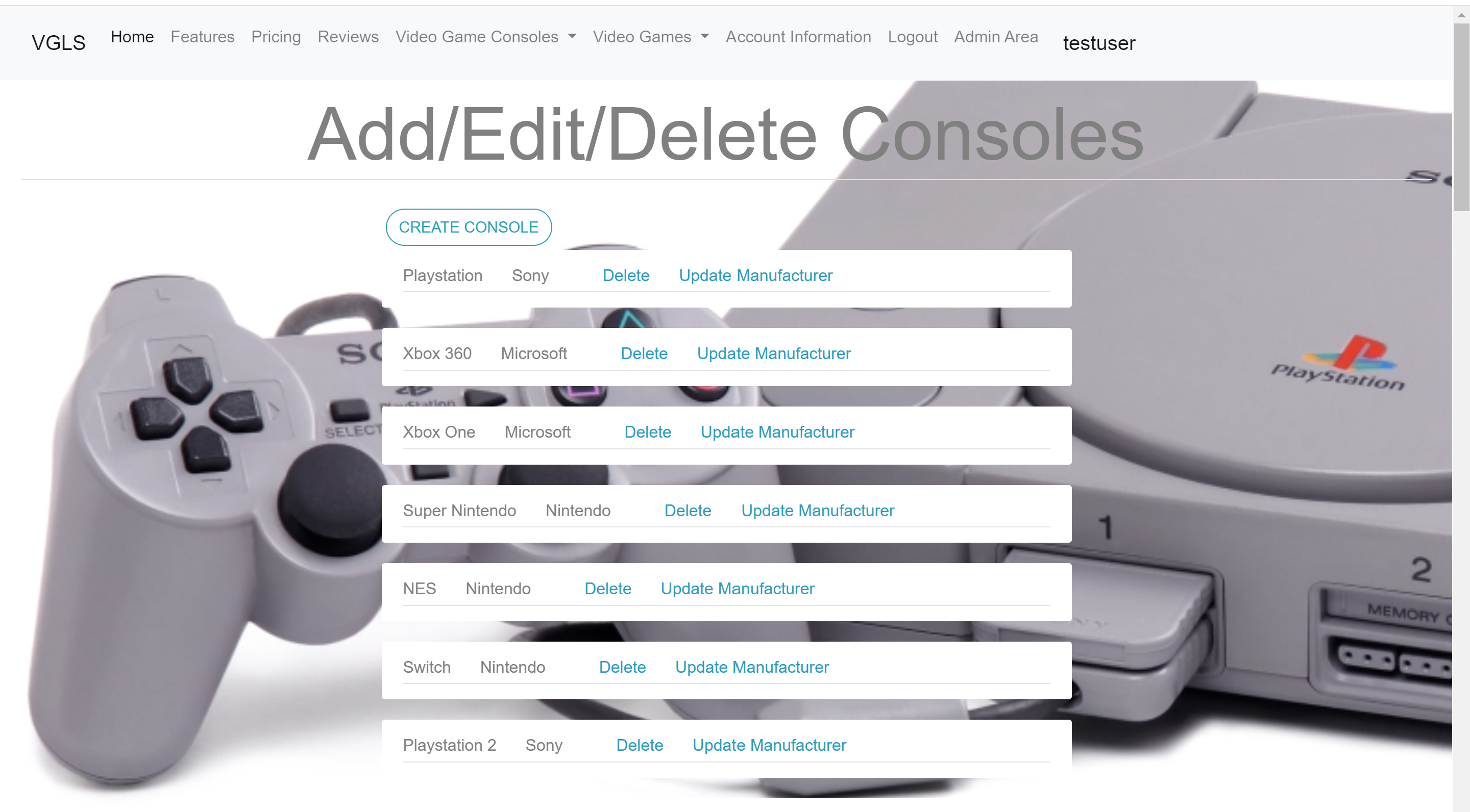

3. Type in the name of the console, then select the manufacturer from the dropdown list. Once you click on Create Console, it will take you back to the main page for consoles so you can click on update.

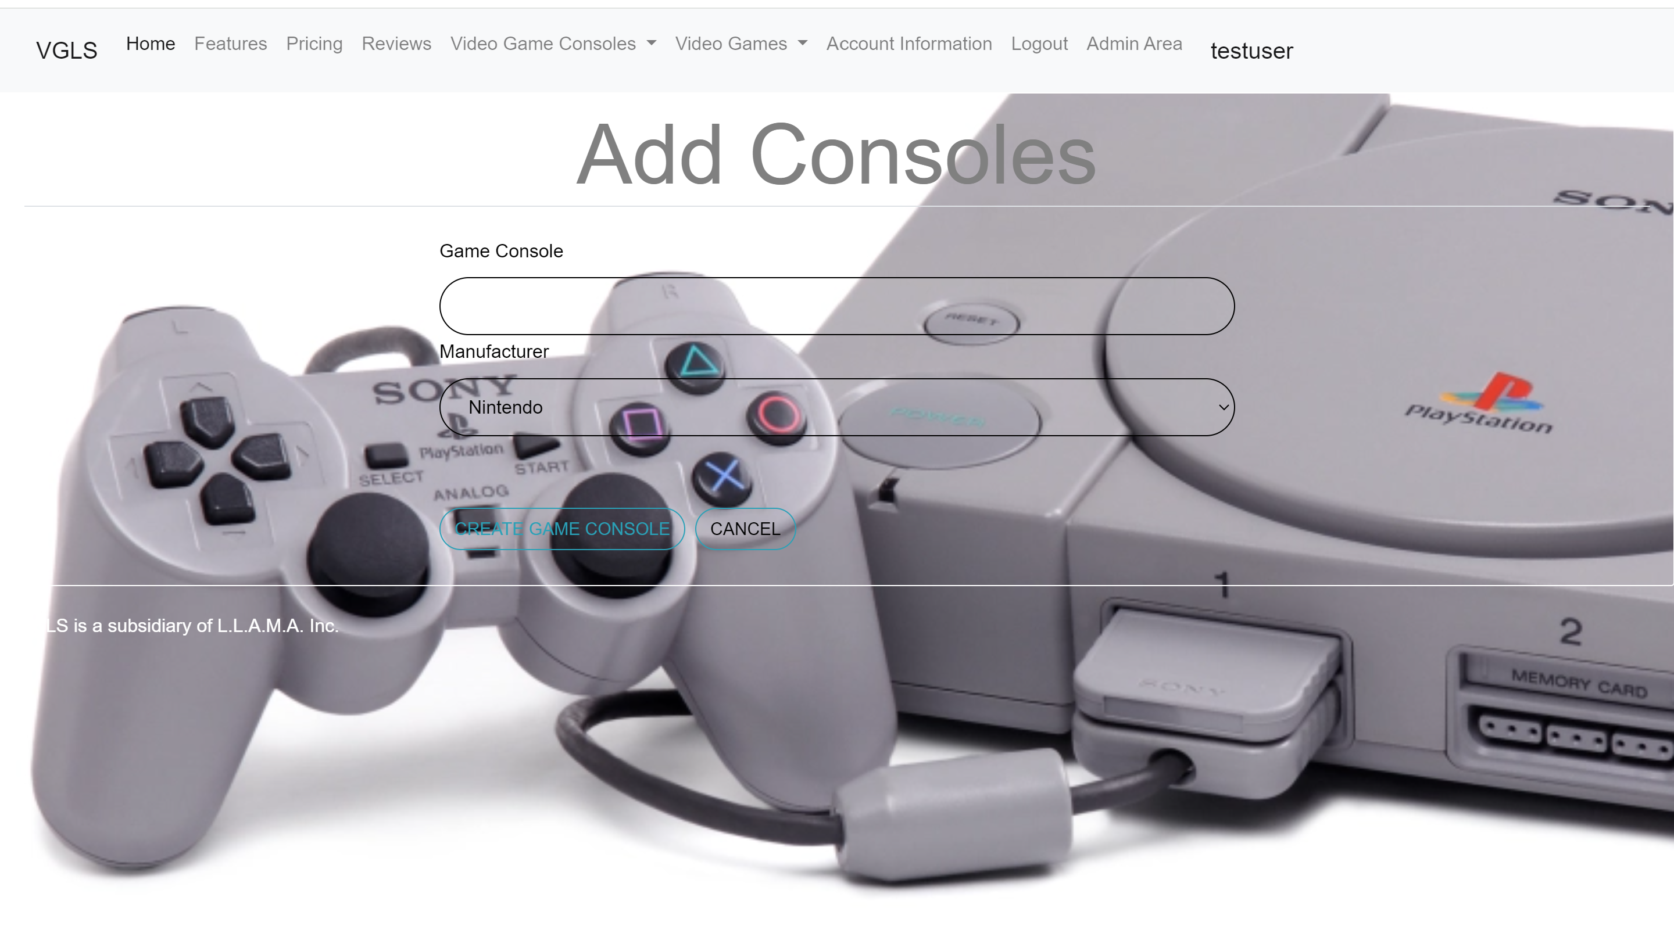

4. You can retype the manufacturer if it is misspelled or use the dropdown list to select the manufacturer.

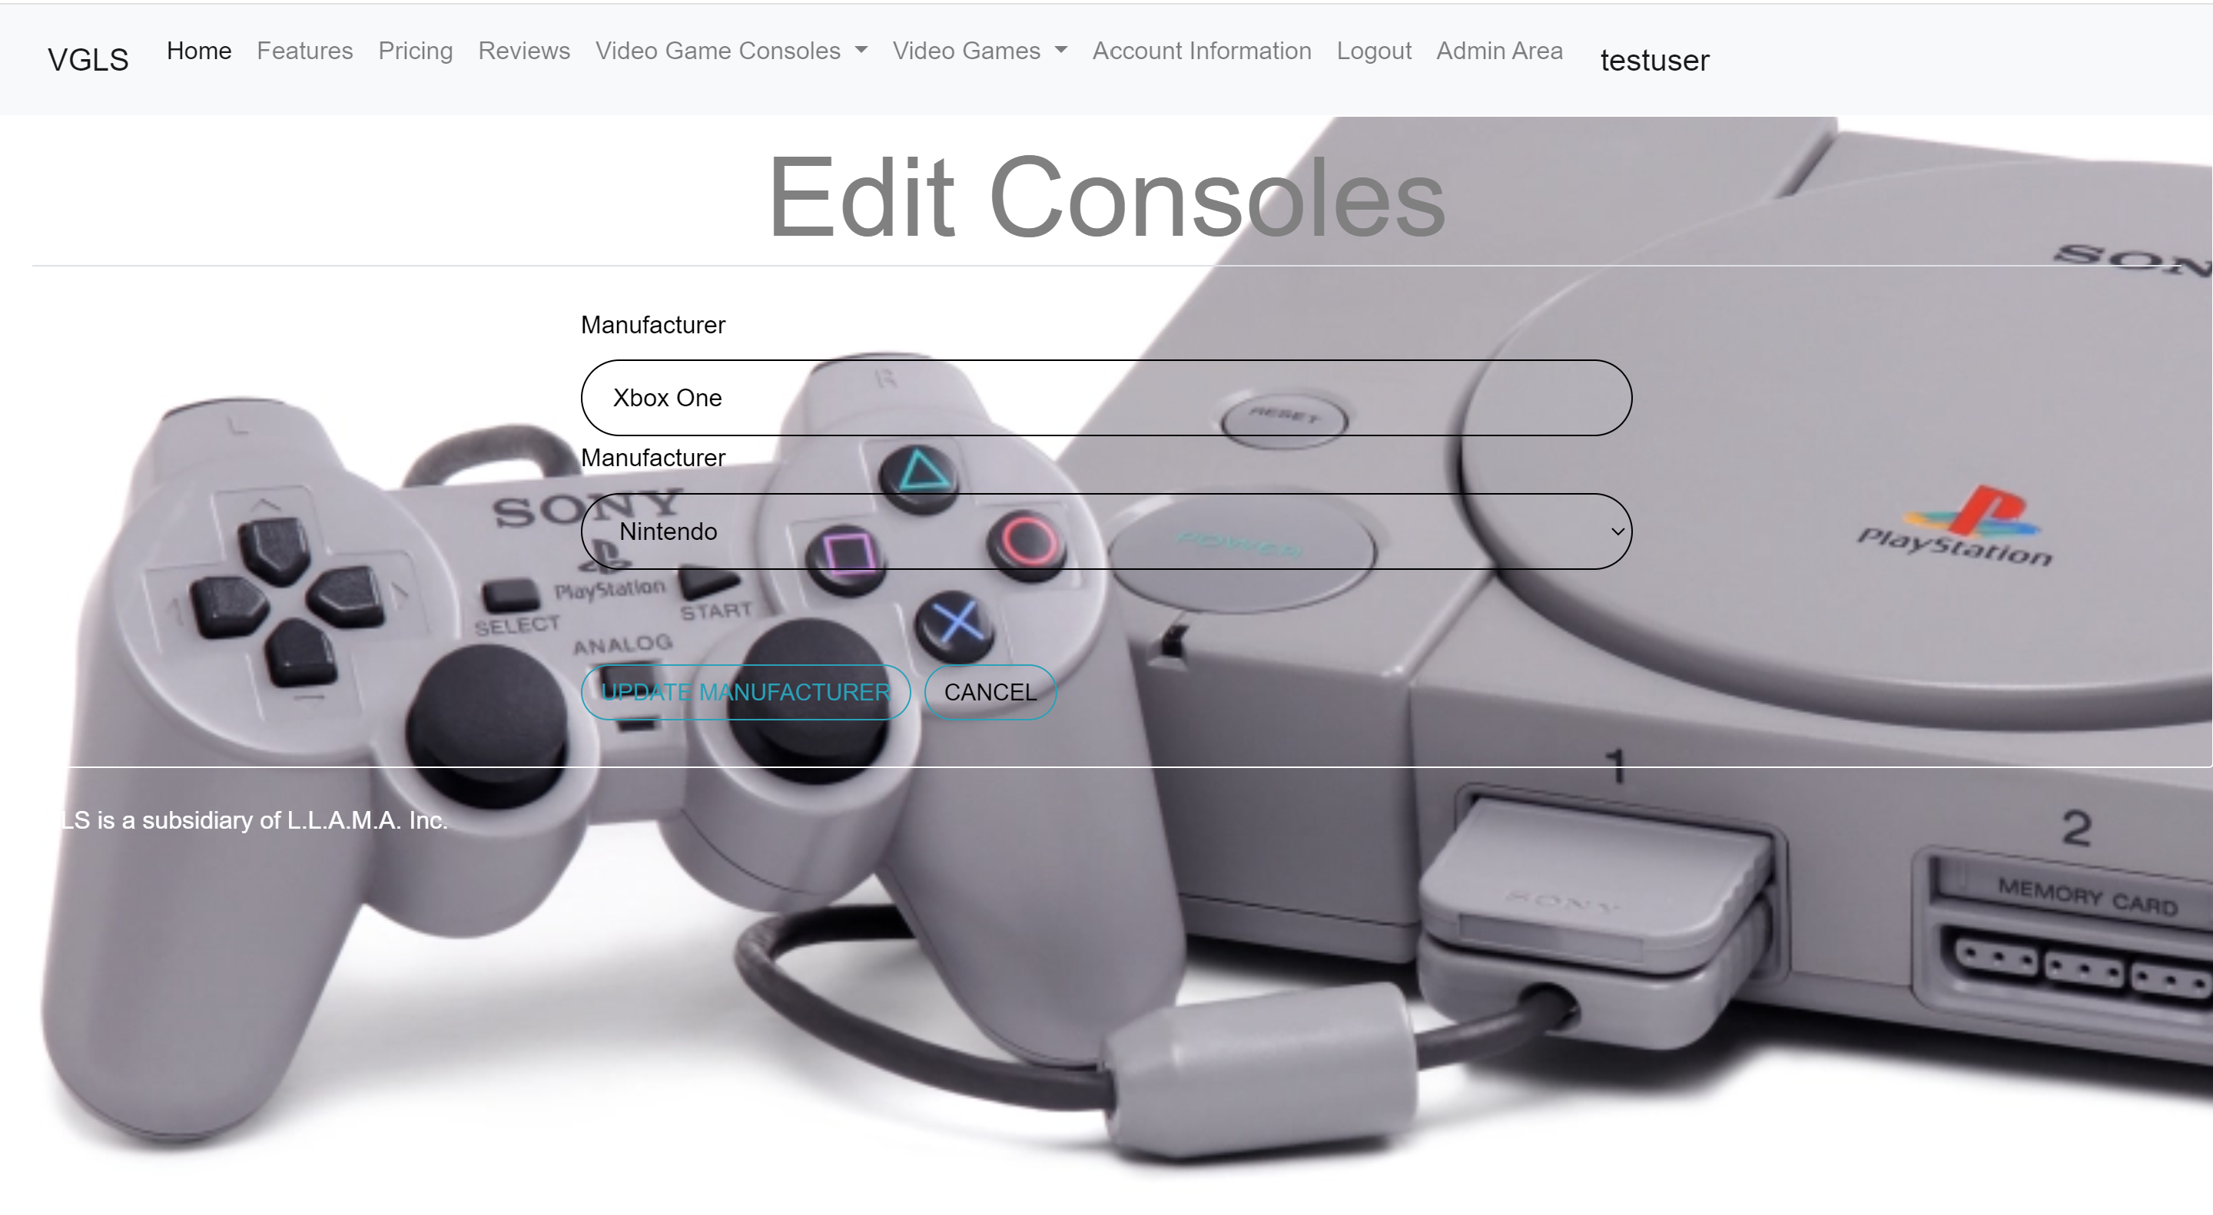

## **Add/Edit Video Games**

1. You can also add video games to the database. To do that, you will click on Add/Edit Video Games.



2. This will show you the video game name and the console. Right now, it is showing the console ID. I am working on getting it to show the console name. You can create a game, delete it or update the game. You can also download the top games if they are not already in your database.

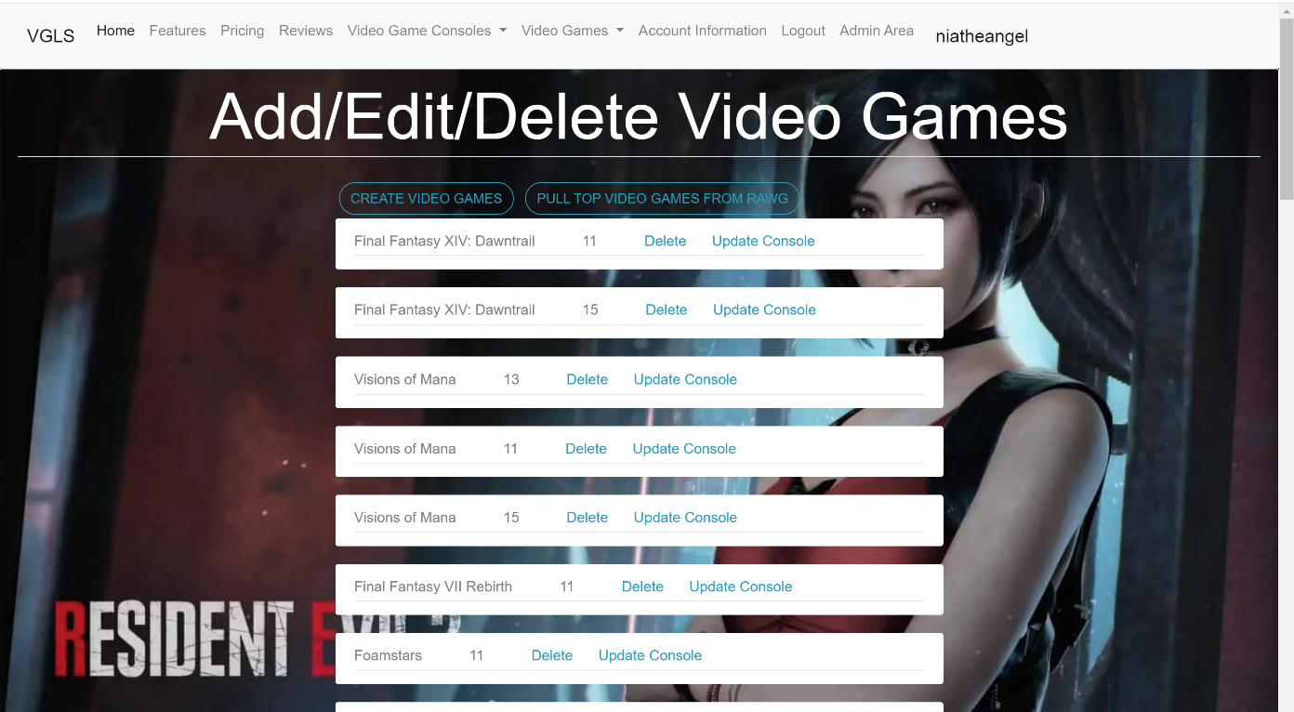

3. Here, you will type in the video game's name, select the console's name using the drop-down arrow, and the manufacturer by using that drop-down arrow. Once you click Create video game, it will take you to the main page for the video games.

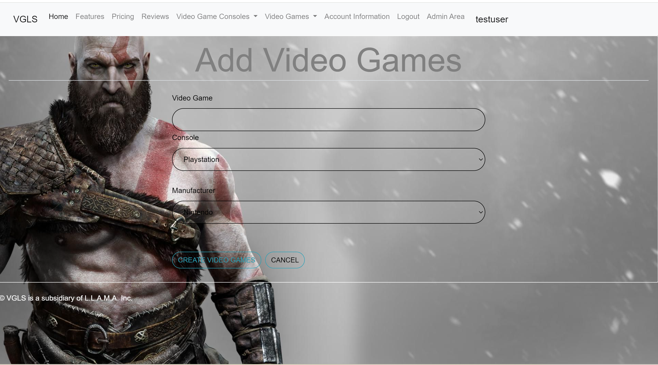

4. Here you can retype the game’s name if it was misspelled, use the drop-down for the console name, and the drop-down for the manufacturer name.

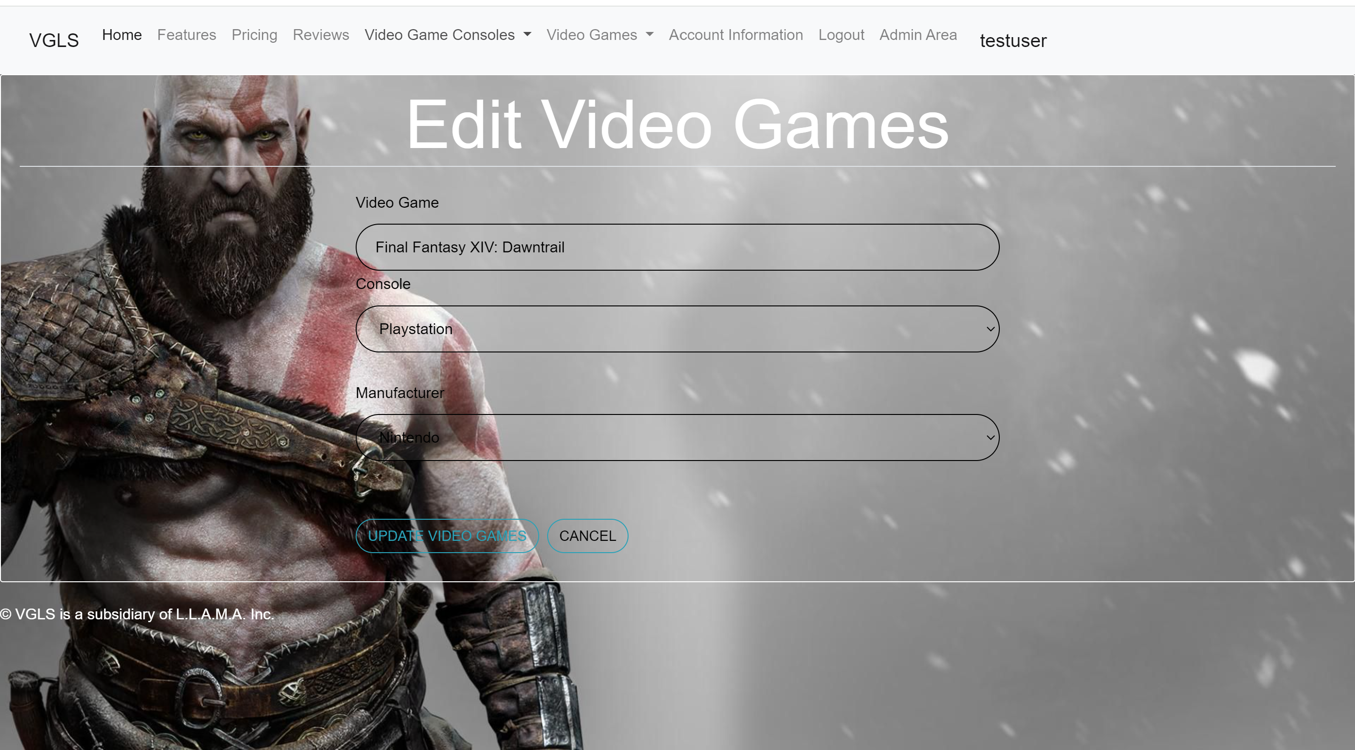

# **Account Information**

1. To view your account information, you will need to click on Account Information in the navigation bar.

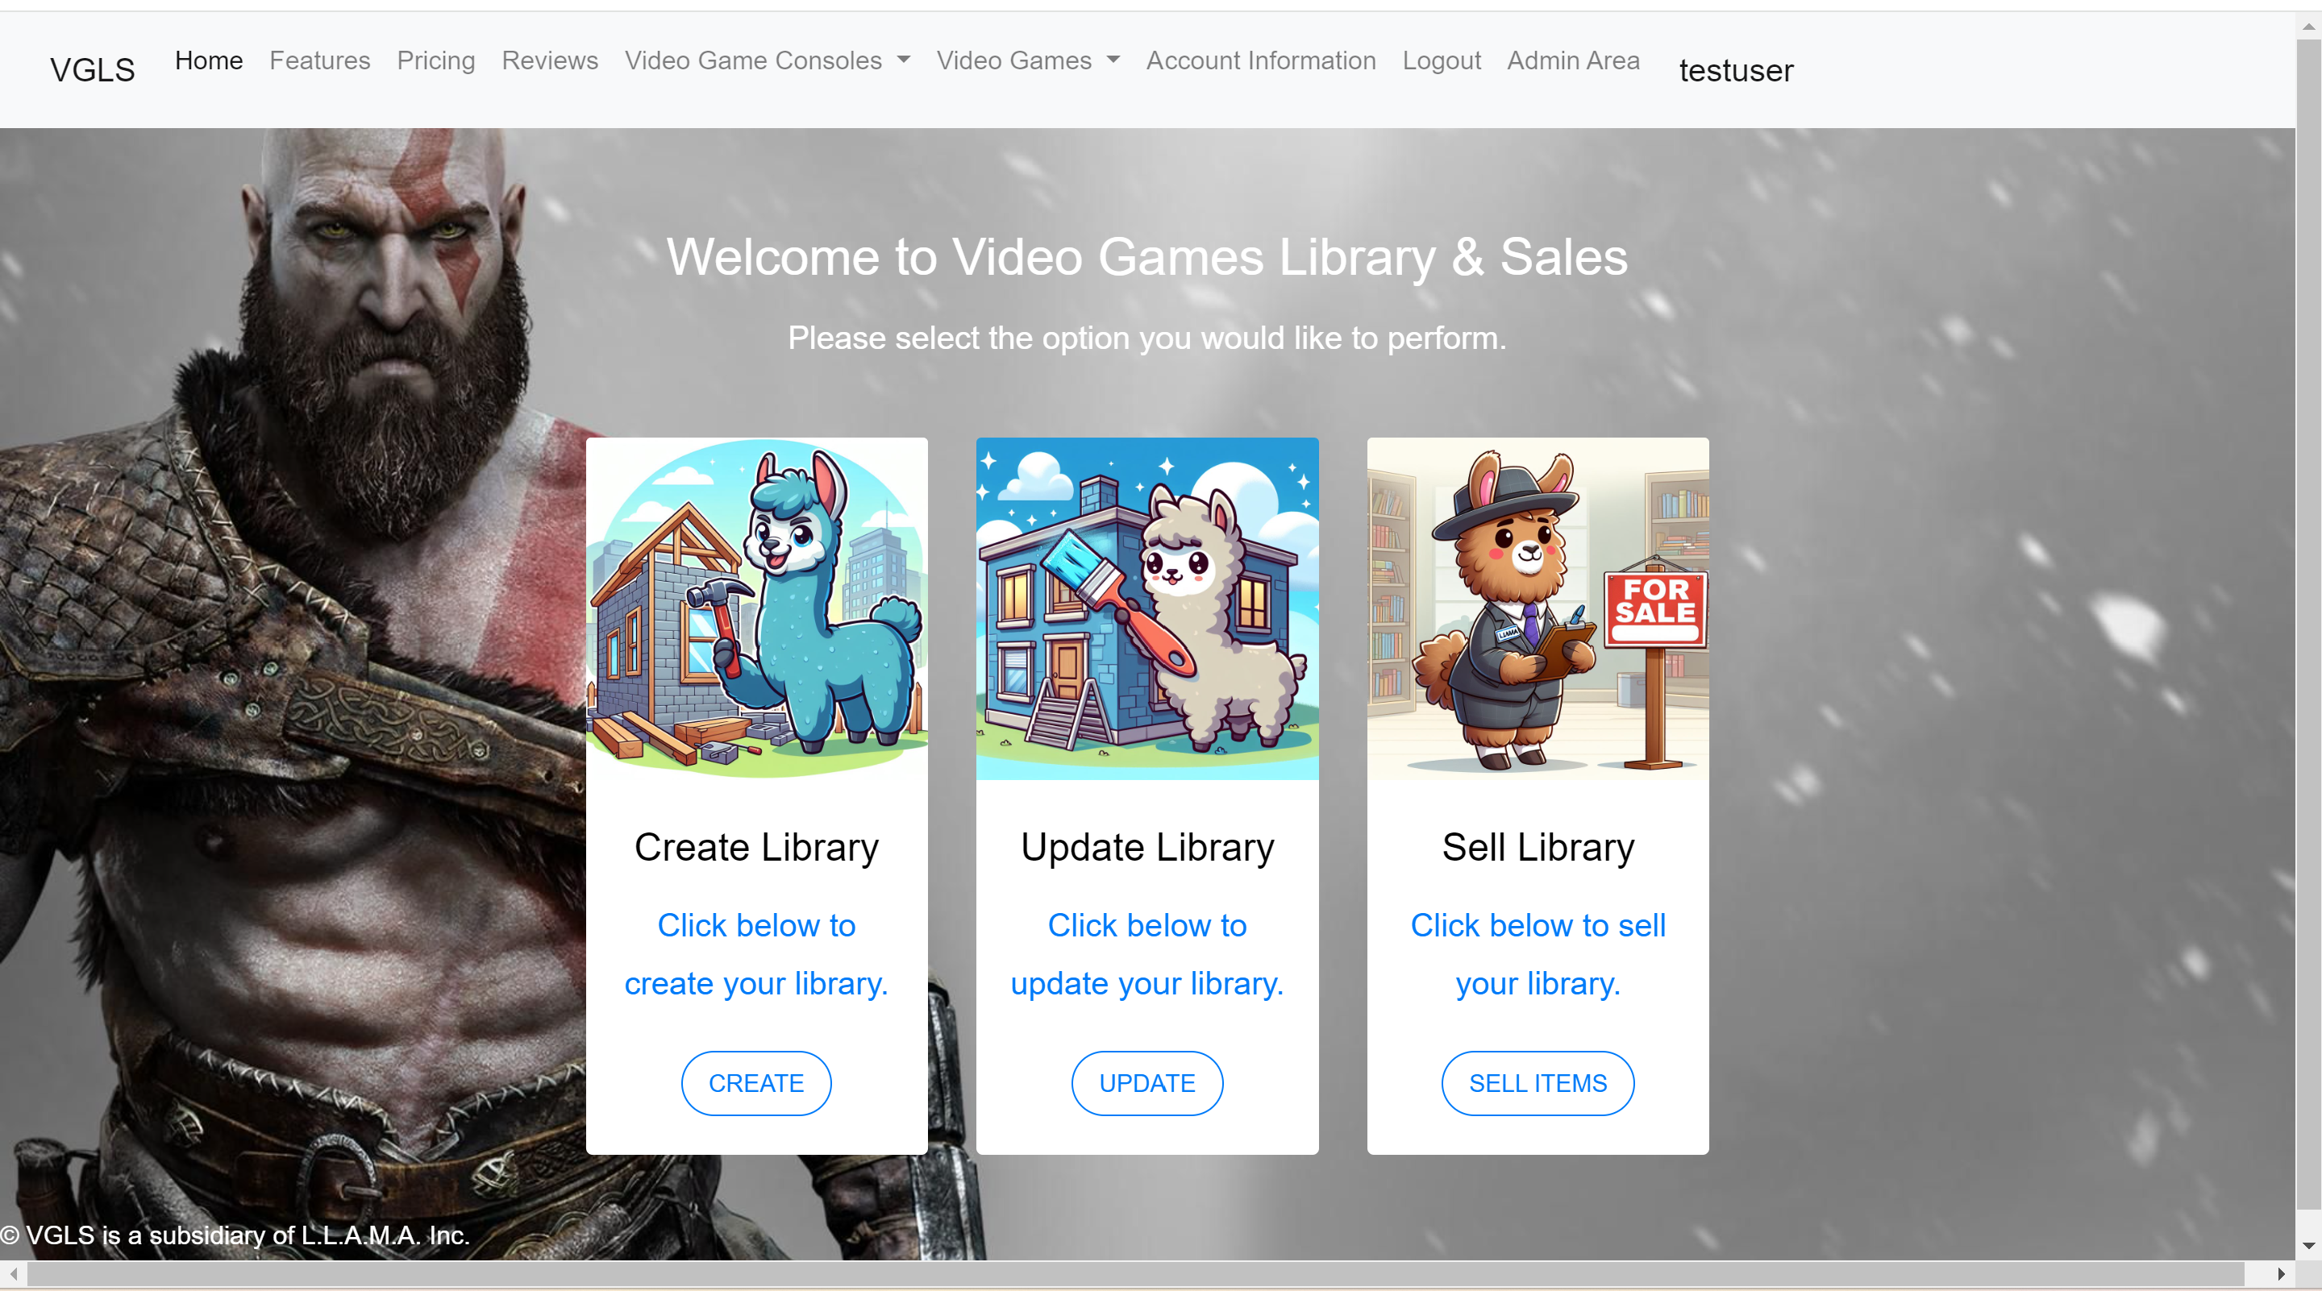

2. Here you can change your username, First Name, Last Name, and profile picture. If the username already exists, you will get an error message when you click on Update Account.

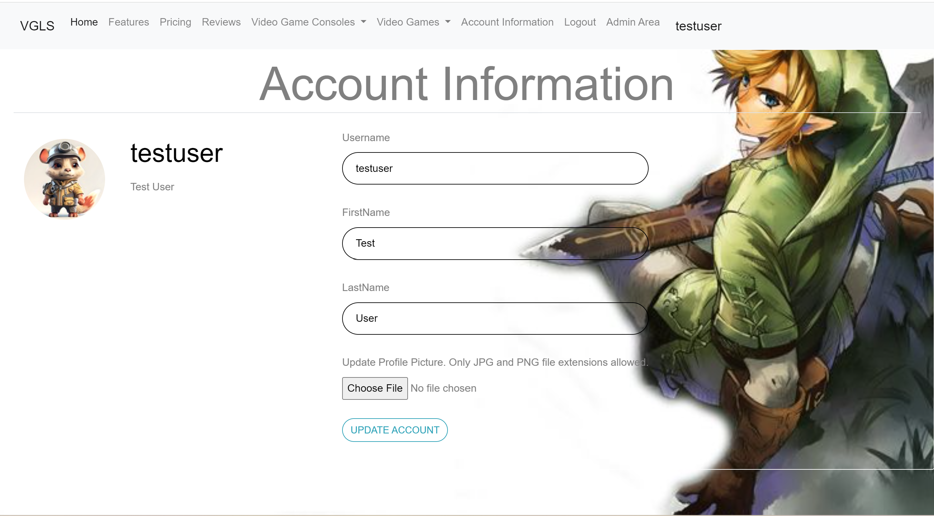

# **Website Reviews**

1. To view, create, delete, and update website reviews, you will click on Reviews in the Navigation Bar.



2. Here, you can see the review headline, create a review, or click on the review link to update or delete it. Only the review creator can update or delete a review.

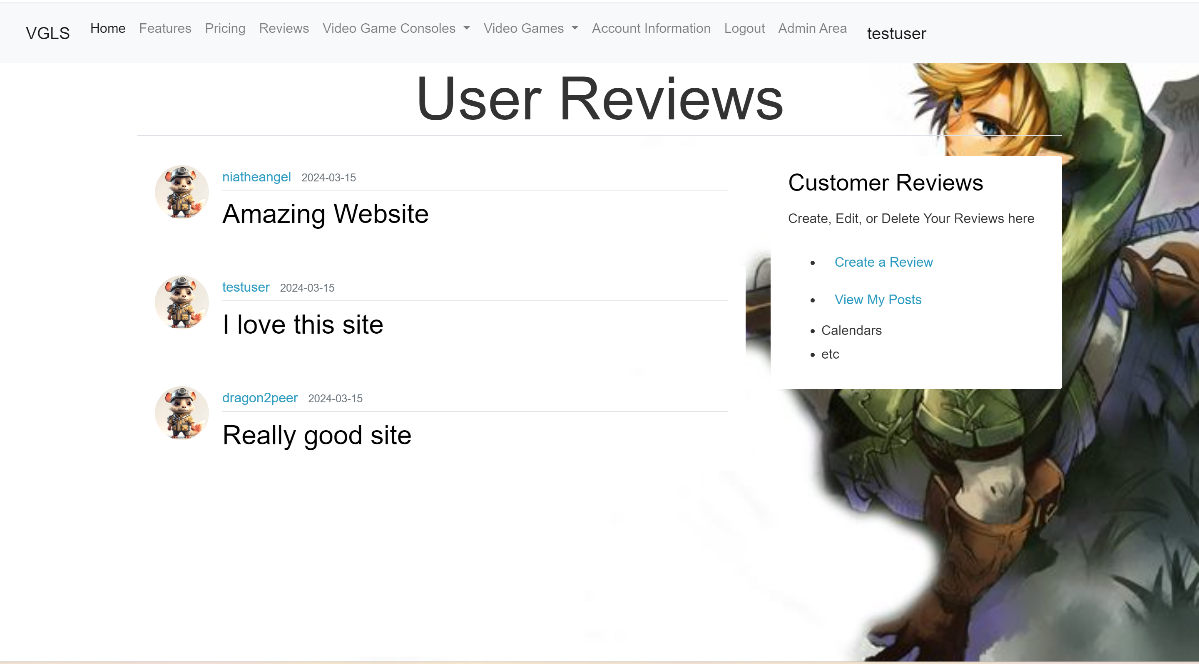

## **Create a Review**

1. You can create a review by clicking on Create a Review. You will give your review a title and then type your review. Once you are done, Click on Submit Review.

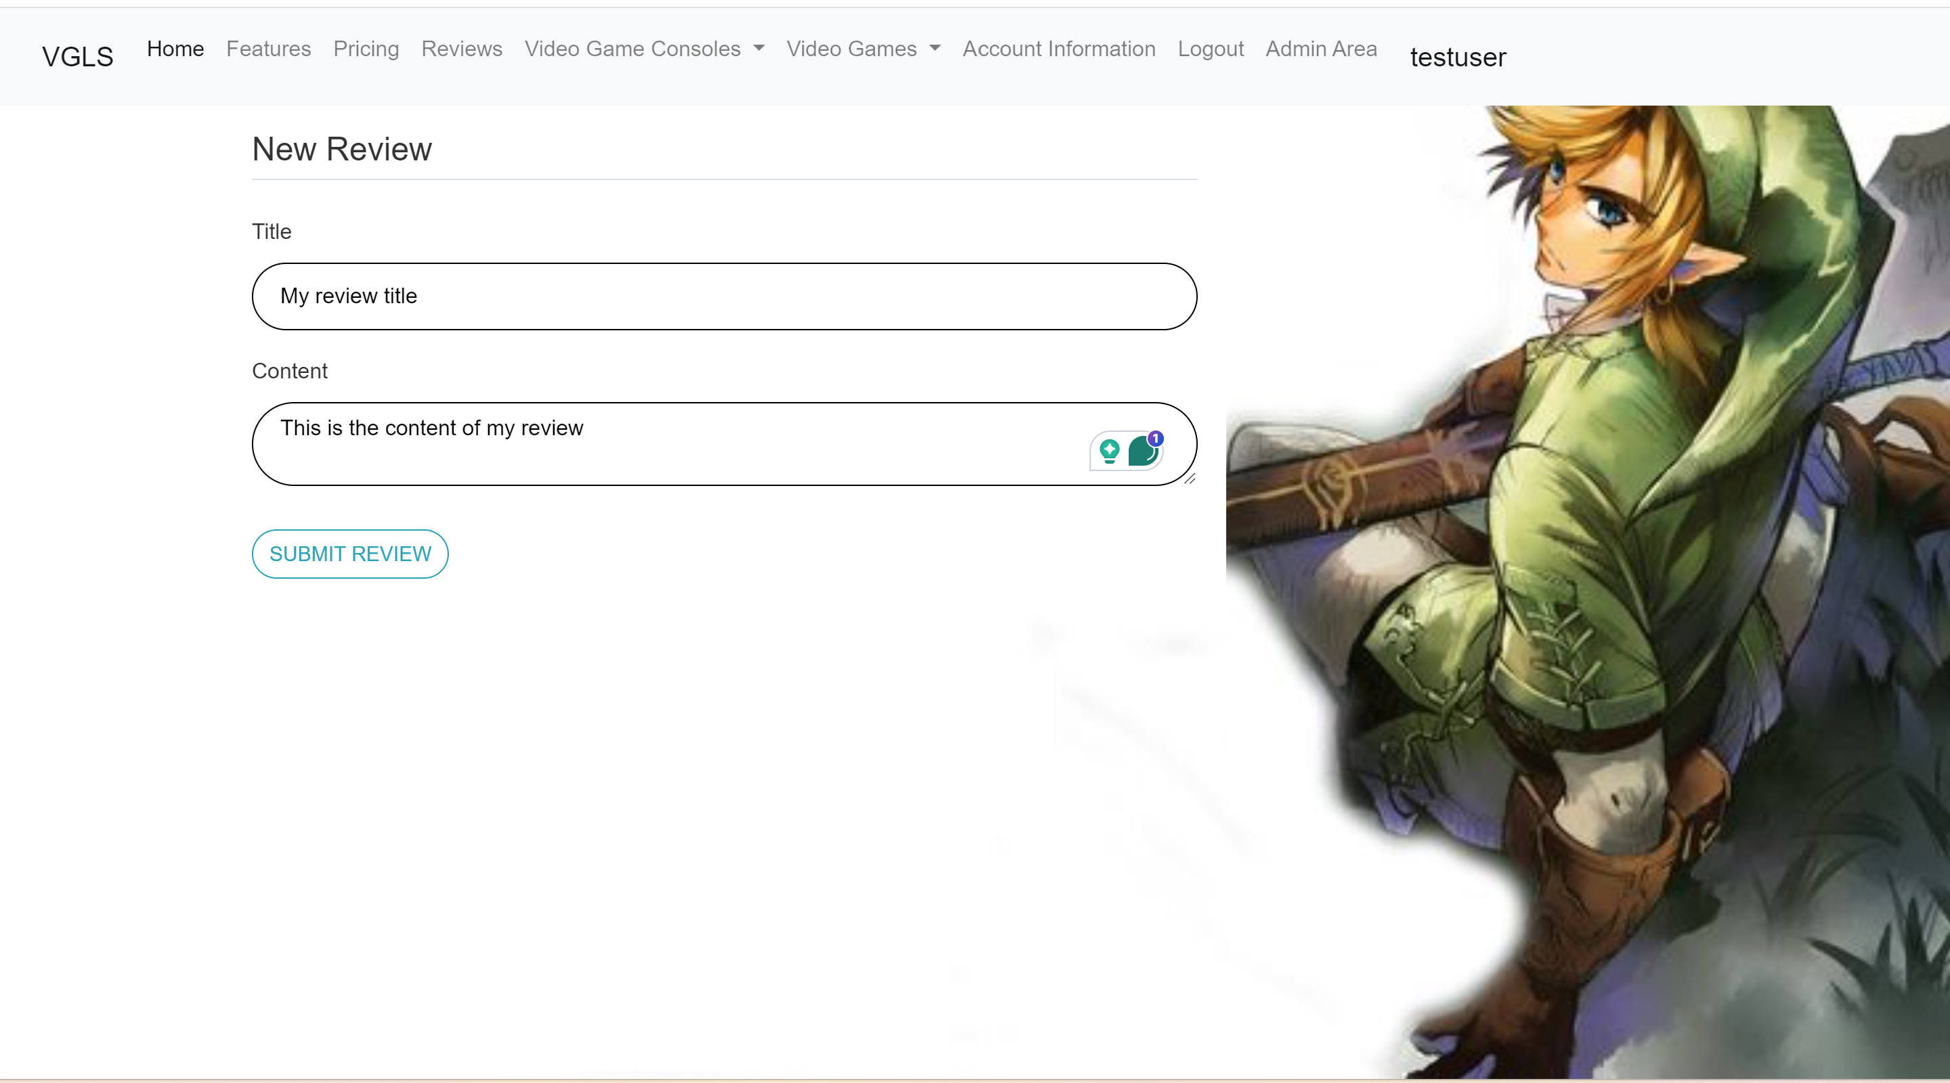

## **Update a Review**

1. You can update your review if you feel it needs to be updated by clicking on the review title.



2. If the review is one you wrote, you can click on update to update your review or you can click on delete to remove your review.

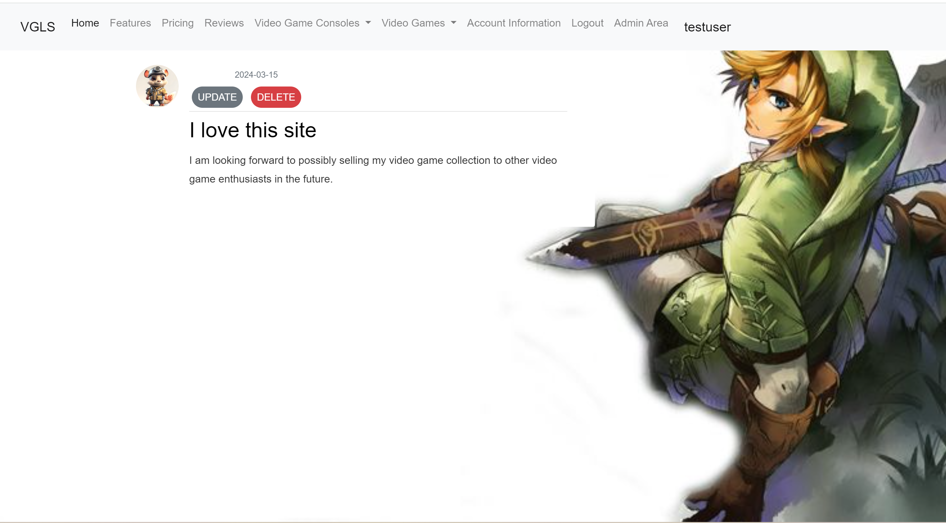

3. Make your changes to your review and click on Submit. You will then receive a message stating that it has been submitted.

